**2021年12月大学英语四级考试真题（第1套）**

Part I Writing (30minutes)

Directions: Suppose your school is organizing an orientation program to help the freshmen adapt to the new environment and academic studies. You are now to write a proposal, which may include its aim, duration, participants and activities. You will have 30 minutes to write the proposal. You should write at least llQ words but no more than 1Jj_Q words.

Part II Listening Comprehension (25 minutes)

Section A

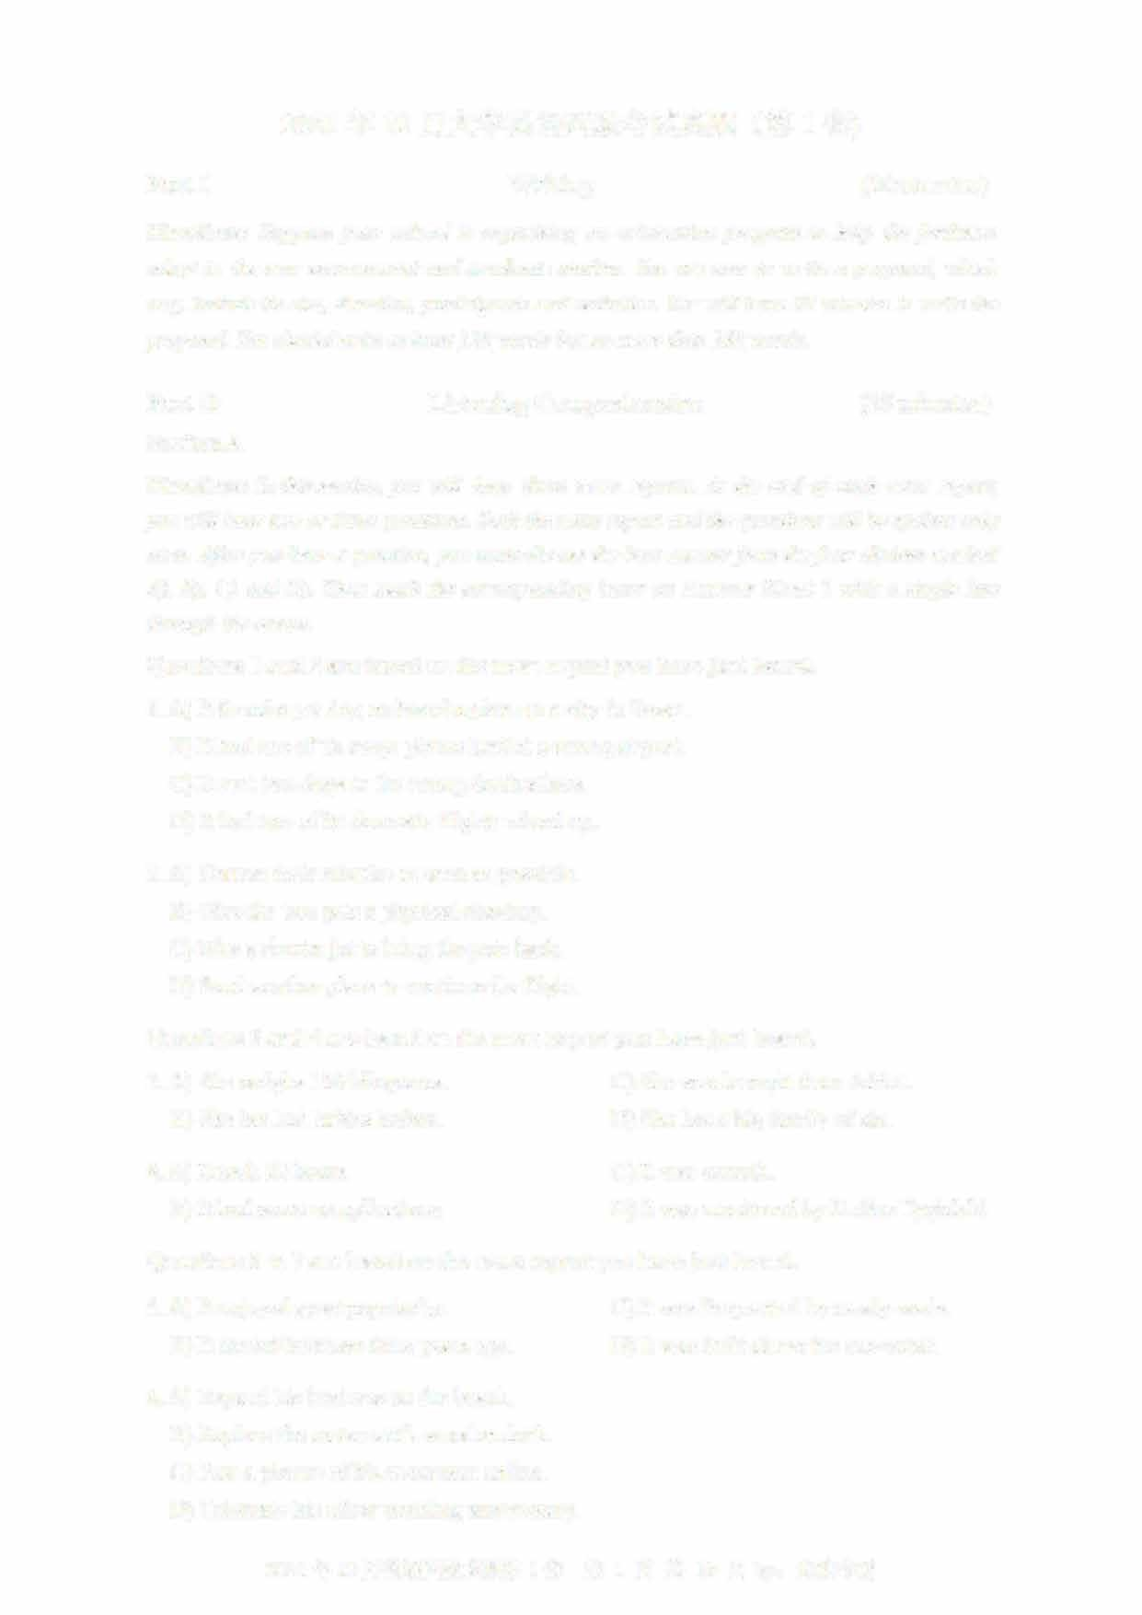Directions: In this section, you will hear three news reports. At the end of each news report, you will hear two or three questions. Both the news report and the questions will be spoken only once. After you hear a question, you must choose the best answer from the four choices marked A), B), C) and D). Then mark the corresponding letter on Answer Sheet 1 with a single line through the centre.

Questions 1 and 2 are based on the news report you have just heard.

1. A) It found a pet dog on board a plane to a city in Texas.B) It had one of its cargo planes land at a wrong airport.
   1. It sent two dogs to the wrong destinations.
   2. It had two of its domestic flights mixed up.
2. A) Correct their mistake as soon as possible.
   1. Give the two pets a physical checkup
   2. Hire a charter jet to bring the pets back
   3. Send another plane to continue the flight.

Questions 3 and 4 are based on the news report you have just heard.

1. A) She weighs 130 kilograms C) She was brought from Africa. B) She has had babies before. D) She has a big family of six
2. A) It took 22 hours. C) It was smooth.
   1. It had some complications. D) It was monitored by Dr.Sue Tygielski

Questions 5 to 7 are based on the news report you have just heard.

1. A) It enjoyed great popularity C) It was frequented by newly-weds. B) It started business three years ago. D) It was built above the sea-water.
2. A) Expand his business on the beach.
   1. Replace the restaurant's wooden deck.
   2. Post a picture of his restaurant online.
   3. Celebrate his silver wedding anniversary.

2021 年 12 月英语四级真题第 1 套 第 1 页共 10 页 by: UVOOC.COM

1. A) She sold it for two thousand dollars. C) She posted its picture on Facebook.
   1. She took it to the restaurant manager. D) She returned it to its owner right away.

Section B

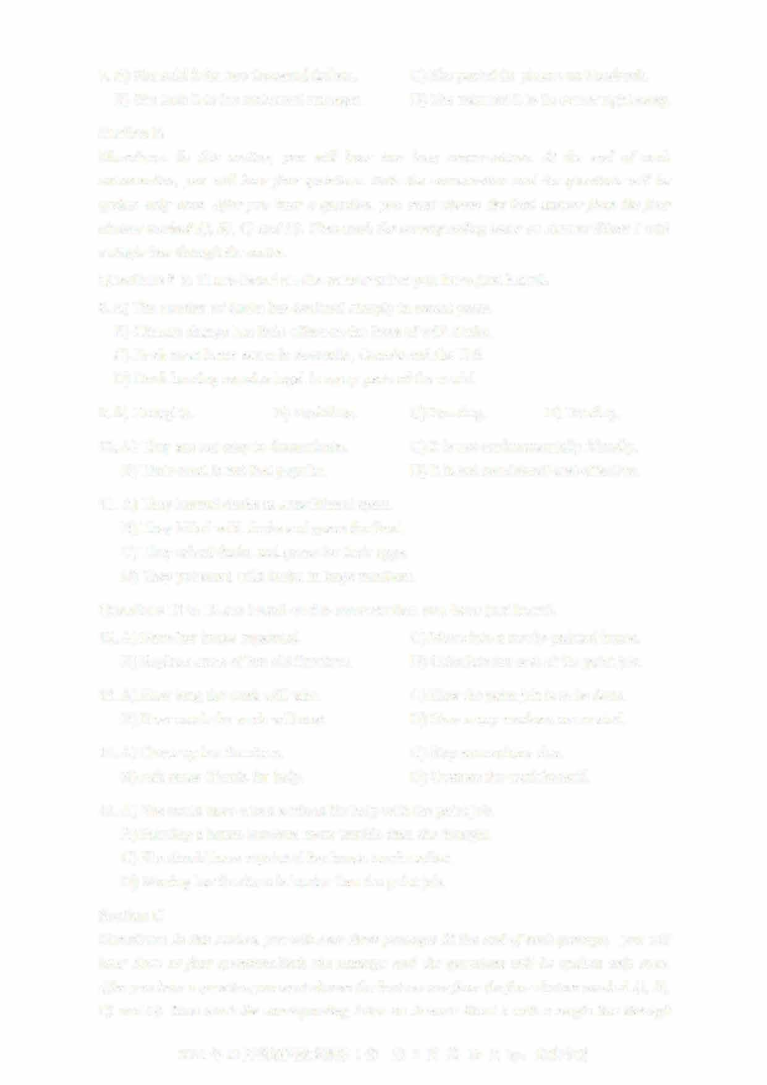Directions: In this section, you will hear two long conversations. At the end of each conversation, you will hear four questions. Both the conversation and the questions will be spoken only once. After you hear a question, you must choose the best answer from the four

choices marked A), B), C) and D). Then mark the corresponding letter on Answer Sheet 1 with a single line through the centre.

Questions 8 to 11 are based on the conversation you have just heard.

1. A) The number of ducks has declined sharply in recent years.B) Climate change has little effect on the lives of wild ducks.
   1. Duck meat is not eaten in Australia, Canada and the U.S.
   2. Duck hunting remains legal in many parts of the world.
2. A) Droughts. B) Bushfires. C) Farming. D) Hunting.
3. A) They are not easy to domesticate. C) It is not environmentally friendly.
   1. Their meat is not that popular. D) It is not considered cost-effective.
4. A) They hunted ducks as a traditional sport.
   1. They killed wild ducks and geese for food.
   2. They raised ducks and geese for their eggs
   3. They poisoned wild ducks in large numbers.

Questions 12 to 15 are based on the conversation you have just heard.

1. A) Have her house repainted. C) Move into a newly-painted house.
   1. Replace some of her old furniture. D) Calculate the cost of the paint job.
2. A) How long the work will take. C) How the paint job is to be done. B) How much the work will cost. D) How many workers are needed.
3. A) Cover up her furniture. C) Stay somewhere else.
   1. Ask some friends for help. D) Oversee the work herself.
4. A) She could have asked a friend for help with the paint job. B) Painting a house involves more trouble than she thought.
   1. She should have repainted her house much earlier.
   2. Moving her furniture is harder than the paint job.

Section C

Directions: In this section, you will hear three passages At the end o「each passage, you will hear three or four questions.Both the passage and the questions will be spoken only once

After you hear a question,you must choose the best answer from the four choices marked A), B),

C) and D). Then mark the corresponding letter on Answer Sheet 1 with a single line through

2021 年 12 月英语四级真题第 1 套 第 2 页共 10 页 by:

the centre.

Questions 16 to 18 are based on the passage you have just heard.

1. A) To cultivate good habits. C) To review what is learned in class. B) To prepare for secondary school. D) To stimulate interest in learning.
2. A) Discuss their academic achievements with them. B) Create an ideal study environment for them.
   1. Allow them to learn independently.
   2. Check their homework promptly.
3. A) Finish them before they get tired.
   1. Tackle the most difficult task first.
   2. Start with something they enjoy
   3. Focus on the most important ones.

Questions 19 to 21 are based on the passage you have just heard.

1. A) Workers who meet its body weight standards.
   1. Workers who can lose 30 pounds in a year
   2. Workers who try the hardest to lose weight
   3. Workers who are in the top 10% of the slimmest.
2. A) Impractical. C) Unmanageable. B) Inconsistent. D) Unfair.
3. A) Offer them much fatter bonuses. C) Encourage healthy behaviors.
   1. Improve working environment. D) Provide free lunch and snacks.

Questions 22 to 25 are based on the passage you have just heard.

1. A) It has not done enough to help left-handed children.
   1. It has treated left-handed children as being disabled.
   2. It has not built facilities specially for the left-handed.
   3. It has ignored campaigns on behalf of the left-handed.
2. A) They are as intelligent as other children. B) They have a distinctive style of handwriting
   1. They sometimes have psychological problems
   2. They tend to have more difficulties in learning.
3. 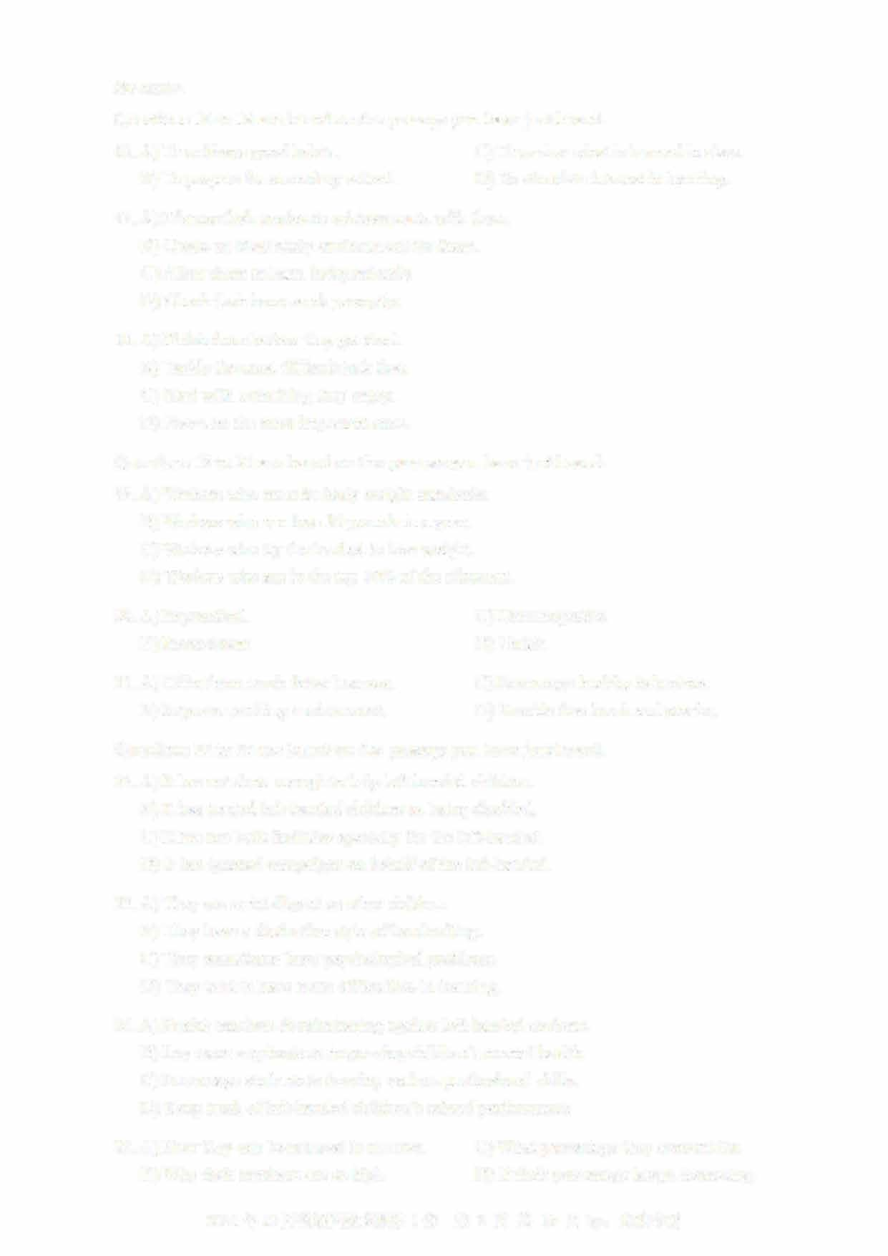A) Punish teachers discriminating against left-handed students. B) Lay more emphasis on improving children's mental health. C) Encourage students to develop various professional skills

D) Keep track of left-handed children's school performance.

1. A) How they can be reduced in number. C) What percentage they account for.
   1. Why their numbers are so high. D) If their percentage keeps increasing

2021年12月英语四级真题第1套 第3页共10页by: UVOOC.COM

**Part III Reading Comprehension (40 minutes)**

# Section A

**Directions: In this section, there is a passage with ten blanks. You are required to select one word for each blank from a list of choices given in a word bank following the passage. Read the passage through carefully before making your choices, Each choice in the bank is iden叩ed by a letter. Please mark the corresponding letter for each item on Answer Sheet 2 with a single**

**line through the centre. You may not use any of the words in the bank more than once.**

**Questions 26 to 35 are based on the following passage.**

**Many people believe that passion and commitment are the foundations of strong romantic relationships. But a relationship is made of two--1.§__ individuals. And the personality traits (it •ri) these individua**（特性） **ls ____XJ___ or lack can often make a relationship more- or less- likely to ----2.L_. Recent research has found that one trait in particular — humility** （谦逊） **—is an important indicator of successful relationships.**

**Humility can sometimes be ___12__ with a lack of confidence. But researchers have come to realize that being humble generally indicates the ____lQ__ of deeply admirable personal qualities. Being humble means you have the ab山ty to accurately ___lL_ your deficiencies without denying your skills and strengths. For example, you might recognize that you are intelligent, but realize that you are not a ___lL__. Thus, humility leads to an honest view of one's own advantages and shortcomings. Humble people do not ignore, avoid, or try to deny their limits or deficiencies. They can__ll__mistakes, see value in things that are far from perfect and identify areas for improvement**

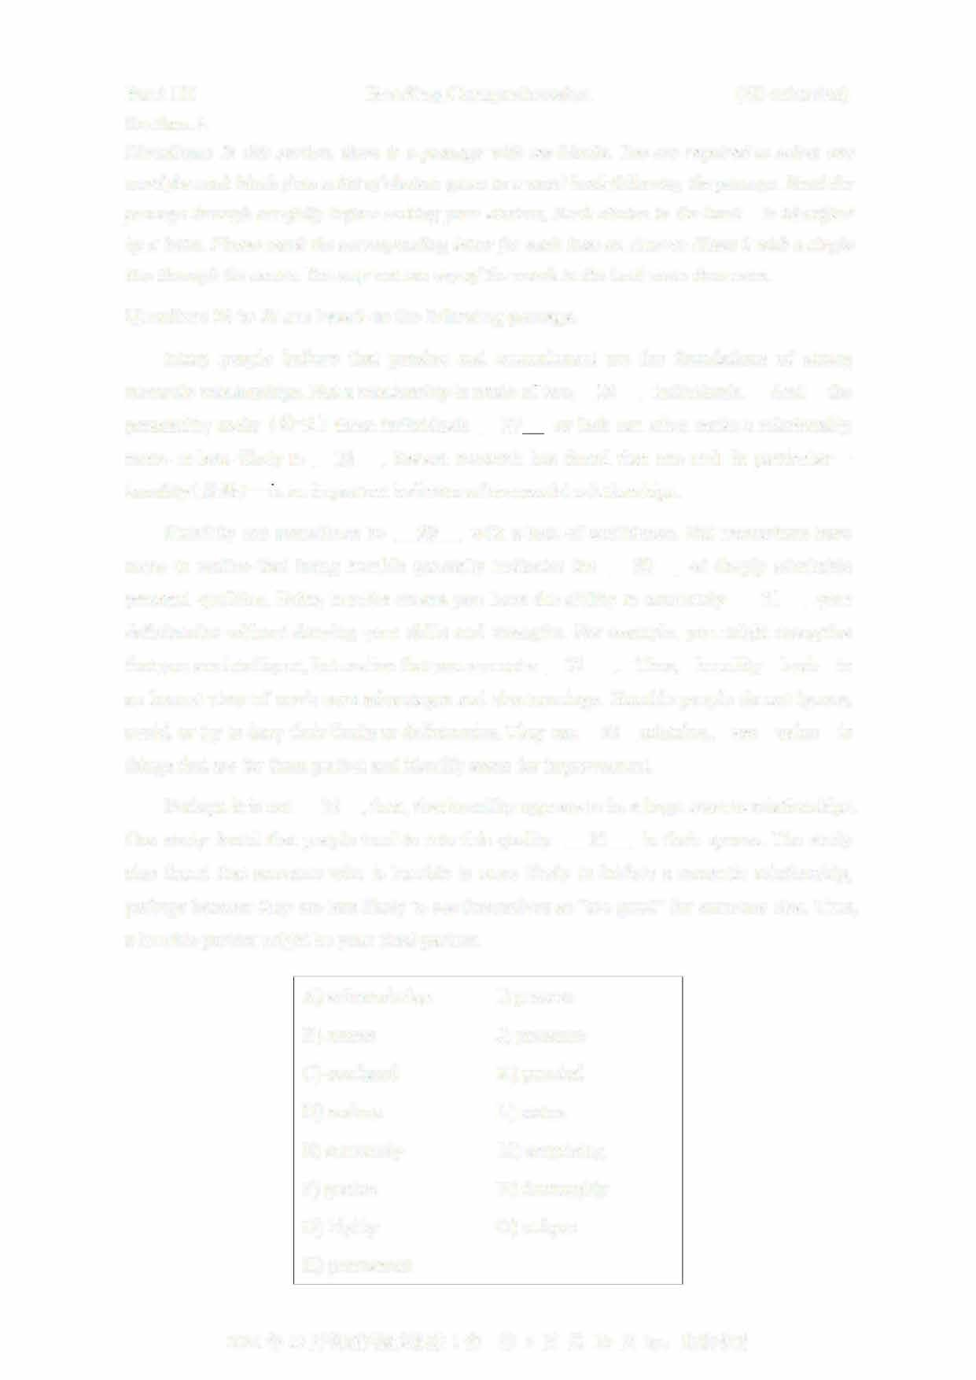

**Perhaps it is not ____lL, then, that humility appears to be a huge asset to relationships One study found that people tend to rate this quality ___lL in their spouse. The study also found that someone who is humble is more likely to initiate a romantic relationship, perhaps because they are less likely to see themselves as "too good" for someone else. Thus, a humble partner might be your ideal partner**

**A) acknowledge I) possess B) assess J) presence**

1. **confused K) puzzled**
2. **endure L) status**
3. **extremely M) s叩rising**
4. **genius N) thoroughly**
5. **highly 0) unique**
6. **permanent**

**2021** 年 **12** 月英语四级真题第 **1套** 第 **4** 页共 **10** 页 **by:**

Section B

Directions: In this section, you are going to read a passage with ten statements attached to it.

Each statement contains information given in one of the paragraphs. Identify the paragraph from which the information is derived. You may choose a paragraph more than once. Each paragraph is marked with a letter. Answer the questions by marking the corresponding letter on Answer Sheet 2.

There's a stress gap between men and women

1. "I used to work very hard. I love to create things, grow them and solve problems, "said Meng Li, a successful app developer in San Francisco. "I didn't really care about my mind and my body until they decided to go on strike."
2. Ms. Li said her stress led to sleeplessness. When she did sleep, she experienced

"problem-solving dreams," which left her feeling unrested when she woke up. "After I became a first-time mother, I quickly realized I was so busy caring for other people and work that I felt like I'd lost myself," she said.

1. It's a common story- one we frequently ridicule and readily dismiss, for example, by claiming that women tend to complain more than men, despite the growing sum of research that underlines the problem. Women are twice as likely to suffer from severe stress and anxiety as men, according to a 2016 study published in The Journal 。if Brain & Behavior. The American Psychological Association reports a gender gap year after year showing that women consistently report higher stress levels. Clearly, a stress gap exists.
2. "The difference is not really news to me, as a clinical psychologist," said Erin Joyce, a women and couples therapist in Los Angeles. "It's been well documented in extensive research over the years that prevalence rates for the majority of the anxiety disorders are higher in women than men." Some people may argue that this is merely reported data, and they say many men feel the same pressures as women in terms of fulfilling responsibilities at work and home. In other words, we're all really, really stressed
3. 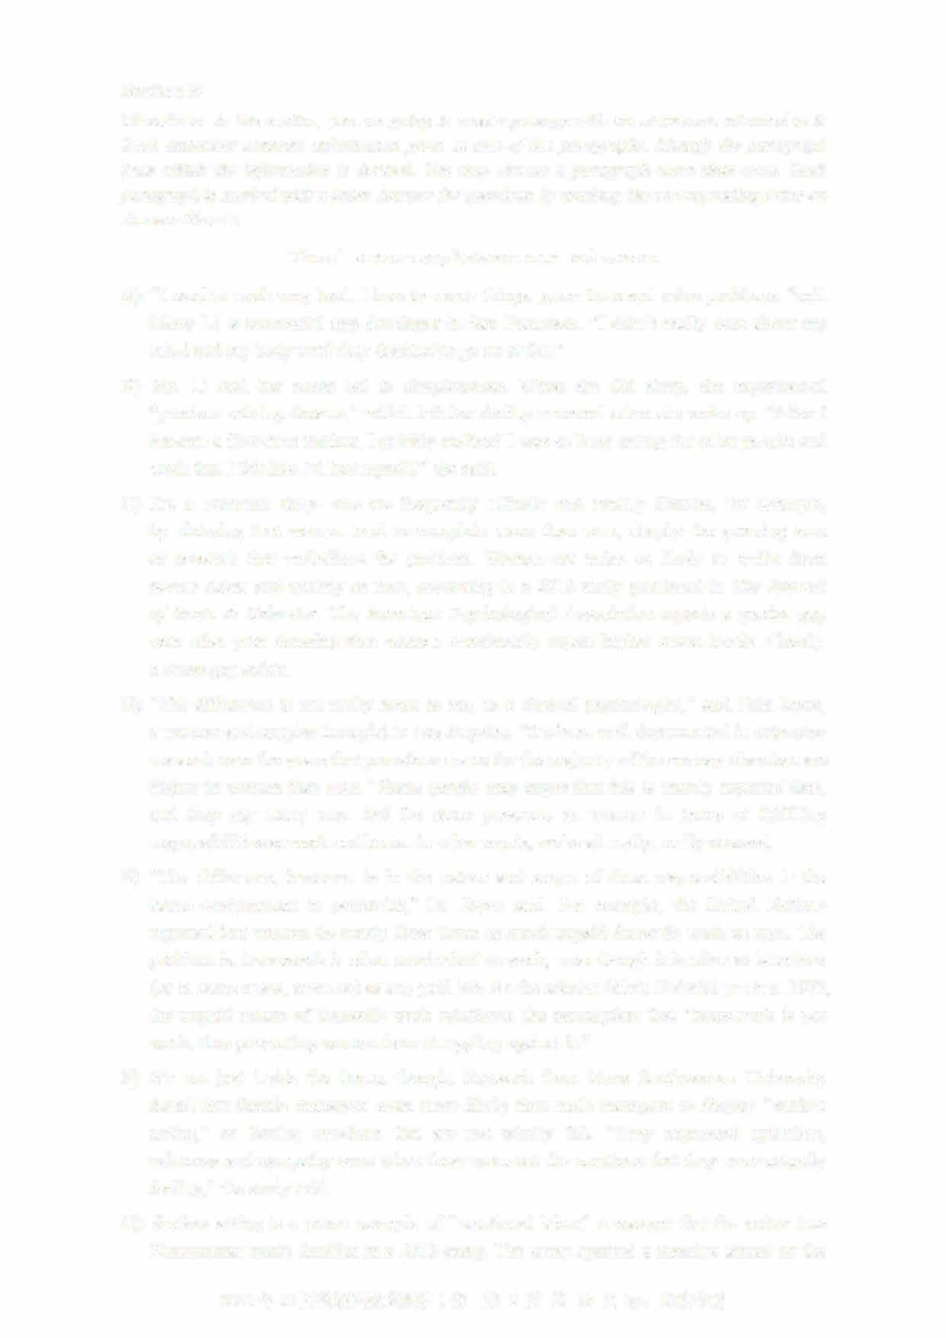"The difference, however, is in the nature and scope of these responsibilities in the home environment in particular," Dr. Joyce said. For example, the United Nations reported that women do nearly three times as much unpaid domestic work as men. The problem is, housework is often overlooked as work, even though it is often as laborious (or in some cases, more so) as any pai切ob. As the scholar S加a Federici put it in 1975, the unpaid nature of domestic work reinforces the assumption that "housework is not work, thus preventing women from struggling against it."
4. It's not just inside the home, though. Research from Nova Southeastern University found that female managers were more likely than male managers to display "surface acting," or forcing emotions that are not wholly felt. "They expressed optimism, calmness and sympathy even when these were not the emotions that they were actually feeling," the study said.
5. Surface acting is a prime example of "emotional labor," a concept that the writer Jess Zimmerman made familiar in a 2015 essay. The essay sparked a massive thread on the

2021 12 1 5 10 by:

internet community blog MetaFilter. Hundreds of women spoke up about their own experience with emotional labor: the duties that are expected of them, but go unnoticed. These invisible duties become apparent only when you don't do them. Like domestic labor, emotional labor is generally dismissed and not labeled work. But research shows it can be just as exhausting as paid work. Emotional labor can lead to difficulty in sleeping and family conflict. Sure, circumstantial stress, like losing a job, may lead to these same issues. But emotional labor is not circumstantial. It's an enduring responsibility based on the socialized gender role of women.

1. Like Ms. Li, many women try to manage the added stress to reach what Dr. Joyce said was an unattainable ideal. "Some professional women aim to do it all. They want to reach the top of the corporate ladder and fly like supermom," she said. When women don't reach this ideal, they feel guilty; and even more stressed. After her own struggle with this, Ms. Li took a step back and used her experience to build Sanity & Self, a self-care app and platform for overworked women. "The realizations I had in that process helped me gain insights and ultimately got me ready to integrate self- care into my daily life," she said.
2. 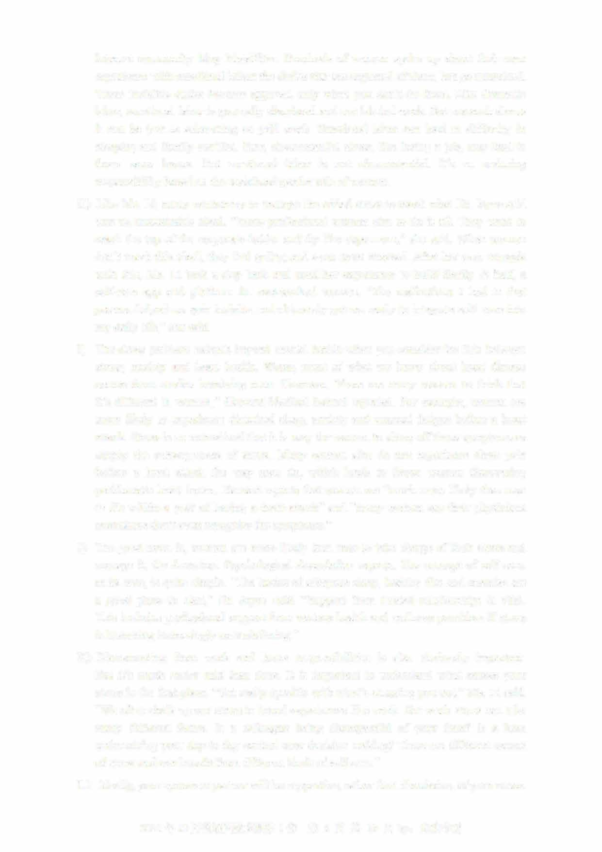The stress problem extends beyond mental health when you consider the link between stress, anxiety and heart health. Worse, most of what we know about heart disease comes from studies involving men. However, "there are many reasons to think that it's different in women," Harvard Medical School reported. For example, women are more likely to experience disturbed sleep, anxiety and unusual fatigue before a heart attack. Stress is so normalized that it is easy for women to shrug off those symptoms as simply the consequences of stress. Many women also do not experience chest pain before a heart attack the way men do, which leads to fewer women discovering problematic heart issues. Harvard reports that women are "much more likely than men to die within a year of having a heart attack" and "many women say their physicians sometimes don't even recognize the symptoms."
3. The good news is, women are more likely than men to take charge of their stress and manage it, the American Psychological Association reports. The concept of self-care, at its core, is quite simple. "The basics of adequate sleep, healthy diet and exercise are a good place to start," Dr. Joyce said. "Support from trusted relationships is vital This includes professional support from various health and wellness providers if stress is becoming increasingly overwhelming."
4. Disconnecting from work and home respons伽lities is also obviously important. But it's much easier said than done. It is important to understand what causes your stress in the first place. "Get really specific with what's stressing you out," Ms. Li said "We often chalk up our stress to broad experiences like work. But work stress can take many different forms. Is a colleague being disrespectful of your time? Is a boss undermining your day-to-day control over decision making? These are different causes of stress and can benefit from different kinds of self-care."
5. Ideally, your spouse or partner will be supportive, rather than dismissive, of your stress

2021年12月英语四级真题第1套 第6页共10页by:

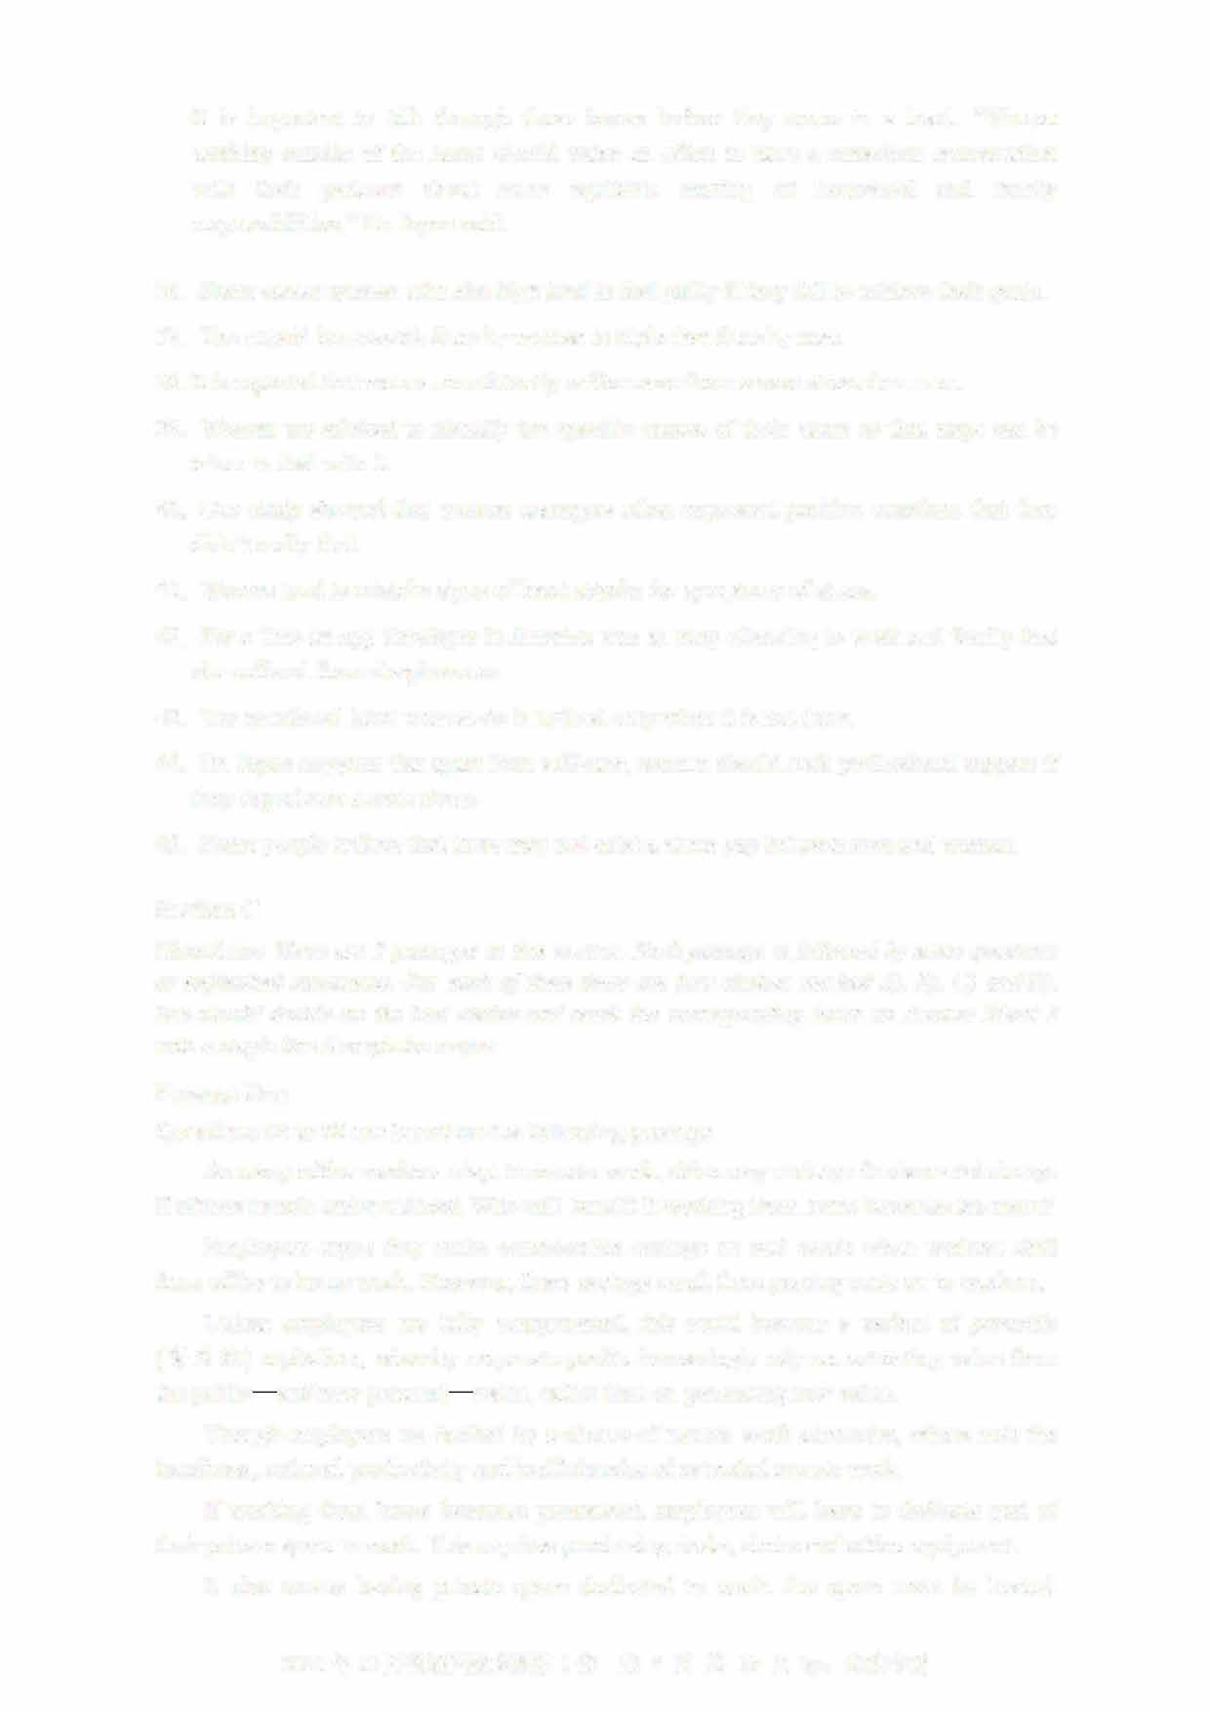It is important to talk through these issues before they come to a head. "Women working outside of the home should make an effort to have a conscious conversation with their partners about more equitable sharing of household and family responsibilities," Dr. Joyce said.

1. Some career women who aim high tend to feel guilty if they fail to achieve their goals.
2. The unpaid housework done by women is triple that done by men
3. It is reported that women consistently suffer more from severe stress than men.
4. Women are advised to identify the specific causes of their stress so that steps can be taken to deal with it.
5. One study showed that women managers often expressed positive emotions that they didn't really feel.
6. Women tend to mistake signs of heart attacks for symptoms of stress.
7. For a time an app developer in America was so busy attending to work and family that she suffered from sleeplessness.
8. The emotional labor women do is noticed only when it is not done.
9. Dr. Joyce suggests that apart from self-care, women should seek professional support if they experience severe stress.
10. Some people believe that there may not exist a stress gap between men and women.

Section C

Directions: There are **2** passages in this section. Each passage is followed by some questions

or unfinished statements. For each of them there are four choices marked AJ, BJ, CJ and DJ You should decide on the best choice and mark the corresponding letter on Answer Sheet **2**

with a single line through the centre.

Passage One

Questions **46** to **50** are based on the following passage.

As many office workers adapt to remote work, c巾es may undergo fundamental change if offices remain under-utilized. Who will benefit if working from home becomes the norm?

Employers argue they make considerable savings on real estate when workers shift from office to home work. However, these savings result from passing costs on to workers.

Unless employees are fully compensated, this could become a variant of parasitic

（寄生的）capitalism, whereby corporate profits increasingly rely on extracting value from the public— and now personal— realm, rather than on generating new value.

Though employers are backed by a chorus of remote work advocates, others note the loneliness, reduced productivity and inefficiencies of extended remote work.

If working from home becomes permanent, employees will have to dedicate part of their private space to work. This requires purchasing desks, chairs and office equipment It also means having private space dedicated to work: the space must be heated,

2021 12 1 7 10 by:

cleaned, maintained and paid for. That depends on many things, but for purposes of illustration, I have run some estimates for Montreal. The exercise is simple but important, since it brings these costs out of the realm of speculation into the realm of meaningful discussion.

Rough calculations show that the savings made by employers when their staff works from home are of similar value to the compensation workers should receive for setting up

offices at home.

What does this mean for offices in cities? One of two things may happen: Employers pass these costs onto employees. This would be a form of expropriation (侵占）， with employees absorbing production costs that have traditionally been paid by the employer. This represents a considerable transfer of value from employees to employers.

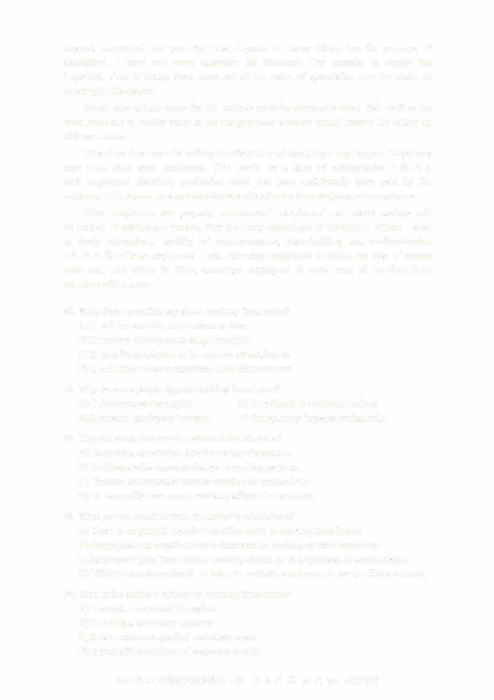When employees are properly compensated, employers' real estate savings will be modest. If savings are modest, then the many advantages of working in offices-such as lively atmosphere, rapidity of communication, team-building and acclimatization （适应环境） of new employees—will encourage employers to shelve the idea of remote work and, like Yahoo in 2013, encourage employees to work most of the time from corporate office space.

46. What does the author say about working from home? A) It will become the norm sooner or later.

1. It requires employees to adapt promptly
2. It benefits employers at the expense of employeesD) It will force cities to transform their infrastructure.

4 7. Why do some people oppose working from home?

1. It discourages team spirit. C) It undem血es traditional values.
2. It invades employees'privacy. D) It negatively impacts productivity.
3. Why did the author run the estimates for Montreal?
   1. To provide convincing data for serious discussion.
   2. To illustrate the ongoing change in working patternsC) To show the impact of remote working on productivity.

D) To exemplify how remote working affects the economy

1. What can we conclude from the author's calculations?
   1. There is no point in transferring office work to working from homeB) Employees can benefit as much from remote working as their employers.

C) Employers'gain from remote working should go to employees as compensation D) Effective measures should be taken to motivate employees to set up offices at home.

1. What is the author's opinion on working from home?A) It should be avoided if possible.
   1. It is only a temporary measure.
   2. It can reduce companies'real estate costs.
   3. It may affect employees'corporate loyalty.

2021年12月英语四级真题第1套 第8页共10页by: UVOOC.COM

Passage Two

Questions 51 to 55 are based on the following passage.

The human thirst for knowledge is the driving force behind our successful development as a species. But curiosity can also be dangerous, leading to setbacks or even downfalls. Given curiosity's complexity, scientists have found it hard to define.

While pinning down a definition has proven tricky, the general consensus is it's some means of infom画on gathering. Psychologists also agree curiosity is intrinsically（内在地） motivated.

Curiosity covers such a large set of behaviors that there probably isn't any single "curiosity gene" that makes humans wonder about and explore their environment. That said, curiosity does have a genetic component. Genes and the environment interact in many complex ways to shape individuals and guide their behavior, including their curiosity.

Regardless of their genetic makeup, infants have to learn an incredible amount of information in a short time, and curiosity is one of the tools humans have found to accomplish that gigantic task.

Hundreds of studies show that infants prefer novelty. It's what motivates non-human animals, human infants and probably human adults to explore and seek out new things before growing less interested in them after continued exposure.

But curiosity often comes with a cost.

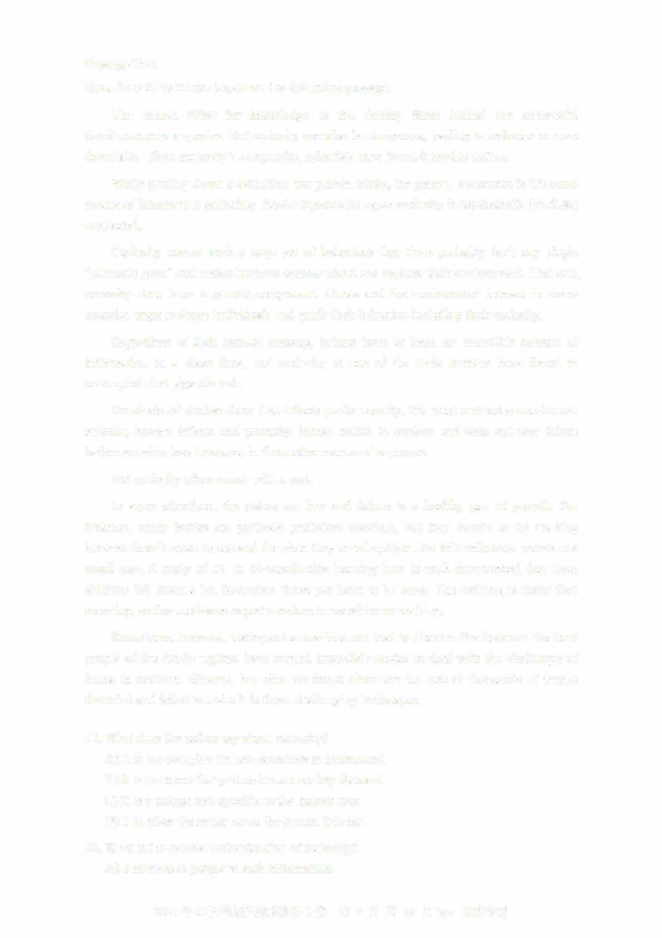In some situations, the stakes are low and failure is a healthy part of growth. For instance, many babies are perfectly proficient crawlers, but they decide to try walking because there's more to see and do when they stand upright. But this milestone comes at a small cost. A study of 12- to 19-month-olds learning how to walk documented that these children fell down a lot. Seventeen times per hour, to be exact. But walking is faster than crawling, so this motivates expert crawlers to transition to walking

Sometimes, however, testing out a new idea can lead to disaster. For instance, the Inuit people of the Arctic regions have created incredible modes to deal with the challenges of living in northern climates, but what we forget about are the tens of thousands of people that tried and failed to make it in those challenging landscapes.

1. What does the author say about curiosity?
   1. It is too complex for non-scientists to understand.
   2. It is the force that pushes human society forward.
   3. It is a unique trait specific to the human race.
   4. It is often the major cause for human failures.
2. What is the general understanding of curiosity?A) It motivates people to seek information.

2021 12 1 9 10 by: UVOOC.COM

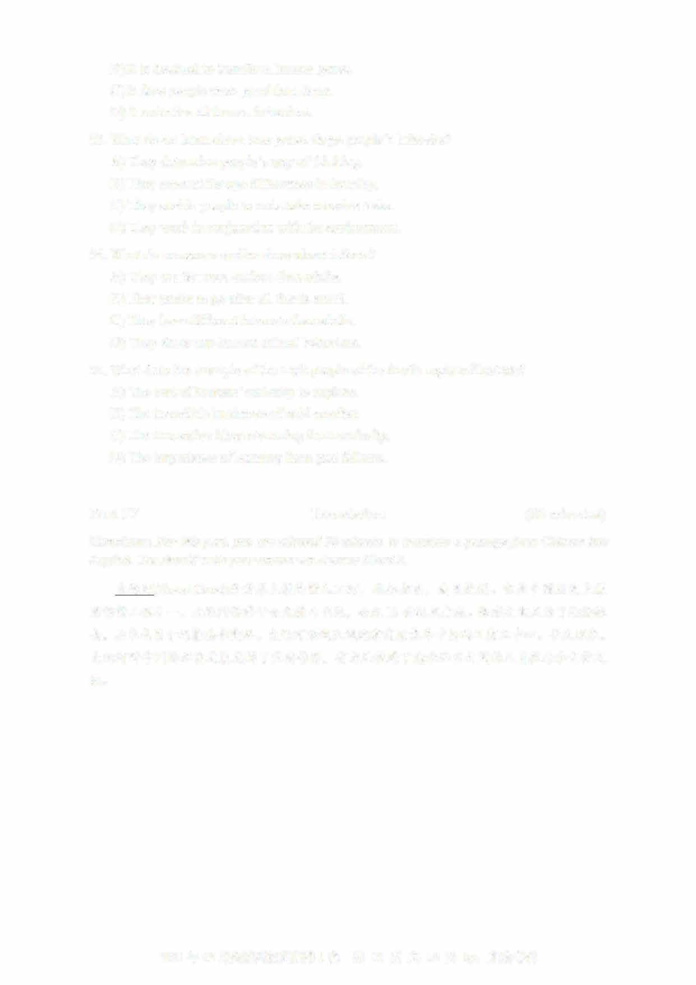

B) It is destined to transform human genes.

C) It does people more good than harm.

D) It underlies all human behaviors.

53

. What do we learn about how genes shape people's behavior?

A) They determine people's way of thinking

B) They account for age differences in learning

C) They enable people to undertake massive tasks.

D) They work in conjunction with the environment.

54

. What do numerous studies show about infants?

A) They are far more curious than adults.

B) They prefer to go after all that is novel.

C) They have different interests than adults.

D) They show non-human animal behaviors.

5

5. What does the example of the Inuit people of the Arctic regions illustrate?

A) The cost of humans' curiosity to explore.

B) The incredible harshness of cold weather.

C) The innovative ideas stemming from curiosity.

D) The importance of learning from past failures

Part IV

Translation

(30

minutes)

Directions: For this part, you are allowed 30 minutes to translate a passage from Chinese into

English. You should write your answer on Answer Sheet 2.

大运河

(

Grand Canal

)

是世界上最长的人工河

，

北起北京， 南至杭州。

它是中国历史上最

宏伟的工程之一。

大运河始建于公元前

4

世纪，

公元

13

世纪末建成。修建之初是为了运输粮

食，

后来也用于运输其他商品。

大运河沿线区域逐渐发展成为中国的工商业中心。

长久以来，

大运河对中国的经济发展发挥了重要作用，

有力地促进了南北地区之间的人员往来和文化交

流。

2021年12

月英语四级真题第1套

第 10页共10页by:

UVOOC.COM

**2021年12月大学英语四级考试真题（第3套）**

# Part I Writing (30 minutes)

**Directions: Suppose you have丿ust participated in a school project of collecting used books on campus. You are now to write a report about the project, which may include its aim, organizers, participants and activities. You will have 30 minutes to write the report. You should write at least** 120 **words but no more than** 180 **words.**

**Part II Listening Comprehension (25 minutes)**

说明：2021年12月大学英语四级考试全国共考了两套听力。 本套的听力内容与第二套相同，因此本套听力部分不再重复给出。

**Part III Reading Comprehension (40 minutes)**

## Section A

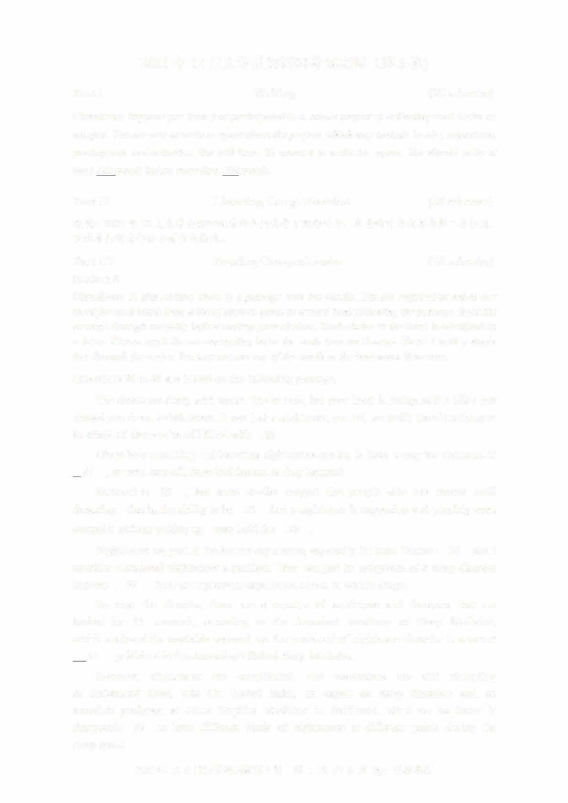**Directions: In this section, there is a passage with ten blanks. You are required to select one word for each blank from a list of choices given in a word bank following the passage. Read the passage through carefully before making your choices, Each choice in the bank is identified by a letter. Please mark the corresponding letter for each item on Answer Sheet 2 with a single line through the centre. You may not use any of the words in the bank more than once.**

**Questions 26 to 35 are based on the following passage.**

**The sheets are damp with sweat. You're cold, but your heart is racing as if a killer just chased you down a dark street. It was just a nightmare, you tell yourself; there's nothing to be afraid of. But you're still filled with____lL.**

**Given how unsettling and haunting nightmares can be, is there a way for dreamers to D.__, or even turn off, these bad dreams as they happen?**

**Research is----1.L_, but some studies suggest that people who can master lucid dreaming-that is, the ab**山**ty to be____22__that a nightmare is happening and possibly even control it without waking up—may hold the ___J_Q__.**

**Nightmares are part of the human experience, especially for kids. Doctors___ll_don't consider occasional nightmares a problem. They can just be symptoms of a sleep disorder that can ____lL from an unpleasant experience, stress, or certain drugs.**

**To treat the disorder, there are a number of medicines and therapies that are backed by___TI__ research, according to the American Academy of Sleep Medicine,**

**which analyzed the available research on the treatment of nightmare disorder in a recent ;H___published in the Journal of Clinical Sleep Medicine**

**However, nightmares are complicated, and researchers are still struggling to understand them, said Dr. Rachel Salas, an expert on sleep disorders and an associate professor at Johns Hopkins Medicine in Baltimore. What we do know is that people___lL to have different kinds of nightmares at different points during the**

**sleep cycle.**

2021年12月英语四级真题第3套 第1页共 **8**页 **by:** UVOOC.COM

1. **amount I) mechanical**
2. **answer J) result C) avoid K) review**
3. **aware L) rigorous**
4. **depart M) tend**
5. **drastically N) timidity**
6. **fear 0) typically** 芒 **limited**

**Section B**

**Directions: In this section, you are going to read a passage with ten statements attached to it.**

**Each statement contains information given in one of the paragraphs. Identify the paragraph from which the information is derived. You may choose a paragraph more than once. Each paragraph is marked with a letter. Answer the questions by marking the corresponding letter on Answer Sheet 2.**

### Why it matters that teens are reading less

1. **Most of us spend much more time with digital media than we did a decade ago. But today 's teens have grown up with smartphones. Compared with teens a couple of decades ago, the way they interact with traditional media like books and movies is fundamentally different.**
2. **Analysis of surveys of over one million teens in the United States collected since 1976 reveals a major shift in how teens are spending their leisure time. Paper books are being**

**ignored, in favor of screens. D屯ital devices are changing other behaviors, too. More and more, young people choose spending time on their electronic devices over engaging in other activities, regardless of the type. Indeed, by 2016, the average American high school senior said they spent six hours a day writing text messages, on social media, and online during their free time. And that covers just three activities, and if other digital media activities were included, that estimate would no doubt rise.**

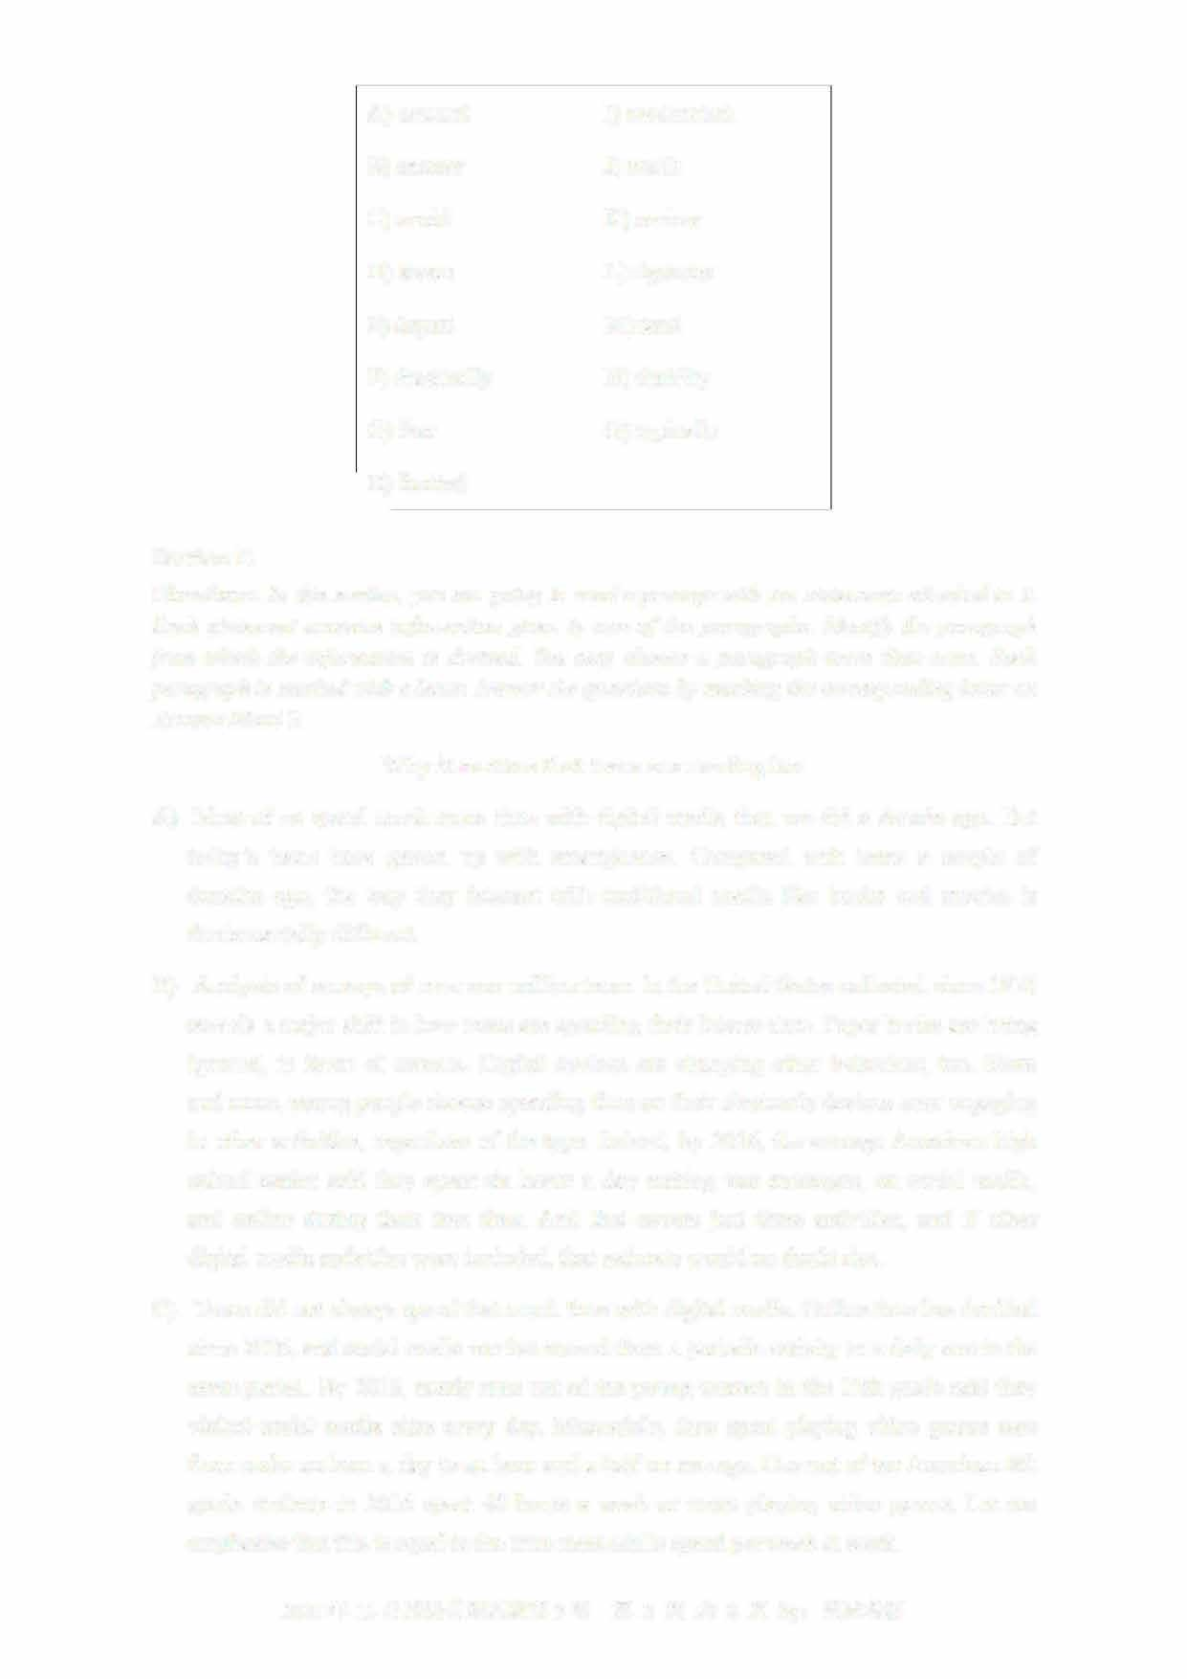

1. **Teens did not always spend that much time with digital media. Online time has doubled since 2006, and social media use has moved from a periodic activity to a daily one in the same period. By 2016, nearly nine out of ten young women in the 12th grade said they visited social media sites every day. Meanwhile, time spent playing video games rose from under an hour a day to an hour and a half on average. One out of ten American 8th**

**grade students in 2016 spent 40 hours a week or more playing video games. Let me emphasize that this is equal to the time most adults spend per week at work.**

* 1. 年 **12** 月英语四级真题第 **3套** 第 **2** 页共 **8** 页

1. If teens are spending so much time using electronic devices, does that mean they have to give up some other activities? Maybe not. Over the years, many scholars have insisted that time online does not necessarily take away time spent engaging with traditional media or on other activities. Some people, they argue, are just more interested in certain kinds of media and entertainment. Thus, using more of one type of media does not necessarily mean less of the other.
2. 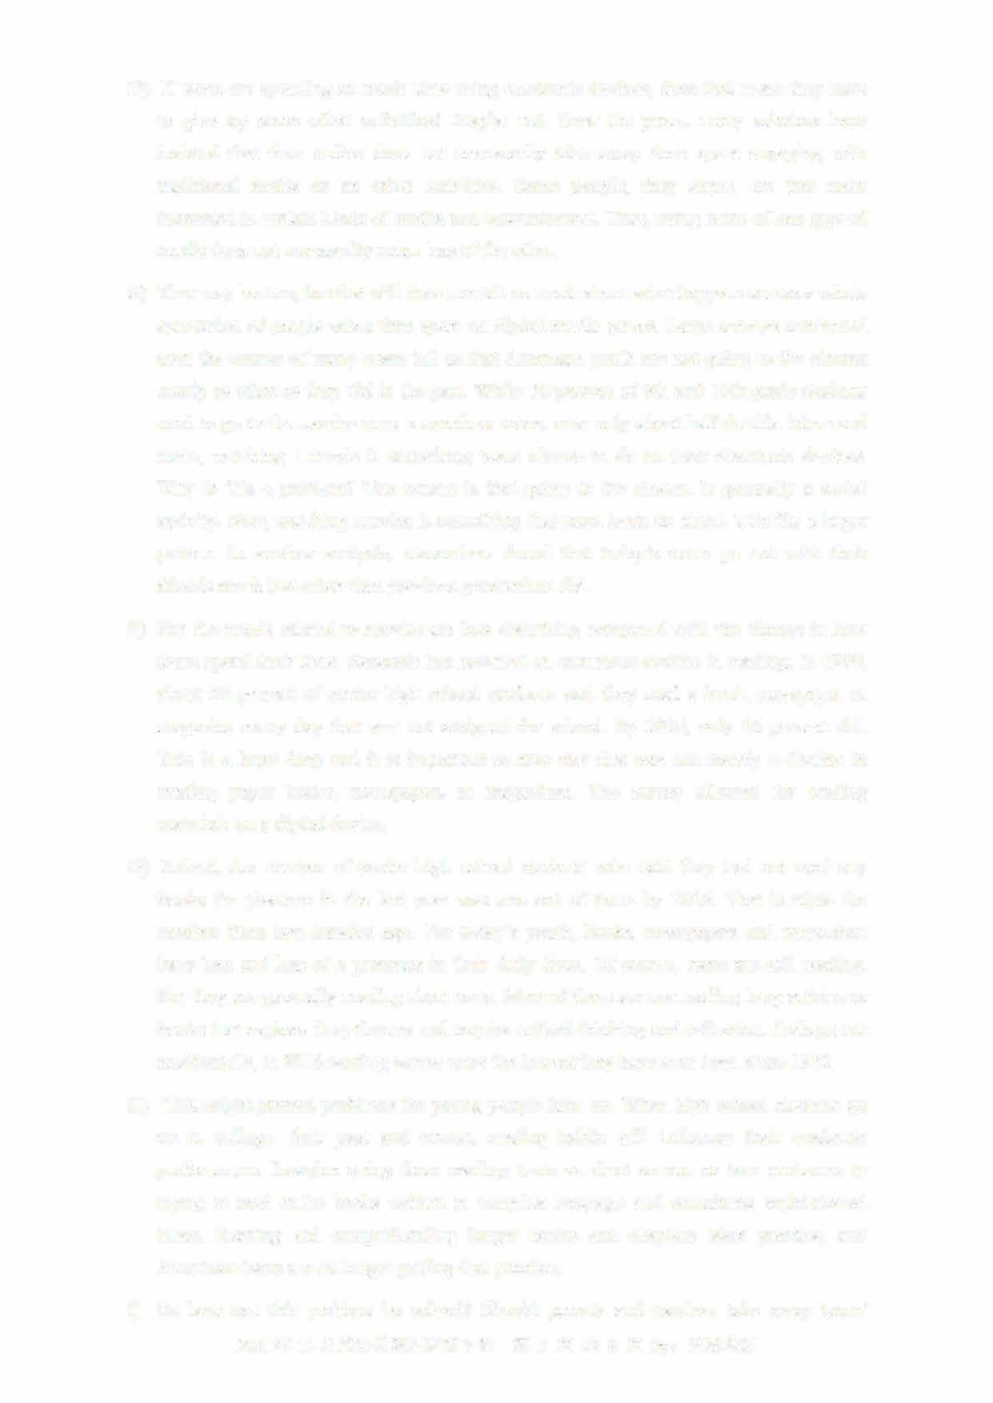That may be true, but that still does not tell us much about what happens across a whole generation of people when time spent on digital media grows. Large surveys conducted over the course of many years tell us that American youth are not going to the cinema nearly as often as they did in the past. While 70 percent of 8th and 10th grade students used to go to the movies once a month or more, now only about half do this. More and more, watching a movie is something teens choose to do on their electronic devices. Why is this a problem? One reason is that going to the cinema is generally a social activity. Now, watching movies is something that most teens do alone. This fits a larger pattern. In another analysis, researchers found that today's teens go out with their 扣ends much less often than previous generations did.
3. But the trends related to movies are less disturbing compared with the change in how teens spend their time. Research has revealed an eno皿ous decline in reading. In 1980, about 60 percent of senior high school students said they read a book, newspaper or magazine every day that was not assigned for school. By 2016, only 16 percent did. This is a huge drop and it is important to note that this was not merely a decline in reading paper books, newspapers or magazines. The survey allowed for reading materials on a digital device.
4. Indeed, the number of senior high school students who said they had not read any books for pleasure in the last year was one out of three by 2016. That is triple the number from two decades ago. For today's youth, books, newspapers and magazines have less and less of a presence in their daily lives. Of course, teens are still reading But they are generally reading short texts. Most of them are not reading long articles or books that explore deep themes and require critical thinking and reflection. Perhaps not accidentally, in 2016 reading scores were the lowest they have ever been since 1972.
5. This might present problems for young people later on. When high school students go on to college, their past and cu订ent reading habits will influence their academic performance. Imagine going from reading texts as short as one or two sentences to trying to read entire books written in complex language and containing sophisticated ideas. Reading and comprehending longer books and chapters takes practice, and American teens are no longer getting that practice.
6. So how can this problem be solved? Should parents and teachers take away teens'
   1. 年 12 月英语四级真题第 3 套 第 3 页共 8 页

smartphones and replace them with paper books? Probably not. Research has shown that smartphones are currently American teens' main form of social communication. This means that, without a smartphone, teens are likely to feel isolated from their peers

However, that does not mean teens need to use electronic devices as often as they do now. Data connecting excessive d屯ital media time to mental health issues suggests a limit of two hours a day of free time spent with screens, a restriction that will also allow time for other activities—like going to the movies with friends or reading longer, more complicated texts.

1. 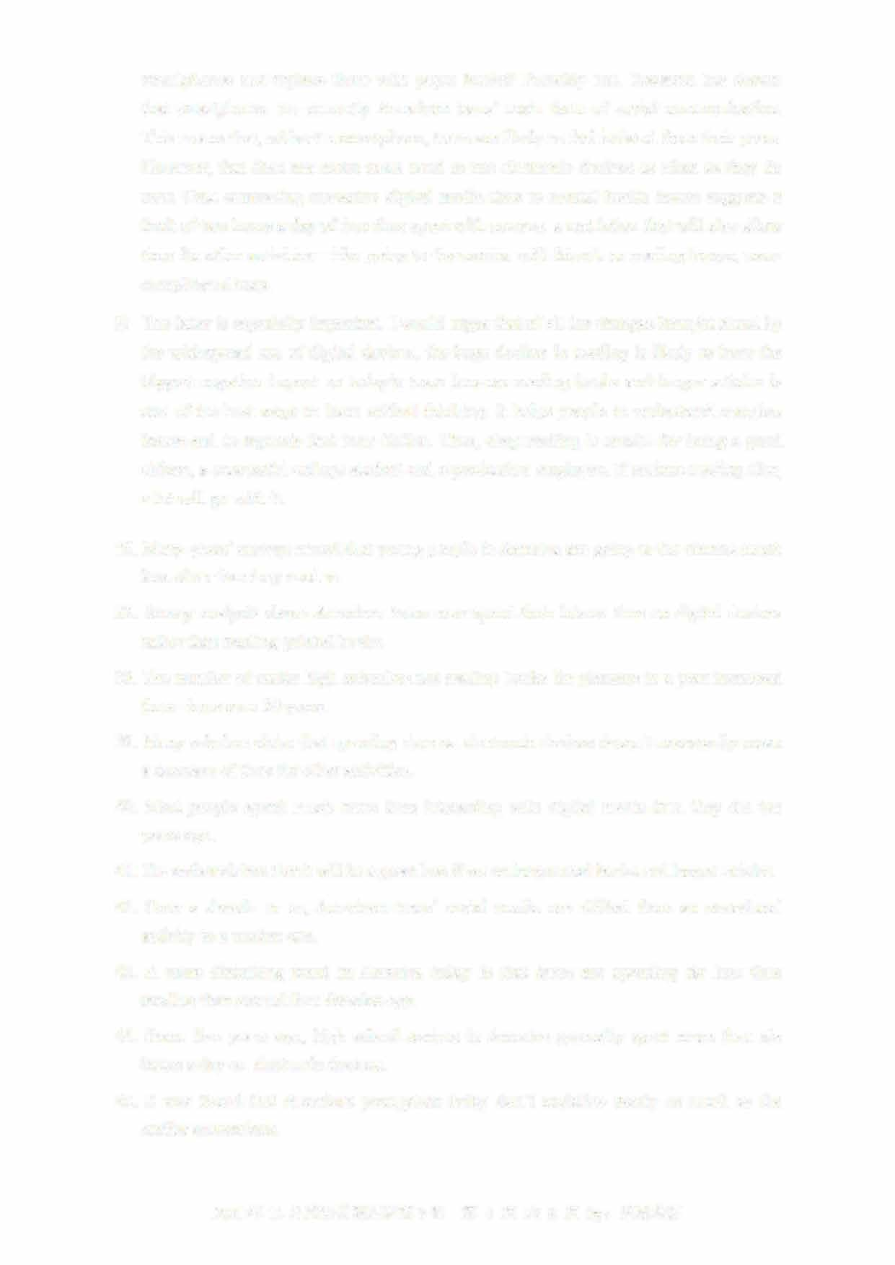The latter is especially important. I would argue that of all the changes brought about by the widespread use of digital devices, the huge decline in reading is likely to have the biggest negative impact on today's teens because reading books and longer articles is one of the best ways to learn critical thinking. It helps people to understand complex issues and to separate fact from fiction. Thus, deep reading is crucial for being a good citizen, a successful college student and a productive employee. If serious reading d比s, a lot will go with it.
2. Many years' surveys reveal that young people in America are going to the cinema muchless often than they used to.
3. Survey analysis shows American teens now spend their leisure time on digital devicesrather than reading printed books.
4. The number of senior high schoolers not reading books for pleasure in a year increasedthree times over 20 years.
5. Many scholars claim that spending time on electronic devices doesn't necessarily meana decrease of time for other activities.
6. Most people spend much more time interacting with d屯ital media than they did ten years ago.
7. The author claims that it will be a great loss if we no longer read books and longer articles.
8. Over a decade or so, American teens'social media use shifted from an occasional activity to a routine one.
9. A more disturbing trend in America today is that teens are spending far less time reading than around four decades ago.
10. Some five years ago, high school seniors in America generally spent more than six hours a day on electronic devices.
11. It was found that American youngsters today don't socialize nearly as much as the earlier generations.

2021年12月英语四级真题第3套 第4页共8页

Section C

Directions: There are 2 passages in this section. Each passage is followed by some questions or unfinished statements. For each of them there are four choices marked AJ, BJ, CJ and DJ You should decide on the best choice and mark the corresponding letter on Answer Sheet 2 with a single line through the centre.

Passage One

Questions 46 to 50 are based on the following passage.

Have you ever wondered how acceptable it is to hug or touch someone? While it may sound safe to avoid all physical contact so as not to offend anyone, the lack of touching 血ght imply cold attitudes or indifference in interpersonal relationships.

So, what should we do? The simple answer is to thoroughly learn unique cultural norms for physical contact. In nonverbal communication terminology (术语）， physical contact and the study of touching are generally referred to as haptics

Haptics in communication often suggest the level of intimacy. They are usually classified into two groups: high-contact and low-contact.

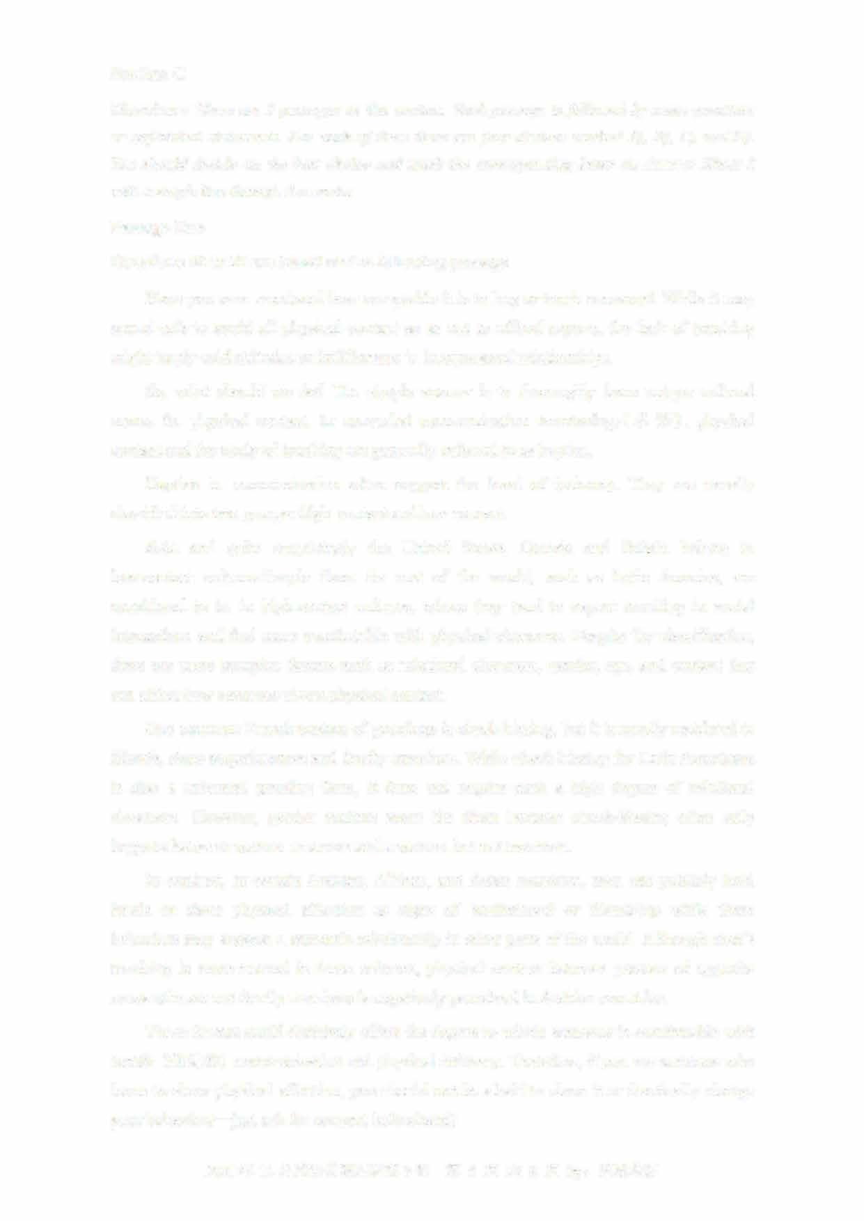Asia and quite surprisingly the United States, Canada and Britain belong to low-contact cultures.People from the rest of the world, such as Latin America, are considered to be in high-contact cultures, where they tend to expect touching in social interactions and feel more comfortable with physical closeness. Despite the classification, there are more complex factors such as relational closeness, gender, age, and context that can affect how someone views physical contact.

One common French custom of greetings is cheek-kissing, but it is mostly restricted to 加nds, close acquaintances and family members. While cheek-kissing for Latin Americans is also a universal greeting form, it does not require such a high degree of relational closeness. However, gender matters more for them because check-kissing often only happens between women or a man and a woman but not two men.

In contrast, in certain Arabian, African, and Asian countries, men can publicly hold hands or show physical affection as signs of brotherhood or friendship while these behaviors may suggest a romantic relationship in other parts of the world. Although men's touching is more normal in these cultures, physical contact between persons of opposite sexes who are not family members is negatively perceived in Arabian countries.

These factors could definitely affect the degree to which someone is comfortable with tactile （触觉的） communication and physical intimacy. Therefore, if you are someone who loves to show physical affection, you should not be afraid to show it or drastically change

— your behaviors just ask for consent beforehand!

2021 年 12 月英语四级真题第 3 套 第 5 页共 8 页

46. What does the author say in the first paragraph about physical contact? A) Its role in interpersonal relationships is getting increasingly important

1. It is becoming more acceptable to many who used to think it offensive
2. Its absence might suggest a lack of warmth in interpersonal relationshipsD) It might prompt different responses from people of different social backgrounds

4 7. What does physical contact in communication suggest?

1. What social class people belong to
2. How civilized the communicators are.
3. What family background people come from
4. How close the communicators' relationships are.
5. What do we learn about people in high-contact cultures?
   1. They are sensitive to the way people express their emotions
   2. They take touching as a cultural norm in social interactions.C) They attach great importance to close ties among people

D) They tend to be more open in interpersonal relationships

1. What do we learn about social customs in Arabian countries?
   1. Men can show friendship in public through physical affection
   2. Non-traditional romantic relationships are simply unacceptable
   3. Physical contact between unfamiliar people is negatively perceivedD) People of different ages and genders show affection in different ways
2. What does the author tell us to do concerning tactile communication?A) Lay emphasis on nonverbal communication.
   1. Learn to use appropriate body language first
   2. Pay attention to the differences between genders.
   3. Take other people's preference into consideration.

Passage Two

Questions 51 to 55 are based on the following passage.

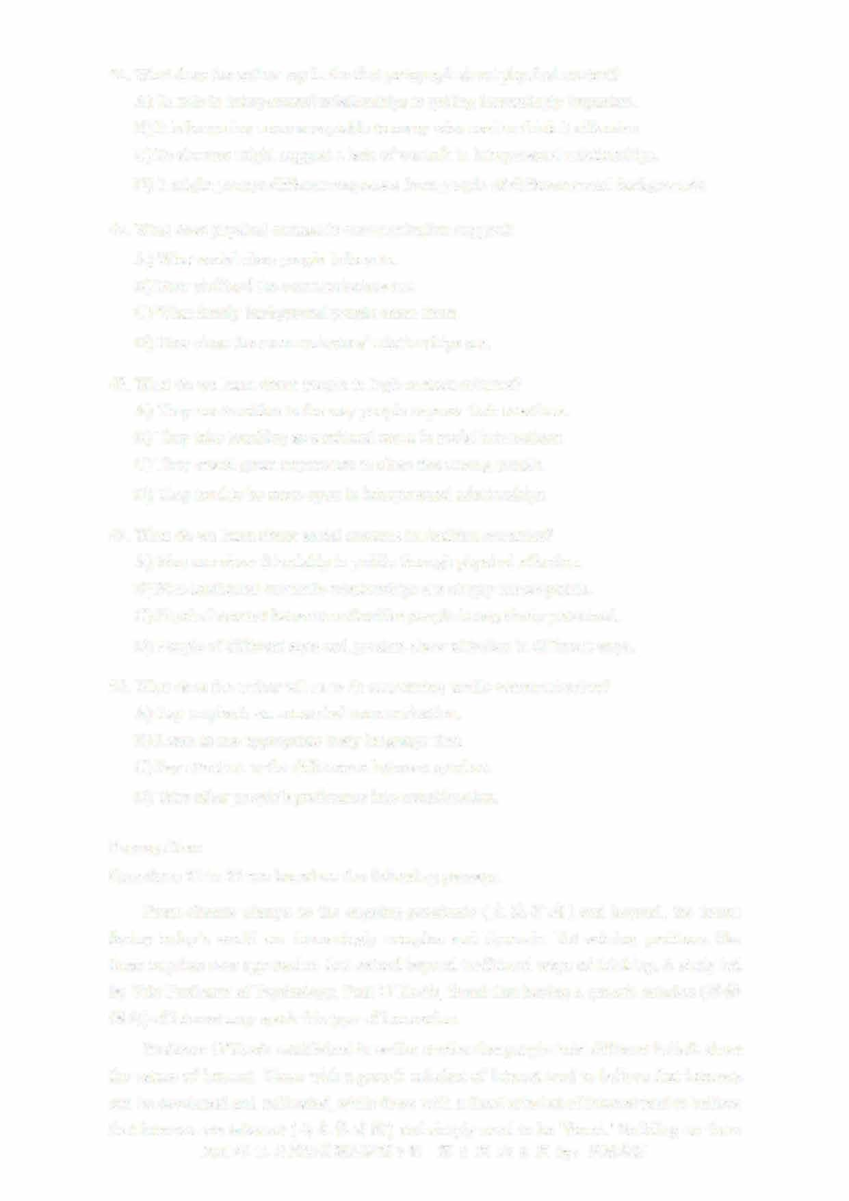From climate change to the ongoing pandemic (大流行病） and beyond, the issues facing today's world are increasingly complex and dynamic. Yet solving problems like these requires new approaches that extend beyond traditional ways of thinking. A study led by Yale Professor of Psychology, Paul O'Keefe, found that having a growth mindset（思维倾向） of interest may spark this type of innovation

Professor O'Keefe established in earlier stud比s that people hold different beliefs about the nature of interest. Those with a growth mindset of interest tend to believe that interests can be developed and cultivated, while those with a fixed mindset of interest tend to believe that interests are inherent （与生俱有的） and simply need to be 'found.'Building on these

2021年12月英语四级真题第3套 第6页共8页

findings, the latest research examined how a growth mindset of interest can boost integrative thinking across the traditional disciplinary boundaries of arts and sciences.

For example, in one task, research participants were instructed to create new college majors by combining two or more existing academic Arts or Science programs at the订 university. After coding and analyzing the ideas they generated, the team found that people with a growth mindset of interest were more likely to bridge programs across the arts and sciences to create new majors like computational economics rather than creating majors that drew from only one of those areas, like computational chemistry.

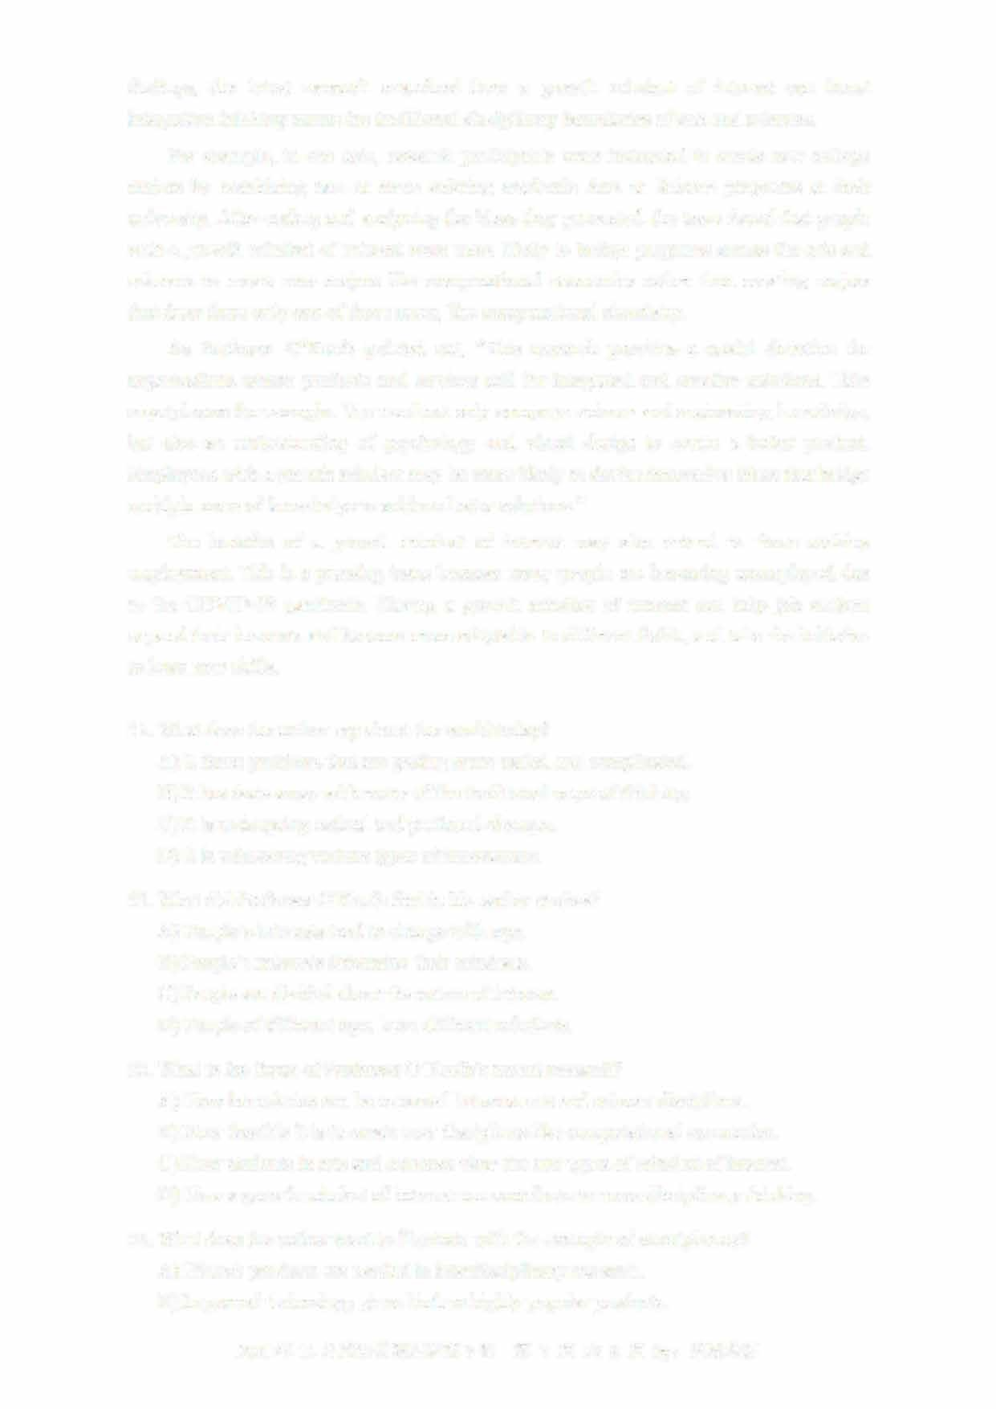As Professor O'Keefe pointed out, "This research provides a useful direction for organizations whose products and services call for integrated and creative solutions. Take smartphones for example. You need not only computer science and engineering knowledge, but also an understanding of psychology and visual design to create a better product Employees with a growth mindset may be more likely to devise innovative ideas that bridge multiple areas of knowledge to achieve better solutions."

The benefits of a growth mindset of interest may also extend to those seeking employment. This is a pressing issue because many people are becoming unemployed due to the COVID-19 pandemic. Having a growth mindset of interest can help job seekers expand their interests and become more adaptable to different fields, and take the initiative to learn new skills.

1. What does the author say about the world today?
   1. It faces problems that are getting more varied and complicated
   2. It has done away with many of the traditional ways of thinkingC) It is undergoing radical and profound changes

D) It is witnessing various types of innovations.

1. What did Professor O'Keefe find in his earlier studies?A) People's interests tend to change with age.
   1. People's interests determine their mindsets.
   2. People are divided about the nature of interest.
   3. People of different ages have different mindsets.
2. What is the focus of Professor O'Keefe's recent research?
   1. How boundaries can be removed between arts and science disciplines.
   2. How feasible it is to create new disciplines like computational economics
   3. How students in arts and sciences view the two types of mindset of interest.
   4. How a growth mindset of interest can contribute to cross-disciplinary thinking.
3. What does the author want to illustrate with the example of smartphones?A) Hi-tech products are needed in interdisciplinary research.

B) Improved technology gives birth to highly popular products

2021年12月英语四级真题第3套 第7页共8页

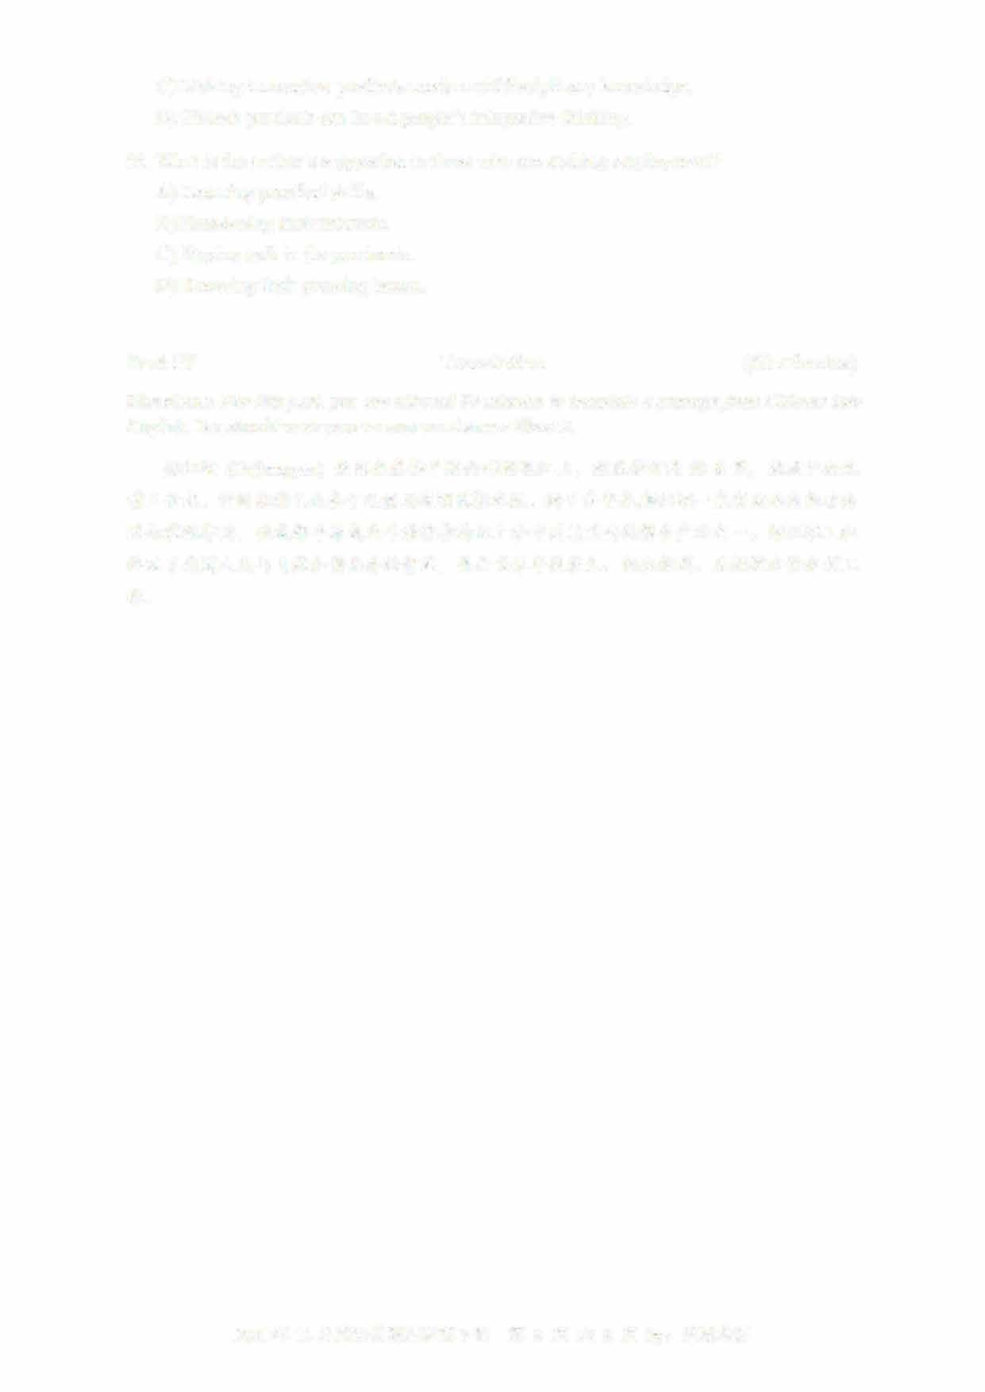

C) Making innovative products needs multidisciplinary knowledge

D) Hi-tech products can boost people's integrative thinking

55

. What is the author's suggestion to those who are seeking employment?

A) Leaming practical skills.

B) Broadening their interests.

C)

Staying safe in the pandemic.

D) Knowing their pressing issues

Part IV

Translation

(30

minutes)

Directions: For this part, you are allowed 30 minutes to translate a passage from Chinese into

English. You should write your answer on Answer Sheet 2.

卢

(

Duji

angyan)

坐落在成都平原西部的氓江上，

距成都市约

50

公里，

始建于公元

前三世纪。

它的独特之处在于无需用堤坝调控水流。

两千多年来，都江堰一直有效地发挥看防

共与灌溉作用，

使成都平原成为旱房保收的沃土和中国最重要的棵食产地之一。

都江堰工程

体现了我国人民与自然和谐共存的智慧，

是全世界年代最久、

仍在使用、

无坝控水的水利工

程。

2021年12

月英语四级真题第3套

第8页共8页

**2021年12月大学英语四级考试真题（第2套）**

Part I Writing (30minutes)

Directions: Suppose your university student union is planning to hold a speech contest. You are now to write a proposal for organizing the contest. The proposal may include the topic, aim , procedure and selection of contestants. You will have 30 minutes to write the proposal. You should write at least且Q words but no more than垃Q words.

Part II Listening Comprehension (25 minutes)

Section A

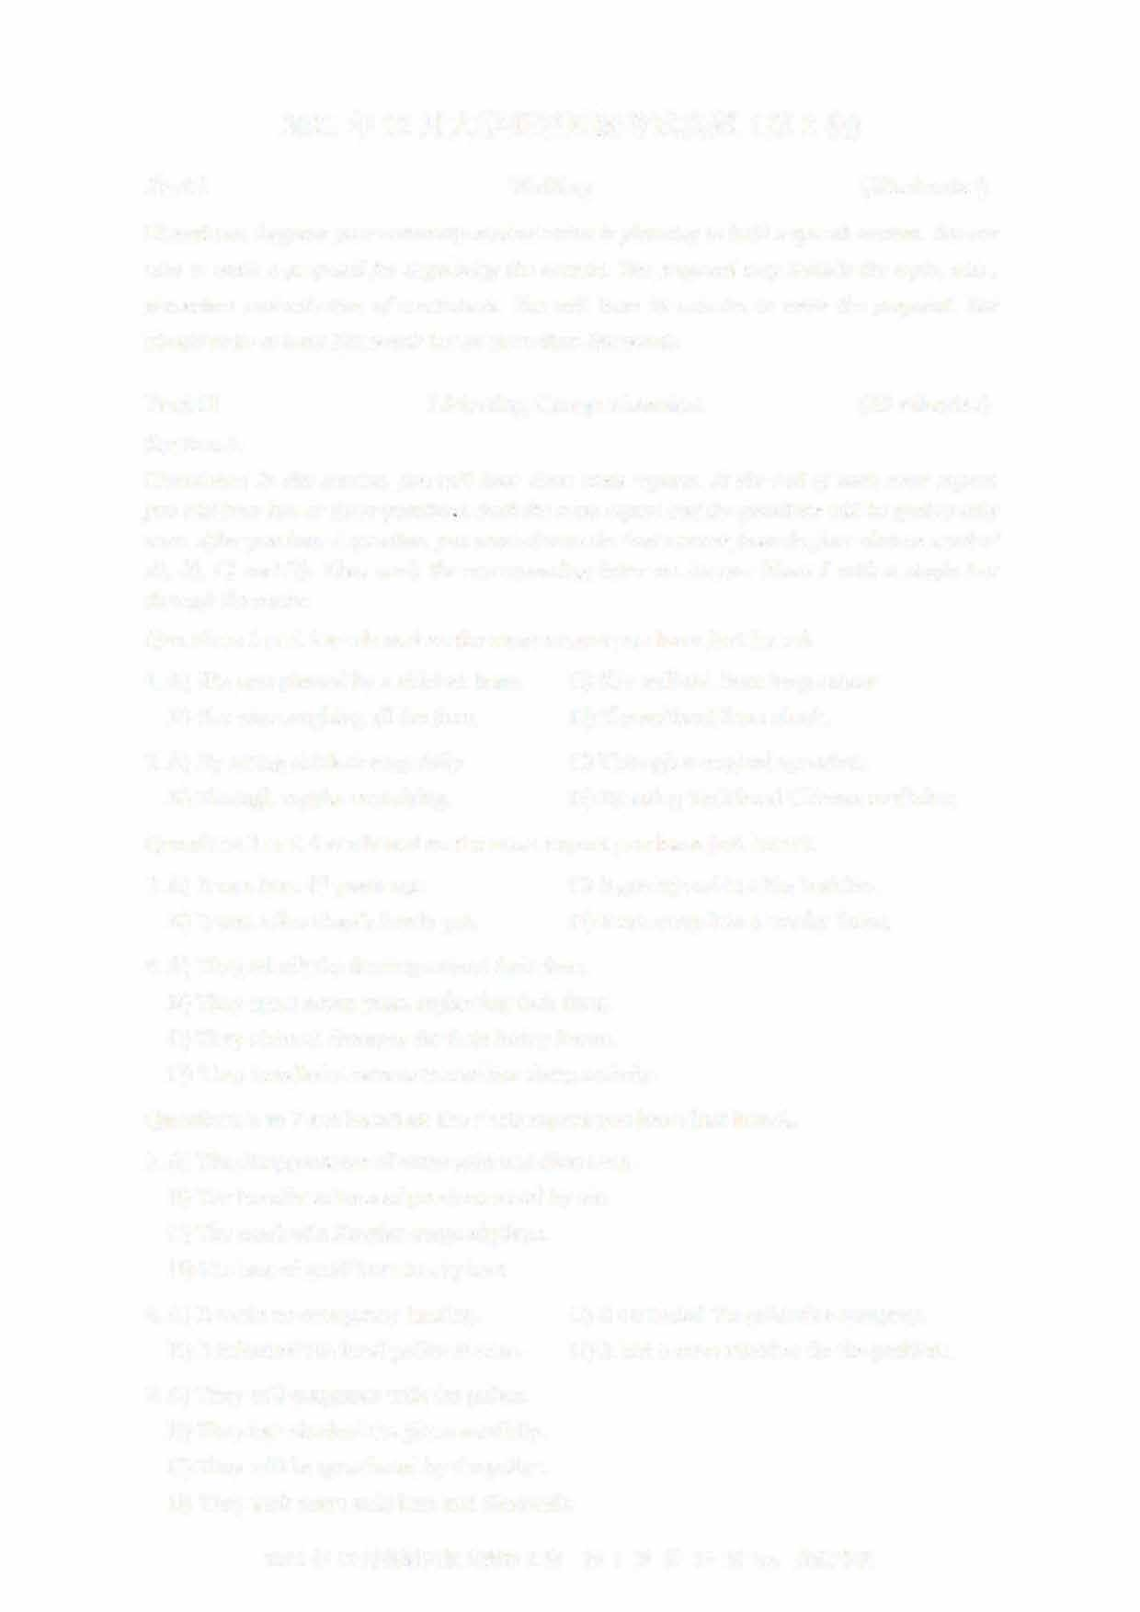Directions: In this section, you will hear three news reports. At the end of each news report, you will hear two or three questions. Both the news report and the questions will be spoken only once. After you hear a question, you must choose the best answer from the four choices marked AJ, BJ, CJ and DJ. Then mark the corresponding letter on Answer Sheet 1 with a single line through the centre.

Questions 1 and 2 are based on the news report you have just heard.

1. A) She was pierced by a chicken bone. C) She suffered from lung cancer. B) She was coughing all the time. D) She suffered from shock.
2. A) By eating chicken soup daily. C) Through a surgical operation.
   1. Through regular exercising D) By using traditional Chinese medicine. Questions 3 and 4 are based on the news report you have just heard.
3. A) It was born 13 years ago. C) It got injured in a big bushfire.
   1. It was Alice Gray's lovely pet. D) It ran away into a nearby forest.
4. A) They rebuilt the fencing around their farm.
   1. They spent seven years replanting their farm.
   2. They claimed damages for their heavy losses.
   3. They installed a camera to monitor sheep activity.

Questions 5 to 7 are based on the news report you have just heard.

1. A) The disappearance of some gold and diamonds.B) The transfer of tons of precious metal by a兀
   1. The crash of a Russian cargo airplane.
   2. The loss of gold from an airplane.
2. A) It made an emergency landing. C) It contacted the goldmine company.
   1. It inforn记d the local police at once. D) It had a crew member fix the problem.
3. A) They will cooperate with the police
   1. They had checked the plane carefully.
   2. They will be questioned by the police.
   3. They took some gold bars and diamonds.
      1. 年 12 月英语四级真题第 2 套 第 1 页共 10 页 by:

Section B

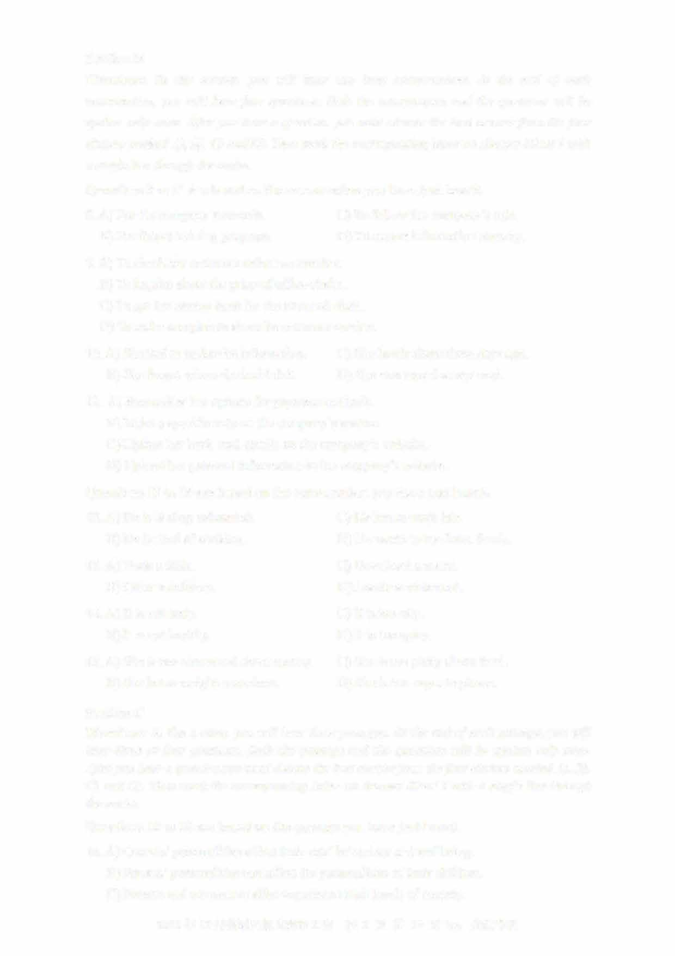Directions: In this section, you will hear two long conversations. At the end of each conversation, you will hear four questions. Both the conversation and the questions will be spoken only once. After you hear a question, you must choose the best answer from the four choices marked A), B), C) and D). Then mark the corresponding letter on Answer Sheet 1 with a single line through the centre.

Questions 8 to 11 are based on the conversation you have just heard.

1. A) For the company's records. C) To follow the company's rule.
   1. For future training purposes. D) To ensure information security.
2. A) To check her customer reference number.
   1. To inquire about the price of office chairs.
   2. To get her money back for the returned chair.
   3. To make complaints about its customer service.
3. A) She had to update its information. C) She lost it about three days ago. B) She forgot where she had left it. D) She was issued a new card.
4. A) Reconsider her options for payment methods.
   1. Make a specific note on the company's system.
   2. Update her bank card details on the company's website.
   3. Upload her personal information to the company's website.Questions 12 to 15 are based on the conversation you have just heard.
5. A) He is feeling exhausted. C) He has to work late.
   1. He is tired of cooking. D) He wants to try Asian foods.
6. A) Book a table. C) Download a menu.
   1. Order a delivery. D) Locate a restaurant.
7. A) It is not tasty. C) It is too oily.
   1. It is not healthy. D) It is too spicy.
8. A) She is too concerned about money. C) She is too picky about food. B) She is too weight-conscious. D) She is too eager to please.

Section C

Directions: In this section, you will hear three passages. At the end of each passage,you will hear three or four questions. Both the passage and the questions will be spoken only once

After you hear a question,you must choose the best answer from the four choices marked A), BJ,

CJ and D). Then mark the corresponding letter on Answer Sheet 1 with a single line through

the centre.

Questions 16 to 18 are based on the passage you have just heard.

1. A) Owners' personalities affect their cats' behaviour and wellbeing.
   1. Parents' personalities can affect the personalities of their children.
   2. Parents and cat owners alike experience high levels of anxiety.
      1. 年 12 月英语四级真题第 2 套 第 2 页共 10 页 by:
   3. More and more people are treating pet cats like their children.
2. A) Give their pets behavioural training.
   1. Provide their pets with the best care.
   2. Know their pets' feelings and desires.
   3. Interact with their pets in novel ways.
3. 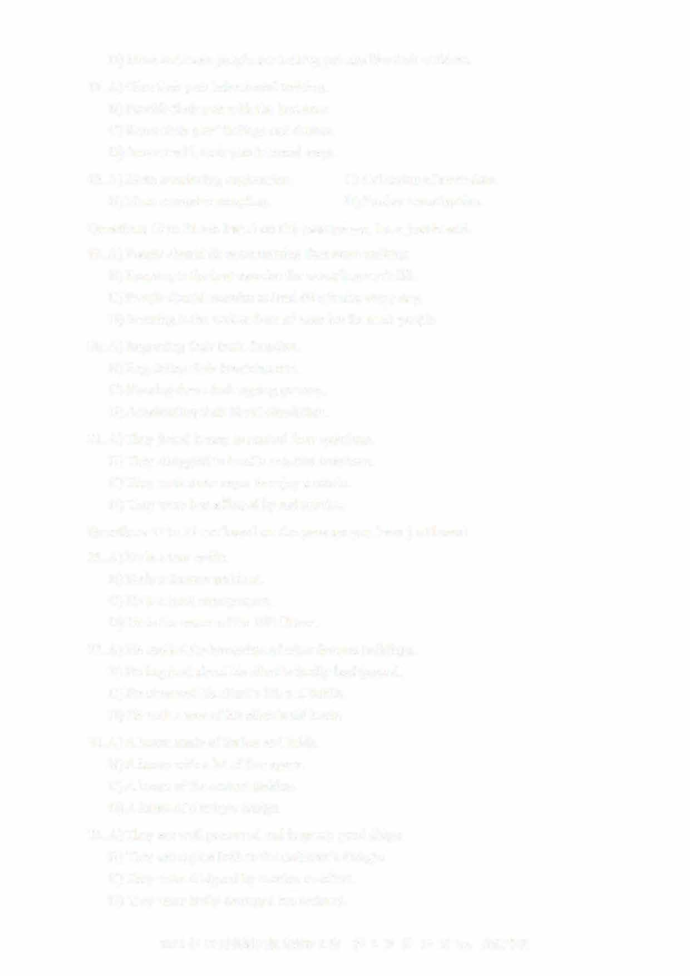A) More convincing explanation. C) Collection of more data. B) More extensive sampling. D) Fmther investigation.

Questions 19 to 21 are based on the passage you have just heard.

1. A) People should do more rwming than mere walking.
   1. Running is the best exercise for extending one's life.
   2. People should exercise at least 60 minutes every day.
   3. Running is the easiest form of exercise for most people.
2. A) Improving their brain function.
   1. Regulating their breathing rate.
   2. Slowing down their ageing process.
   3. Accelerating their blood circulation.
3. A) They found it easy to control their emotions. B) They struggled to handle negative emotions.
   1. They were more eager to enjoy a movie.
   2. They were less affected by sad movies.

Questions 22 to 25 are based on the passage you have just heard.

1. A) He is a tour guide.
   1. He is a famous architect.
   2. He is a local entrepreneur.
   3. He is the owner of the Hill House.
2. A) He studied the blueprints of other famous buildings. B) He inquired about his client's family background.
   1. He observed his client's life and habits.
   2. He took a tour of his client's old home.
3. A) A house made of timber and brick. B) A house with a lot of free space.
   1. A house of the current fashion.
   2. A house of a unique design.
4. A) They are well preserved and in pretty good shape. B) They are copies built to the architect's designs.
   1. They were designed by another architect.
   2. They were badly damaged but restored.

2021年12月英语四级真题第2套 第3页共10页by:

Part III Reading Comprehension (40 minutes)

Section A

Directions: In this section, there is a passage with ten blanks. You are required to select one word for each blank from a list of choices given in a word bank following the passage. Read the passage through carefully before making your choices, Each choice in the bank is identified by a letter. Please mark the corresponding letter for each item on Answer Sheet 2 with a single

line through the centre. You may not use any of the words in the bank more than once.

Questions 26 to 35 are based on the following passage.

It is commonly believed that the great English dramatist and poet William Shakespeare was born in Stratford-on-Avon on April 23, 1564. But it is impossible to know the_1_Lday on which he was born.

Church records show he was baptized (施洗礼） on April 26, and three days was a customary amount of time to wait before baptizing a newly born baby. Shakespeare's date of death is ____IJ__ known, however: it was April 23, 1616. He was 52 and had retired to Stratford three years before.

Although few plays have been performed or analyzed as extensively as the 38 plays Shakespeare wrote, there are few surviving details about his life. This ---2.L_ of biographical information is due primarily to his social ____2_2__; he was not a noble, but the

son of a leather trader.

Shakespeare ___JQ__ attended the grammar school in Stratford, where he would have studied Latin and read ___J_l__ literature. He did not go to university and at age 18 married Anne Hathaway, who was eight years his ____l_L. They had four children, including the twins, Hamnet and Judith. Nothing is known of the period between the birth of the twins and Shakespeare's ___J_.1_ as a dramatist in London in the early 1590s.

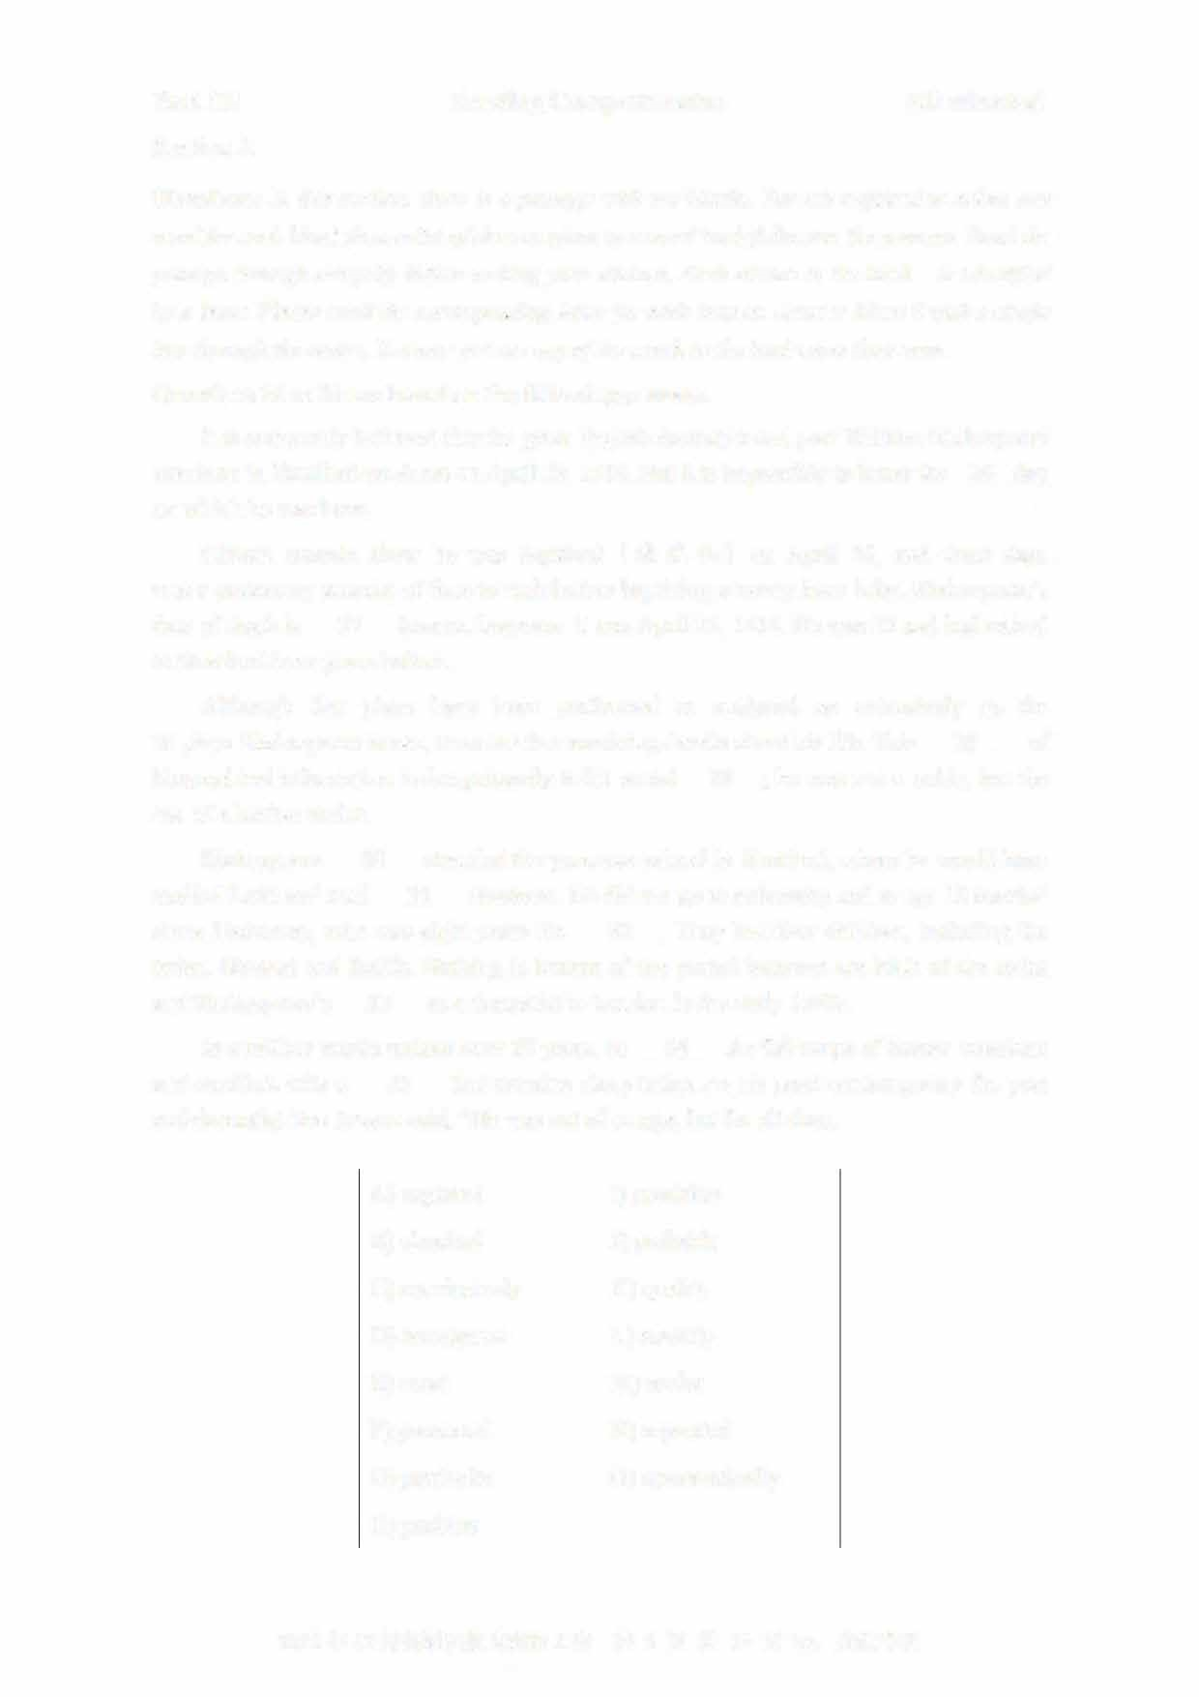

In a million words written over 20 years, he ____l±_ the full range of human emotions and conflicts with a ___J_L that remains sharp today. As his great contemporary the poet and dramatist Ben Jonson said, "He was not of an age, but for all time.

1. captured I) precision
2. classical J) probably
3. conclusively K) quality
4. emergence L) scarcity
5. exact M) senior
6. generated N) separated
7. particular 0) systematically
8. position

2021 年 12 月英语四级真题第 2 套 第 4 页共 10 页 by:

Section B

Directions: In this section, you are going to read a passage with ten statements attached to it. Each statement contains information given in one of the paragraphs. Identify the paragraph from which the information is derived. You may choose a paragraph more than once. Each paragraph is marked with a letter. Answer the questions by marking the corresponding letter on Answer Sheet 2.

How to not be boring

1. Humans are creatures of habit. We love to establish a routine and stick with it. Then we often put ourselves on auto-pilot. Routines can be incredibly use血in helping you get things done. However, too much of a routine can also make you incredibly boring. Nevertheless, many people live lives that are boringly predictable, or live a life where everything is outlined or planned.
2. To tell the truth, interesting people are more popular among their friends. If you don't arouse someone's curiosity or brighten someone's day, you probably come across as being a little bit dull. But that doesn't mean your life has ended and you can't do anything to change it. If you find yourself searching for something to say beyond small

talk, try these tactics to find more interesting approaches to conversation.

1. 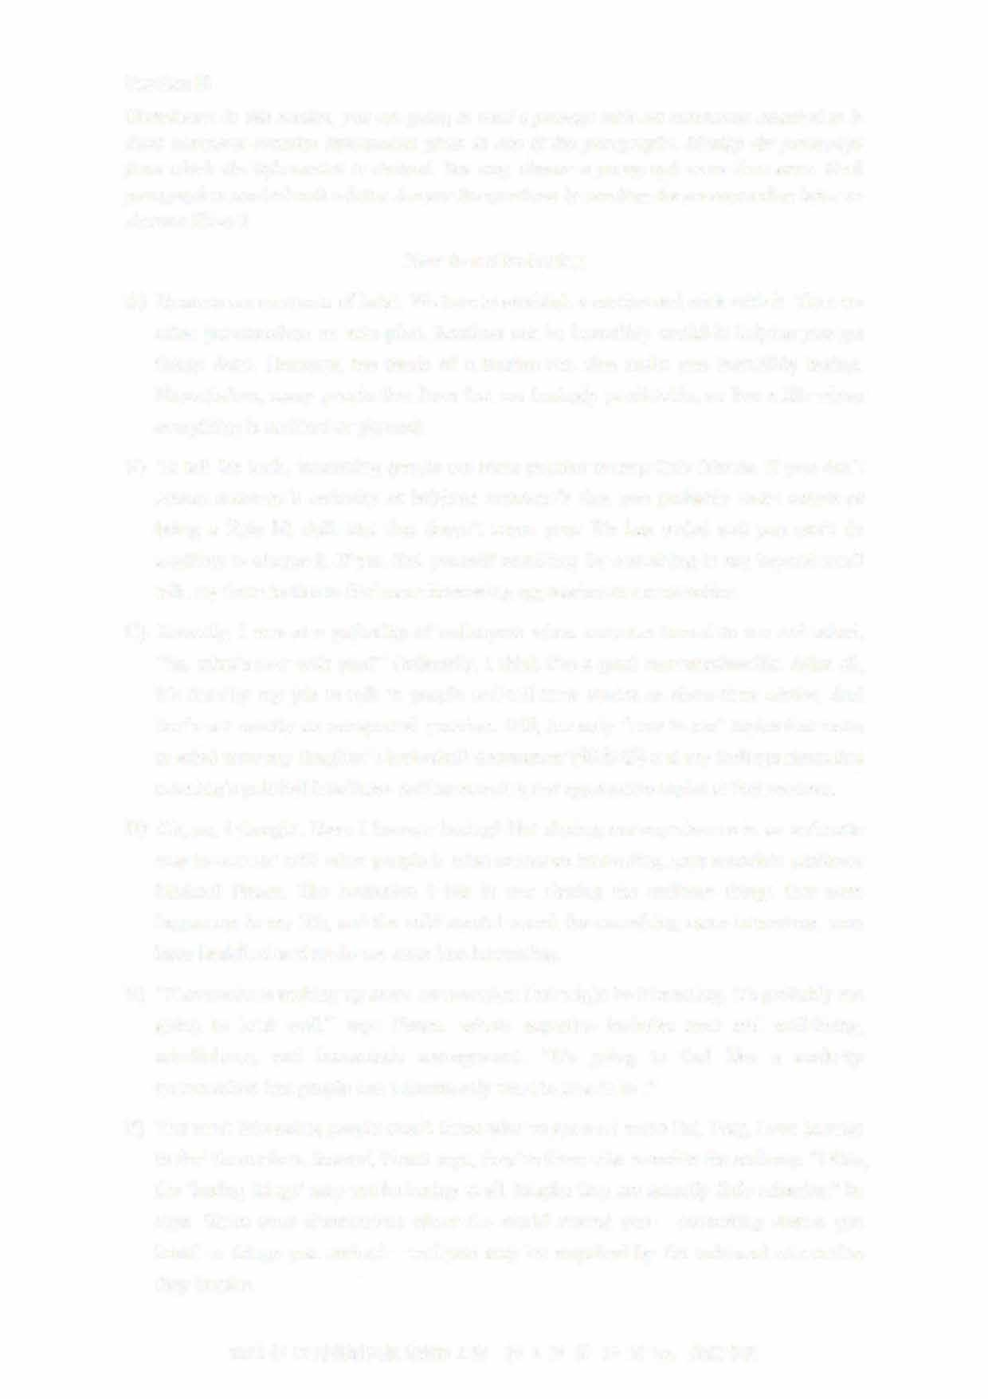Recently, I was at a gathering of colleagues when someone turned to me and asked, "So, what's new with you?" Ordinarily, I think I'm a good conversationalist. After all, it's literally my job to talk to people and tell their stories or share their advice. And that's not exactly an unexpected question. Still, the only "new-to-me" topics that came to mind were my daughter's basketball tournament （锦标赛） and my feelings about that morning's political headlines- neither amusing nor appropriate topics at that moment.
2. Oh, no, I thought. Have I become boring? But sharing our experiences in an authentic way to connect with other people is what makes us interesting, says associate professor Michael Pirson. The hesitation I felt in not sharing the ordinary things that were happening in my life, and the wild mental search for something more interesting, may have backfired and made me seem less interesting.
3. "If someone is making up some conversation that might be interesting, it's probably not going to land well," says Pirson, whose expertise includes trust and well-being, mindfulness, and humanistic management. "It's going to feel like a made-up conversation that people don't necessarily want to皿e in to ."
4. The most interesting people aren't those who've gone on some Eat, Pray, Love journey to find themselves. Instead, Pirson says, they're those who examine the ordinary. "Often, the 'boring things' may not be boring at all. Maybe they are actually little miracles," he says. Share your observations about the world around you —interesting stories you heard or things you noticed—and you may be surprised by the universal connection

they inspire.

2021 年 12 月英语四级真题第 2 套 第 5 页共 10 页 by:

1. This is essentially how Jessica Hagy starts her day.T he author of How to Be Interesting: An Instruction Manual,H agy spends a lot of time thinking about what's interesting to her.P eople who are interesting are persistently curious,s he says.
2. Think about the everyday things around you and ask questions about them. What is that roadside monument I see on my way to work every day? Who built that interesting building in my city? What nearby attractions haven't I visited? Why do people do things that way? Use what you find to ask more questions and learn more about the world arolllld you. "Having that sort of curiosity is almost like a protective gear from getting into boredom," she says. And when you find things that are truly interesting to you, share them.
3. Television veteran Audrey Morrissey,e xecutive producer of NBC's The Voice, is always looking for what will make a person or story interesting to viewers: It's usually a matter of individuality. "Having a strong point of view, signature style, or being a super-enthusiast in a particular field makes someone interesting," she says.T hat means embracing what is truly interesting or llllique about yourself. "Many people are'not boring' in the way that they c叩 carry a conversation or can be good at a social gathering, etc.T o be interesting means that you have lived life, taken risks, traveled,

sought out experience to learn for yourself and share with others," she says.

1. Of course, it's possible to be a folllltain of knowledge and a boring person, says public relations consultant 知drea Pass. Paying a甘ention to the listener is an important part of having a conversation that's interesting to both parties.T alking on and on about what's interesting to you isn't going to make you an interesting person, she says.
2. 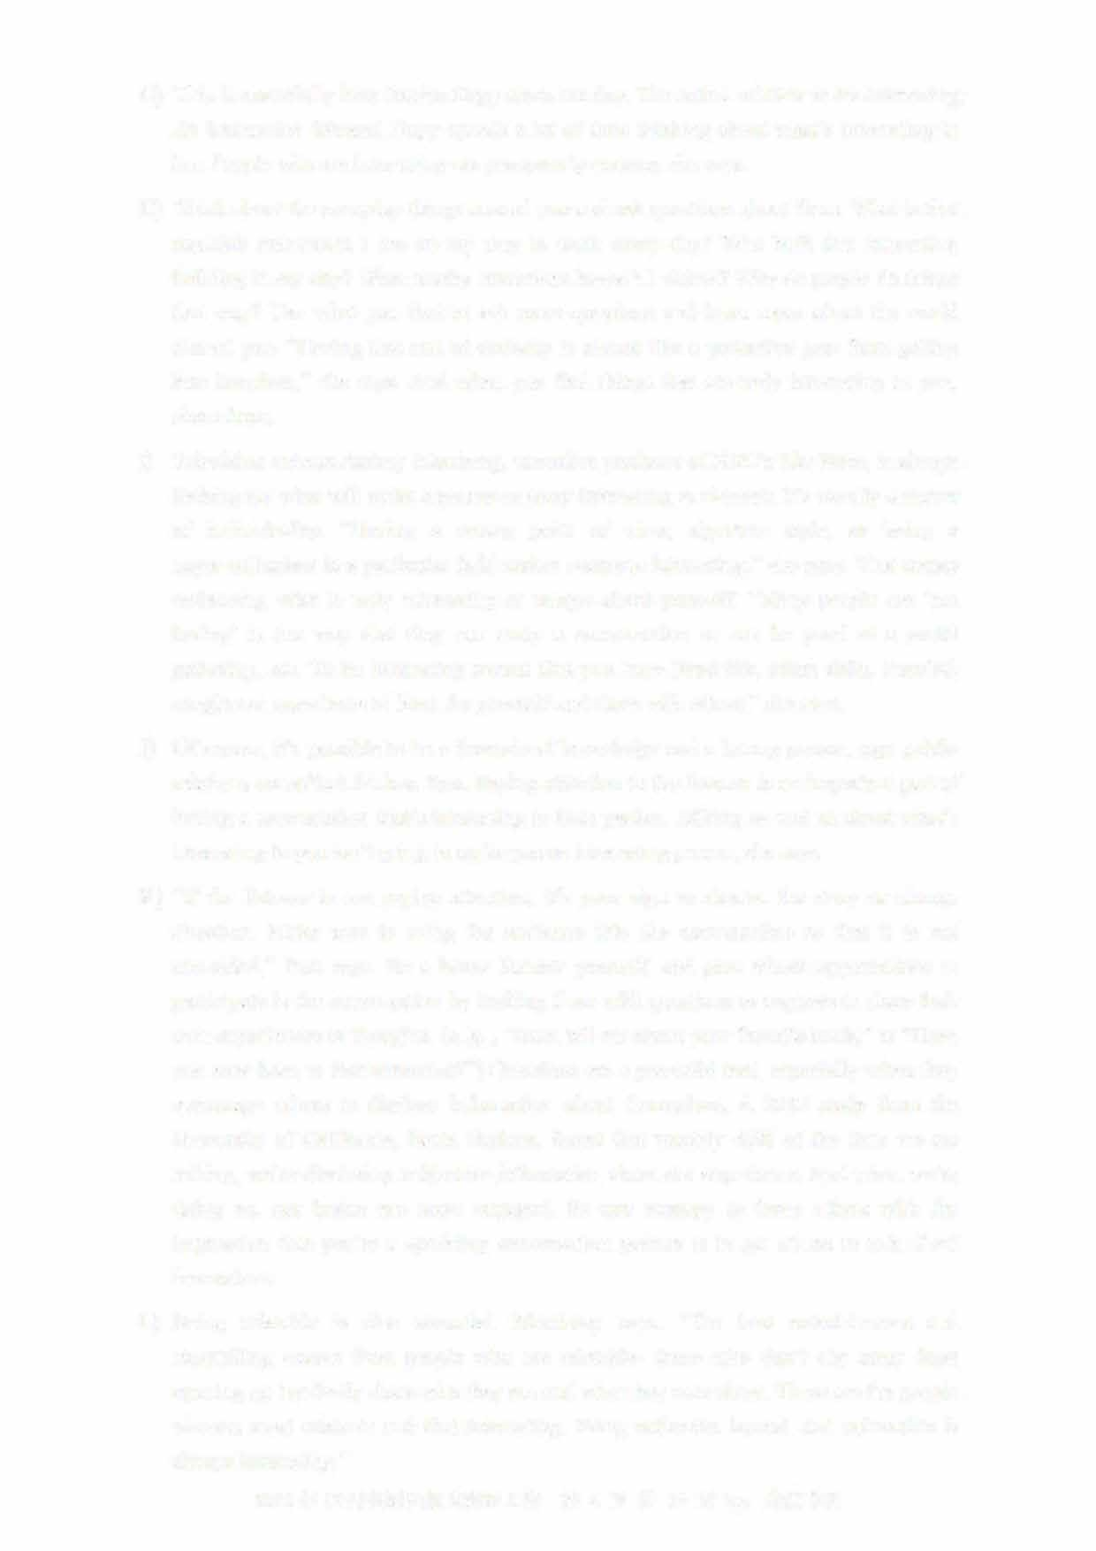"If the listener is not paying attention, it's your sign to shorten the story or change direction. Make sure to bring the audience into the conversation so that it is not one-sided," Pass says. Be a better listener yourself, and give others opportunities to participate in the conversation by inviting them with questions or requests to share the订 own experiences or thoughts. (e. g., "Now,t ell me about your favorite book," or "Have you ever been to that attraction?") Questions are a powerful tool, especially when they encourage others to disclose information about themselves. A 2012 study from the University of California, Santa Barbara, fom1d that roughly 40% of the time we are talking, we're disclosing subjective information about our experience.知d when we're

doing so, our brains are more engaged. So one strategy to leave others with the impression that you're a sparkling conversation partner is to get others to talk about themselves.

1. Being relatable is also essential, Morrissey says. "The best entertainment and storytelling comes from people who are relatable- those who don't shy away from opening up but freely share who they are and what they care about.T hese are the people

viewers most relate to and find interesting. Being authentic, honest, and vulnerable is always interesting."

2021年12月英语四级真题第2套

1. I have now come to realize that being boring, in actuality, is not only about who you areas a person, but also how you present yourself. No matter what, make sure you are having fun in life. Because when you are enjoying, people around you will begin to enjoy as well. Show some interest in them and they will definitely show some in you. If you are a very reserved person, this could be a little difficult at first. But with a little effort, you can definitely improve.
2. Pirson claims that some ordinary things may often prove to be miraculously interesting.
3. To make a conversation interesting, it is important that you listen to the other party attentively.
4. A person who is unable to stimulate others' curiosity or make their life enjoyable may appear somewhat boring.
5. Interesting people usually possess certain unique qualities, according to a TV program producer.
6. Be interested in others and they are sure to be interested in you.
7. The author considers himself usually good at conducting conversations.
8. Interesting people are always full of curiosity.
9. Falling into a routine can ttm1 a person into an utter bore.
10. One strategy to be a good conversationalist is to motivate your partner to tell their own stories.
11. Interesting as it might appear, a made-up conversation will probably turn out to be dull.

Section C

Directions: There are 2 passages in this section. Each passage is followed by some questions or unfinished statements. For each of them there are four choices marked A), BJ, C) and D) You should decide on the best choice and mark the corresponding letter on Answer Sheet 2

with a single line through the centre.

Passage One

Questions 46 to 50 are based on the following passage.

With obesity now affecting 29% of the population in England, and expected to rise to

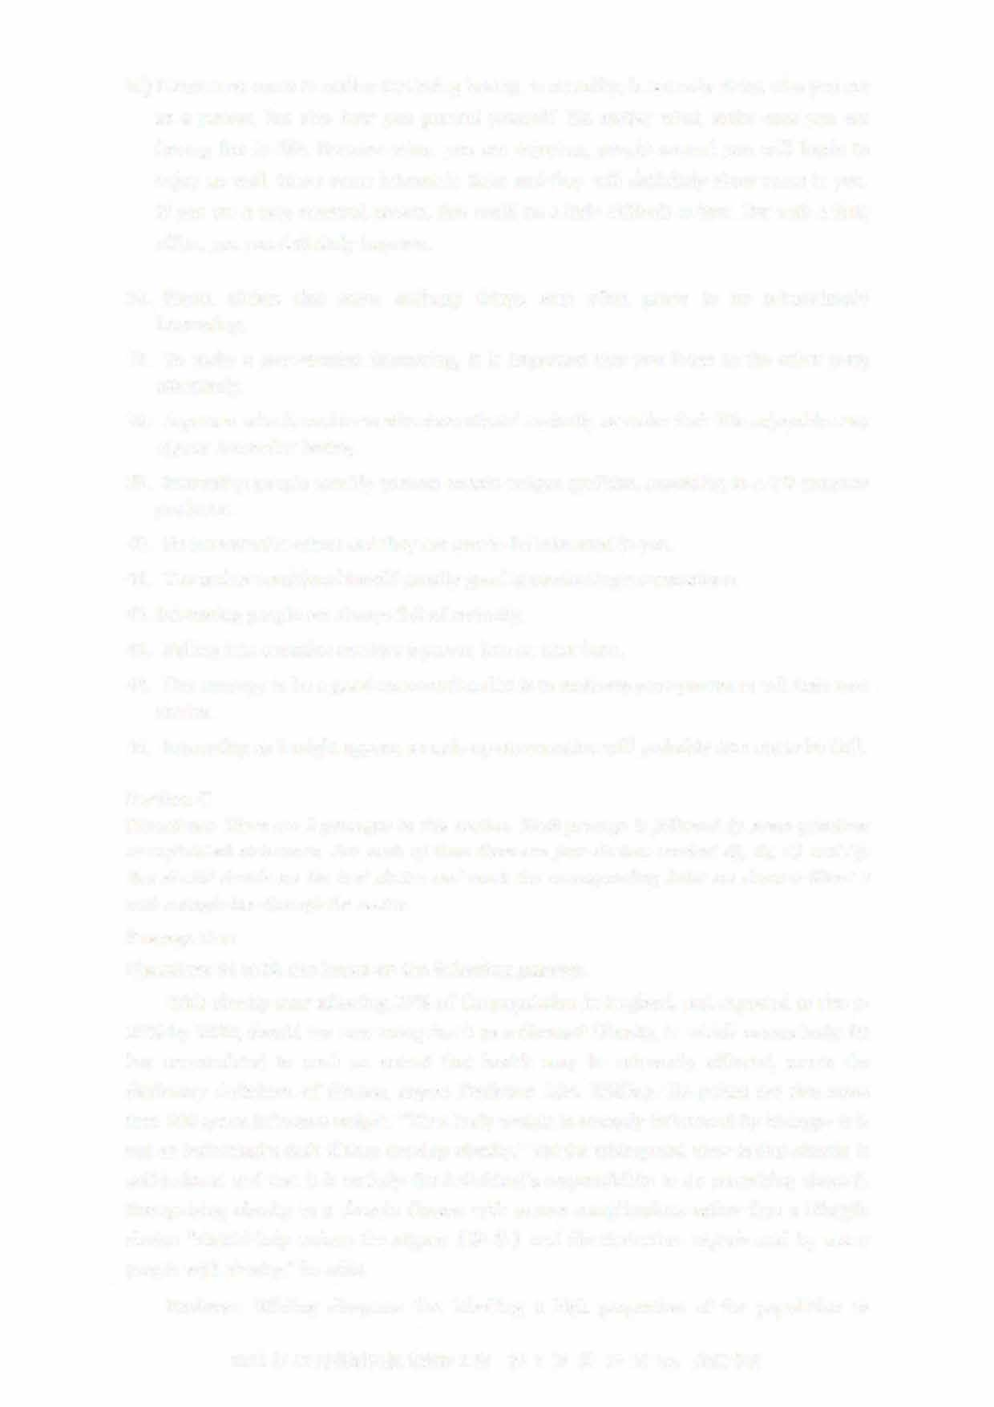35% by 2030, should we now recognise it as a disease? Obesity, in which excess body fat has accumulated to such an extent that health may be adversely affected, meets the dictionary definition of disease, argues Professor John Wilding. He points out that more than 200 genes influence weight. "Thus body weight is strongly influenced by biology- it is not an individual's fault if they develop obesity." Yet the widespread view is that obesity is self-induced and that it is entirely the individual's responsibility to do something about it. Recognising obesity as a chronic disease with severe complications rather than a lifestyle choice "should help reduce the stigma（耻辱）and discrimination experienced by many people with obesity," he adds.

Professor Wilding disagrees that labelling a high proportion of the population as

2021 年 12 月英语四级真题第 2 套 第 7 页共 10 页 by:

having a disease removes personal responsibility or may overwhelm health services, pointing out that other common diseases, such as high blood pressure and diabetes, require people to take action to manage their condition. He suggests that most people with obesity will eventually develop complications. "But unless we accept that obesity is a disease, we are not going to be able to tackle it," he concludes.

But Dr. Richard Pile, a physician with a special interest in diabetes, argues that adopting this approach "could actually result in worse outcomes for individuals and society." He believes that the dictionary definition of disease "is so vague that we can

classify almost anything as a disease" and says the question is not whether we can, but whether we should, and to what end.

If labelling obesity as a disease was harmless then it wouldn't really matter, he writes.

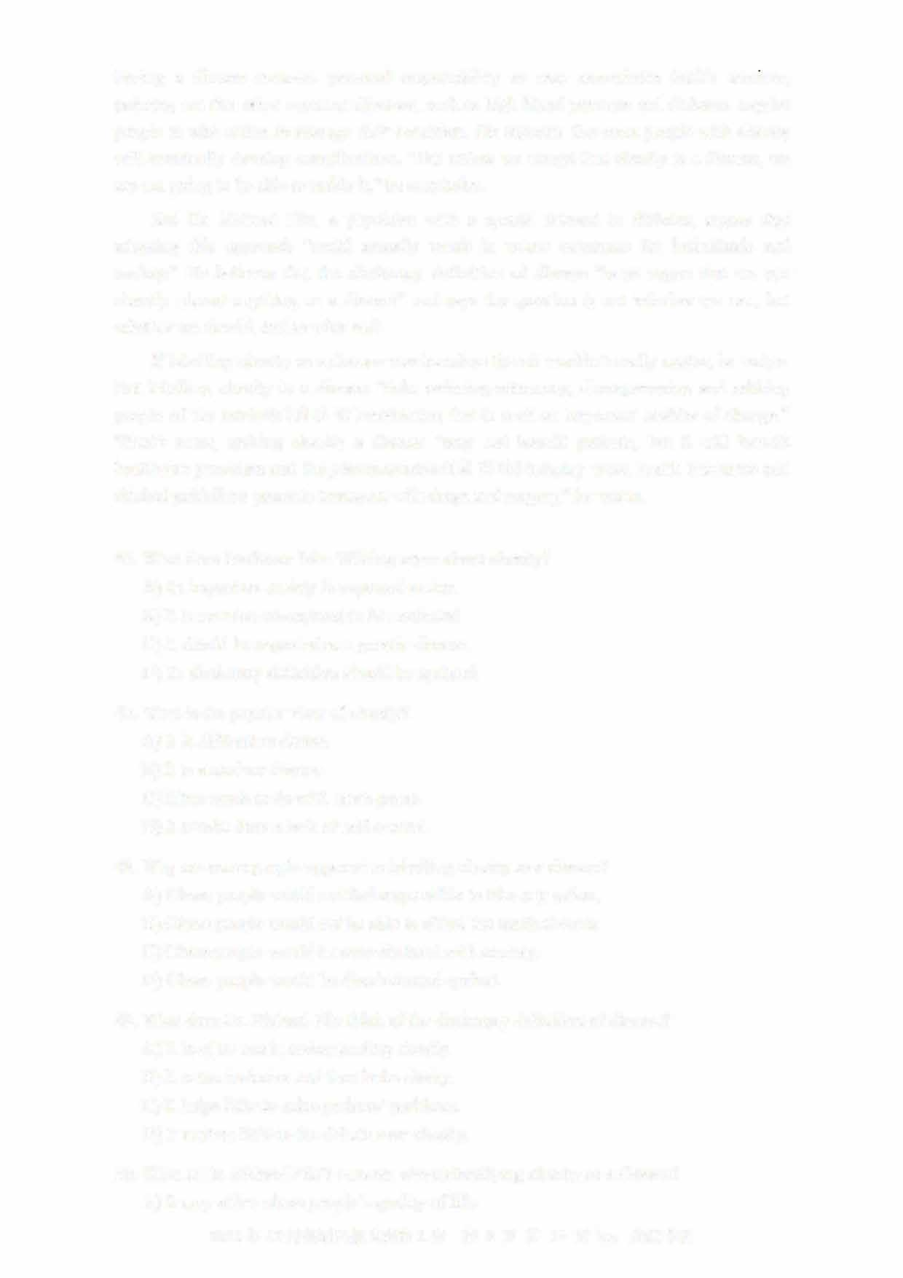But labelling obesity as a disease "risks reducing autonomy, disempowering and robbing people of the intrinsic (内在的） motivation that is such an important enabler of change." What's more, making obesity a disease "may not benefit patients, but it will benefit healthcare providers and the pharmaceutical （制药的） industry when health insurance and clinical guidelines promote treatment with drugs and surgery," he warns.

46. What does Professor John Wilding argue about obesity? A) Its impact on society is expected to rise.

1. It is now too widespread to be neglected.
2. It should be regarded as a genetic小sease.
3. Its dictionary definition should be updated.

4 7. What is the popular view of obesity? A) It is difficult to define.

1. It is a modem disease.
2. It has much to do with one's genes.
3. It results from a lack of self-control.
4. Why are some people opposed to labelling obesity as a disease?

A) Obese people would not feel responsible to take any action B) Obese people would not be able to afford the medical costs.

* 1. Obese people would be overwhelmed with anxiety.
  2. Obese people would be discriminated against.

1. What does Dr. Richard Pile think of the dictionary definition of disease?A) It is of no use in understanding obesity.
   1. It is too inclusive and thus lacks clarity.
   2. It helps little to solve patients' problems.
   3. It matters little to the debate over obesity.
2. What is Dr. Richard Pile's concern about classifying obesity as a disease?A) It may affect obese people's quality of life.

2021年12月英语四级真题第2套

* 1. It may accelerate the spread of obesity.
  2. It may cause a shortage of doctors.
  3. It may do little good to patients.

Passage Two

Questions 51 to 55 are based on the following passage.

Nationwide, only about three percent of early childhood teachers are male in the U. S.

Experts say this can have an impact on young children whose 皿derstanding of gender roles and identity are rapidly forming. Research has fo皿d that having access to diverse teachers is beneficial for children. For the youngest learners, it means they are more likely to get exposed to different varieties of play and communication. It also helps them develop healthy ideas aro皿d gender.

"In our world and our society, we have very specific stereotypes （模式化形象） of gender roles," said Mindi Reich-Shapiro, an assistant professor in the teacher education department of the Borough of Ma汕attan Commtmity College, and one of the authors of a recent study. "It's important for children to see other poss伽lities and other paths they can take."

Despite mostly feeling supported by colleagues and family members, many of the male educators surveyed in the study reported facing social or cultural resistance in their careers as early education teachers. Some also reported that there were parents surprised or concerned that their child had a male teacher. And they had been advised by colleagues or other staff not to hug children.

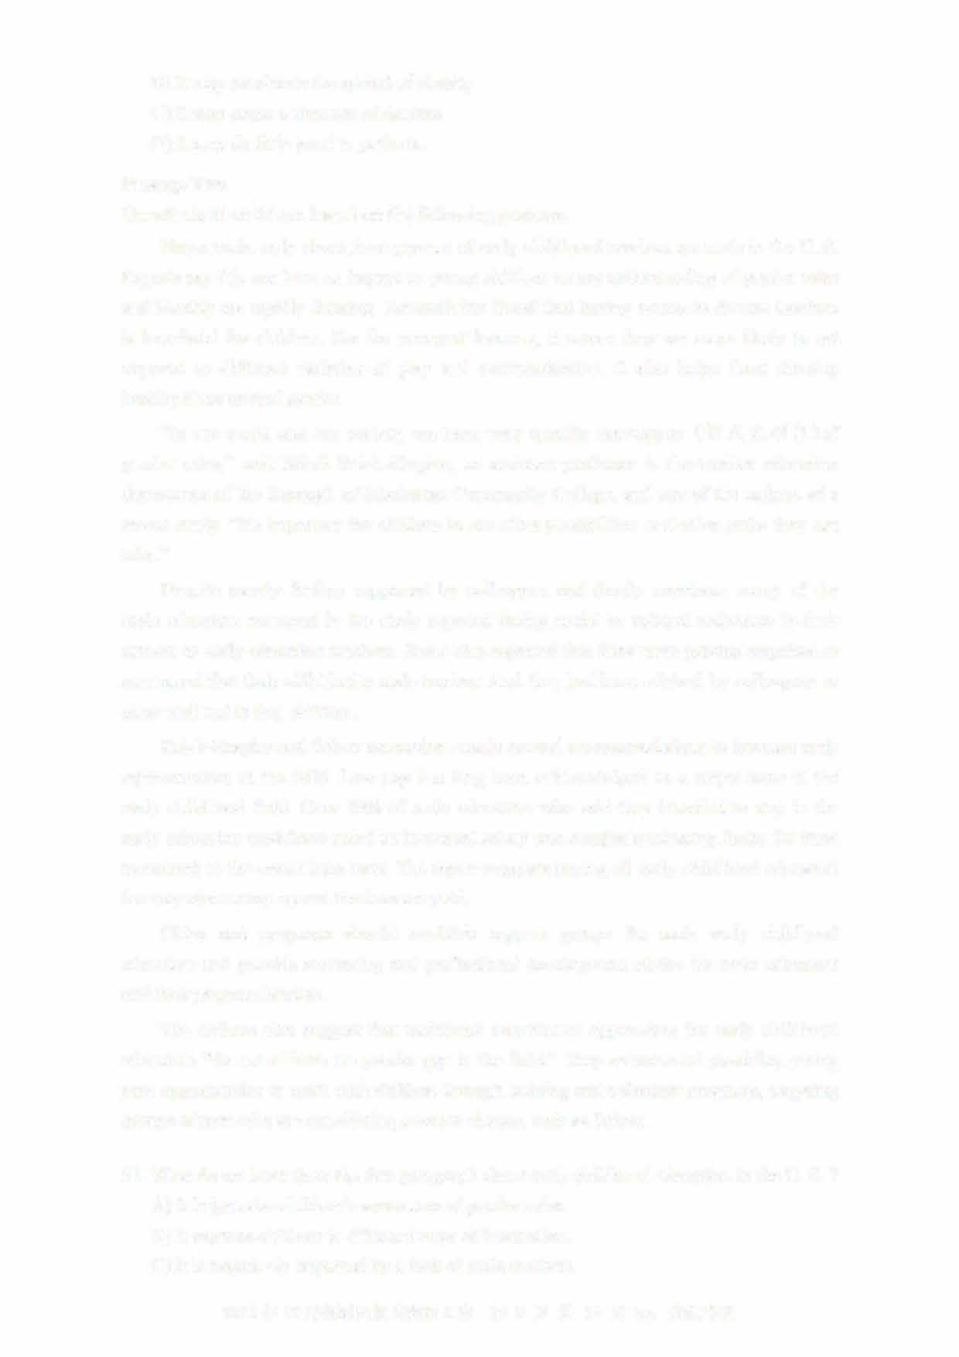Reich-Shapiro and fellow researchers made several recommendations to increase male representation in the field. Low pay has long been acknowledged as a major issue in the early childhood field. Over 70% of male educators who said they intended to stay in the early education workforce noted an increased salary was a major motivating factor for them to commit to the career long-term. The report suggests paying all early childhood educators the way elementary school teachers are paid

C巾es and programs should establish support groups for male early childhood educators and provide mentoring and professional development advice for male educators and their program leaders.

The authors also suggest that traditional recruitment approaches for early childhood educators "do not address the gender gap in the field." They recommend providing yotmg men opporttmities to work with children through training and volunteer programs, targeting groups of men who are considering a career change, such as fathers.

1. What do we learn from the first paragraph about early childhood education in the U. S. ?A) It helps raise children's awareness of gender roles.
   1. It exposes children to different ways of interaction.
   2. It is negatively impacted by a lack of male teachers.

2021年12月英语四级真题第2套

* 1. It clearly aims to form children's identity through play.

1. What does Mindi Reich-Shapiro emphasize in her comment on childhood education?A) The importance of broadening children's horizons.
   1. The responsibilities of fathers for children's growth.
   2. The urgency of creating teacher education programs.
   3. The role of teachers in motivating children to learn.
2. What do we learn about male teachers from their responses in the study?A) Some of them find it awkward when hugging children.
   1. They feel pressured to keep up with female colleagues.
   2. They find it hard to meet the expectations of kids' parents.
   3. Many of them feel prejudiced against socially and culturally.
3. What is needed for men to commit to early childhood education?A) Higher pay.
   1. Job security.
   2. Social recognition.
   3. Better working conditions.
4. What do the authors of the study recommend to bridge the gender gap in early childhood education?
   1. Recruiting young men who have a passion for education young children.
   2. Taking measures to attract prospective male teachers to work in the field.
   3. Persuading prospective fathers to consider a change in their career.D) Providing male teachers with more opportunities for advancement.

Part IV Translation (30 minutes)

Directions: For this part, you are allowed 30 minutes to translate a passage from Chinese into English. You should write your answer on Answer Sheet 2.

坎儿井(Karez)是新疆干旱地区的一种水利系统， 由地下渠道将水井连接而成。 该系统将

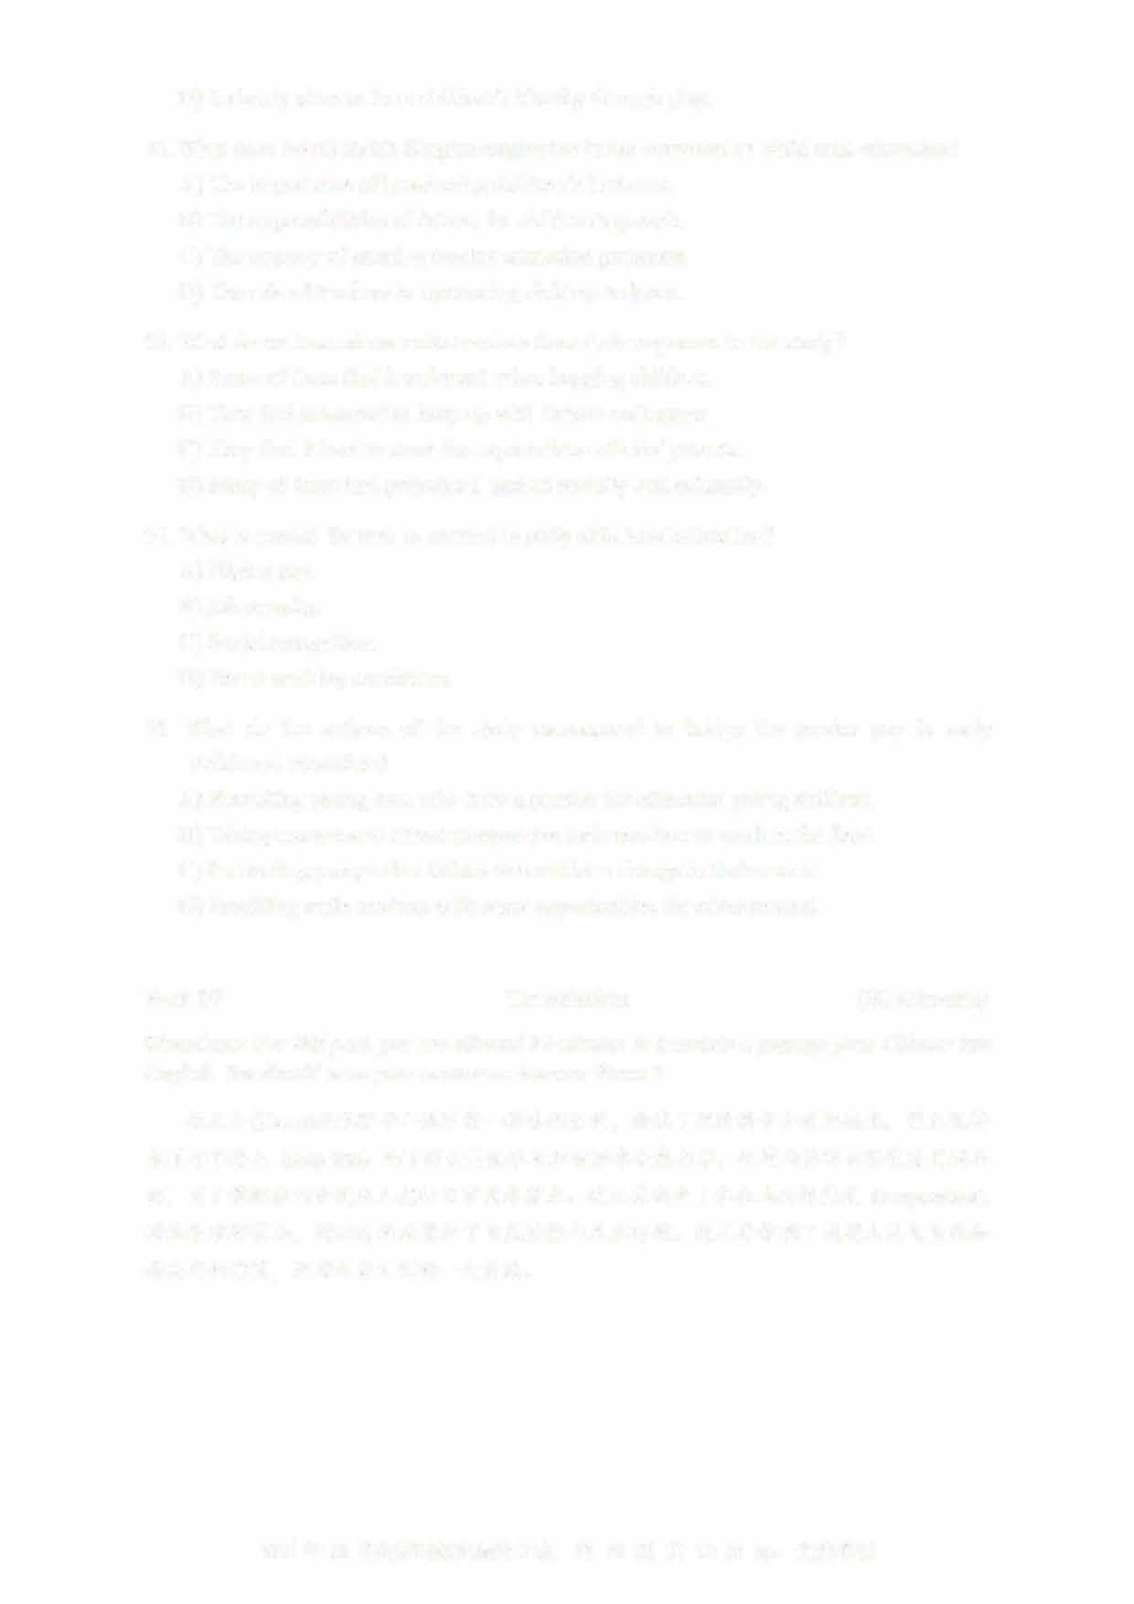春夏季节登!:::c_ (seep into) 地下的大量币水及积雪融水收集起来， 通过山体的自然坡度引到地面， 用于灌溉农田和满足人们的日常用水需求。 坎儿井减少了水在地面的思}1,,,_ (evaporation),

对地表破坏很小， 因而有效地保护了自然资源与生态环境。 坎儿井体现了我国人民与自然和谐共存的智慧， 是对人类文明的一大贡献。

2021年12月英语四级真题第2套 UVOOC.COM

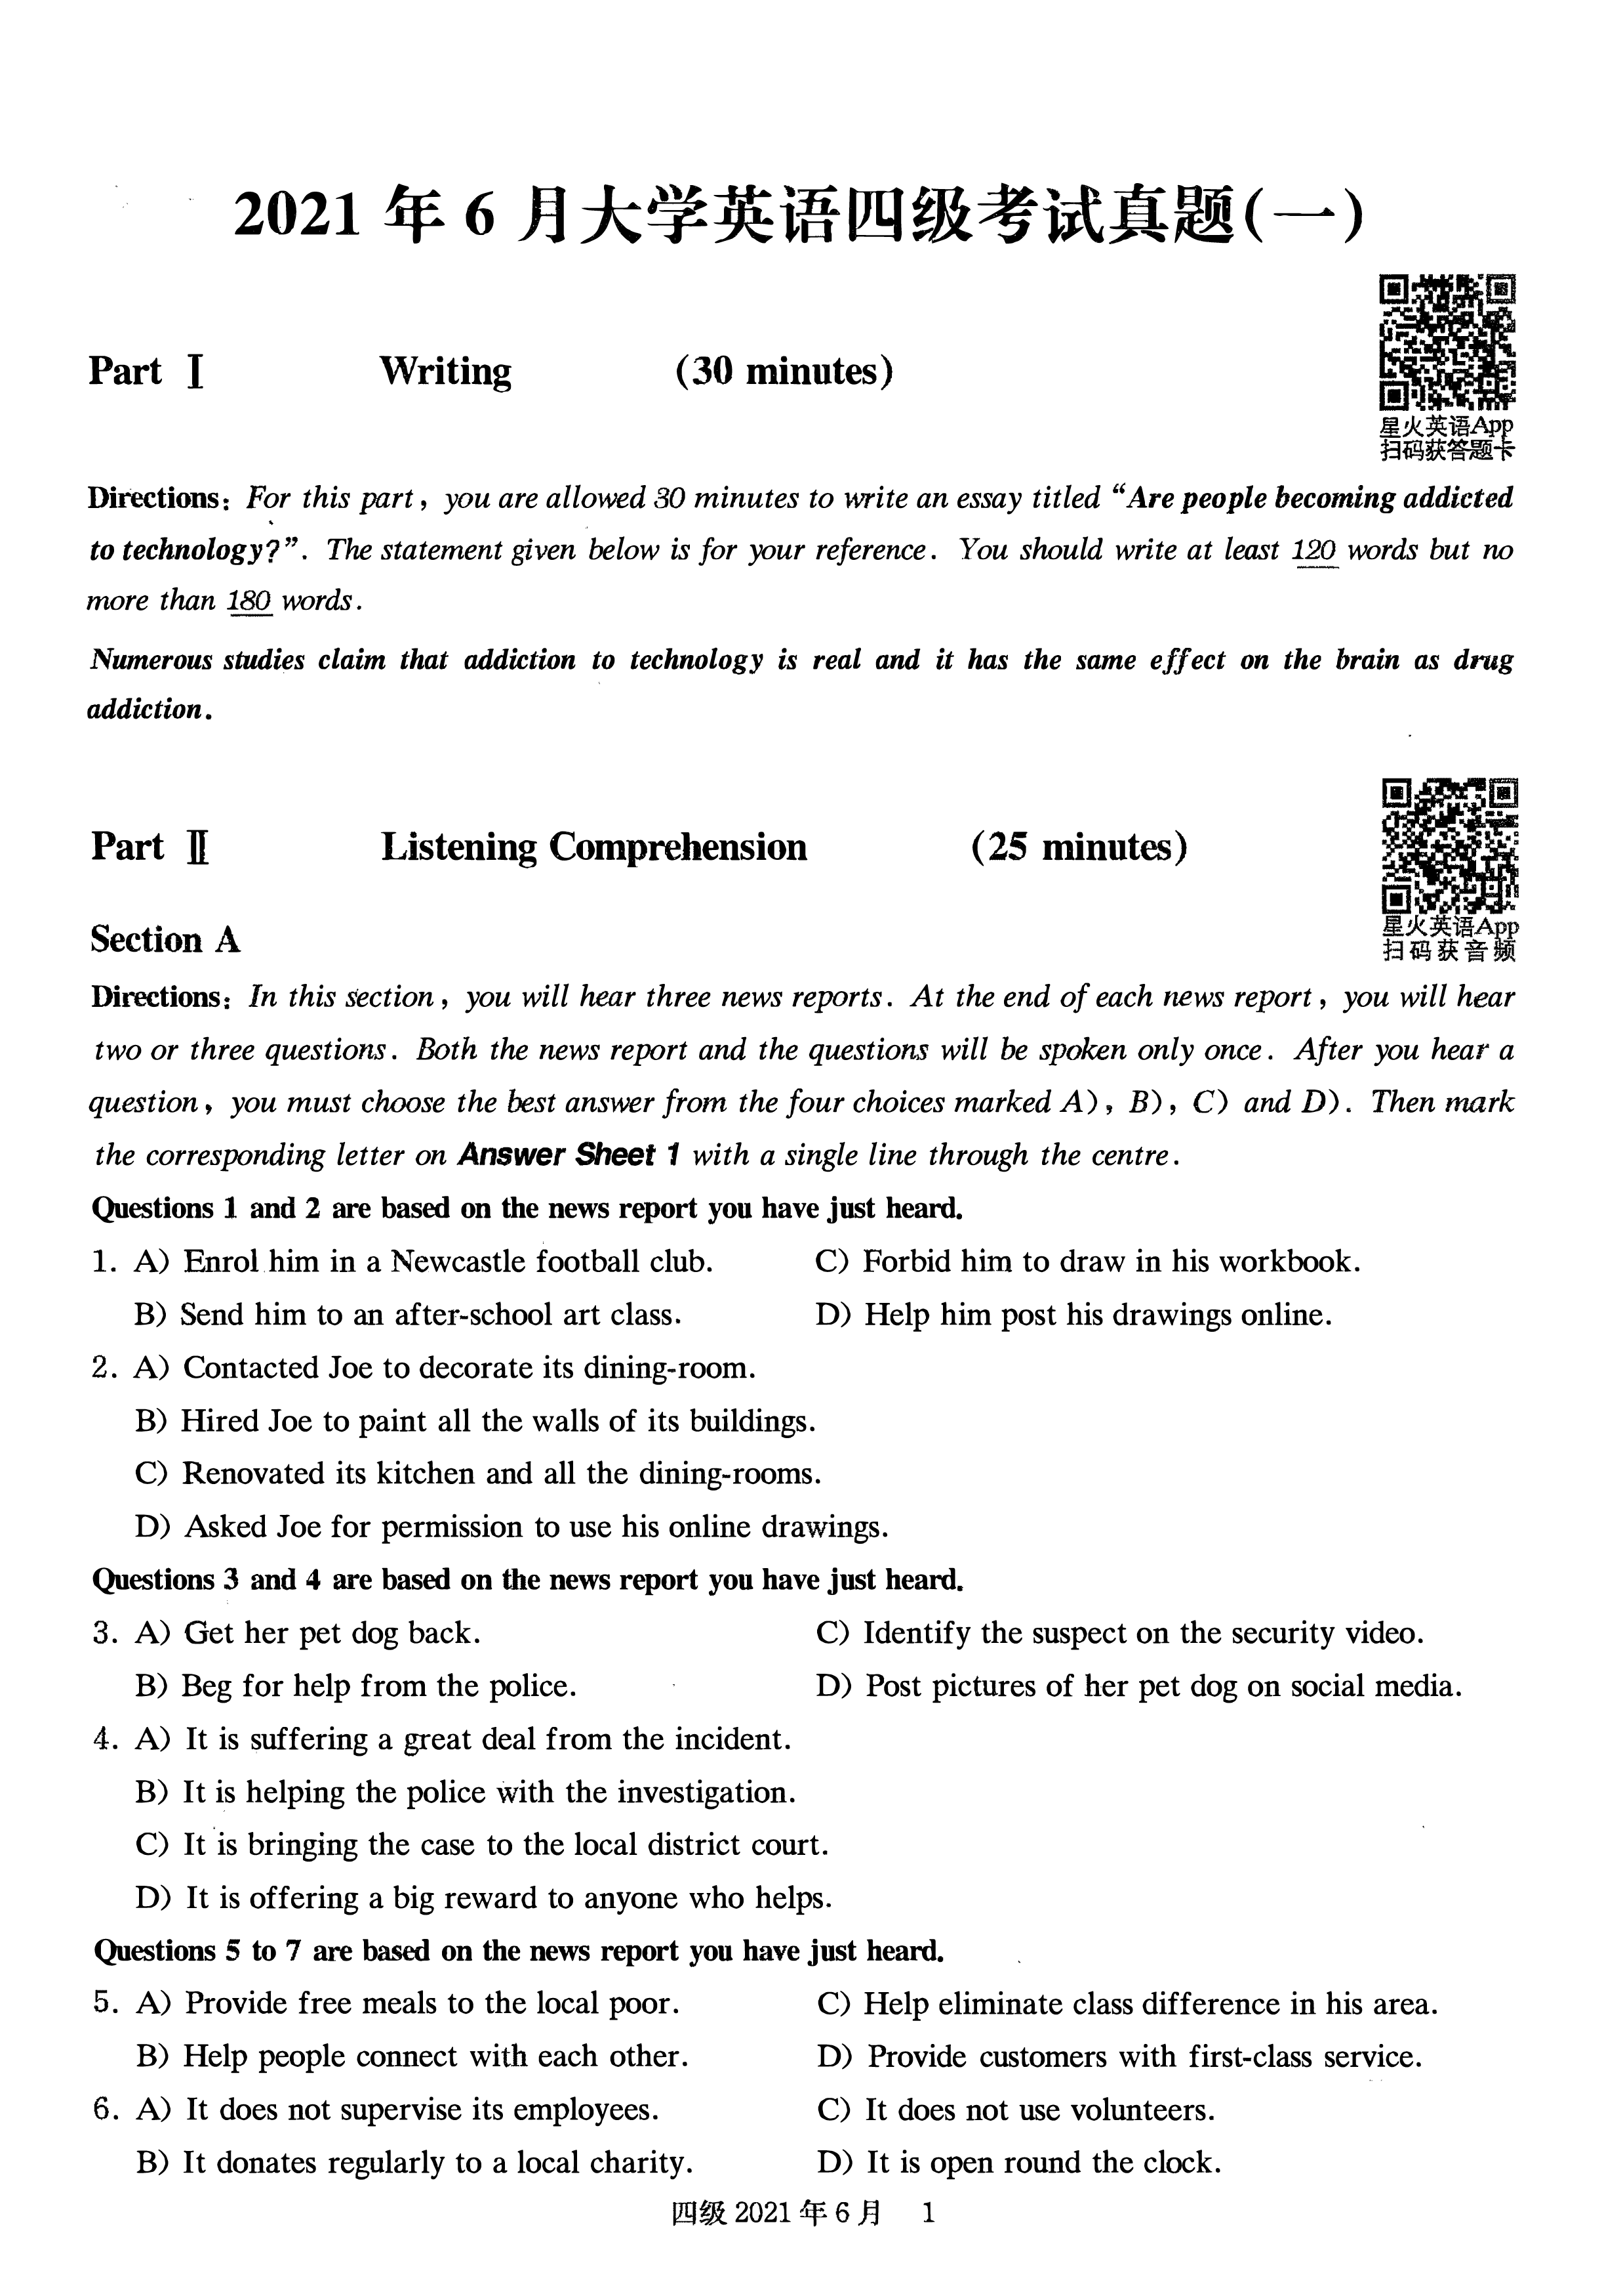

7. A) They will realise the importance of communication. B) They will come to the cafe even more frequently.

1. They will care less about their own background.
2. They will find they have something in common.

# Section B

**Directions:** *In this section, you will hear two long conversations. At the end of each conversation, you* ***will*** *hear four questions. Both the conversation and the questions will be spoken only once. After you hear a question, you must choose the best answer from the four choices marked* A), B), C) *and* D). *Then mark the corresponding letter on* ***Answer Sheet 1*** *with a single line through the centre.* **Questions 8 to 11 are based on the conversation you have just heard.**

1. A) A surprise party for Paul's birthday. C) Preparations for Saturday's get-together.
   1. Travel plans for the coming weekend. D) The new market on the other side of town.
2. A) **It** makes the hostess's job a whole lot easier.
   1. **It** enables guests to walk around and chat freely.
   2. **It** saves considerable time and labor.
   3. **It** requires fewer tables and chairs.
3. A) It offers some big discounts. C) **It** is more spacious and less crowded. B) It is quite close to her house. D) **It** sells local wines and soft drinks.
4. A) Cook a dish for the party. C) Prepare a few opening remarks. B) Arrive 10 minutes earlier. D) Bring his computer and speakers.

**Questions 12 to 15 are based on the conversation you have just heard.**

1. A) For commuting to work. C) For getting around in Miami.
   1. For long-distance travel. D) For convenience at weekends.
2. A) They are reliable. C) They are spacious.
   1. They are compact. D) They are easy to drive.
3. A) Buy a second-hand car. C) Seek advice from his friend.

-t Tlll_s! her ownjudge_!lt. D) Look around before deciding.- --- - 15. A) He sells new cars. C) He is starting a business.

* 1. He can be trusted. D) He is a successful car dealer.

# Section C

**Directions:** *In this section* , *you will hear three passages. At the end of each passage* , *you will hear three or four questions. Both the passage and the questions will be spoken only once. After you hear a question* , *you must choose the best answer from the four choices marked A* ) , *B)* , C) *and D)* . *Then mark the*

*corresponding letter on* ***Answer Sheet 1*** *with a single line through the centre.* **Questions 16 to 18 are based on the passage you have just heard.**

1. A) Many escaped from farms and became wild.
   1. They were actually native to North America.
   2. Many got killed in the wild when searching for food.
   3. They were hunted by Spanish and Russian explorers.
2. A) They often make sudden attacks on people. B) They break up nature's food supply chain.
   1. They cause much environmental pollution.
   2. They carry a great many diseases.

fil}20216J=j

1. A) They lived peacefully with wild pigs. C) They fell victim to eagles. B) They ran out of food completely. D) They reproduced quickly.

**Questions 19 to 21 are based on the passage you have just heard.**

1. A) Taste coffee while in outer space. C) Develop a new strain of coffee bean.
   1. Roast coffee beans in outer space. D) Use a pressurised tank to brew coffee.
2. A) They can easily get burned. C) They have to be heated to 36D°C.
   1. They float around in the oven. D) They receive evenly distributed heat.
3. A) They charged a high price for their space-roasted coffee beans. B) They set up a branch in Dubai to manufacture coffee roasters.

C) They collaborated on building the first spacC;! coffee machine. D) They abandoned the attempt to roast coffee beans in space.

**Questions 22 to 25 are based on the passage you have just heard.**

1. A) It is the best time for sightseeing. C) They come to clean the Iditarod Trail.
   1. A race passes through it annually. D) It is when the villagers choose a queen.
2. A) Its children's baking skills. C) Its tasty fruit pies.
   1. Its unique winter scenery. D) Its great food variety.
3. A) The contestants. C) Jan Newton and her friends.
   1. The entire village. D) People from the state of Idaho.
4. A) She owned a restaurant in Idaho. C) She went to Alaska to compete in a race.

'B) She married her husband in 1972. D) She helped the village to become famous.

**Part ][ Reading Comprehension ( 40 minutes)**

**Section A**

**Directions: *In this section*** , ***there is a passage with ten blanks. You are required to select one word for each blank from a list of choices given in a word bank following the passage. Read the passage through carefully***

***before making your choices. Each choice in the bank is identified by a letter. Please mark the corresponding letter for each item on Answer Sheet 2 with a single line through the centre. You may not use any of the***

***words in the bank more than once*** .

Most animals seek shade when temperatures in the Sahara Desert soar to 120 degrees Fahrenheit. But for the Saharan silver ant, ___1L from their underground nests into the sun's brutal rays to _JJ__ for food, this is the perfect time to seek lunch. In 2015 these ants were joined in the desert by scientists from two Belgian universities, who spent a month in the heat tracking the ants and digging out their nests. The goal was simple, to discover how the adapted to the kind of heat that can melt the bottom of shoes.

Back in Belgium, the scientists looked at the ants under an electronic microscope and found that their

_l!_, triangular hair reflects light like a ***prism*** (4.t), giving them a metallic reflection and protecting them from the sun's awful heat. When Ph.D. student Quentin Willot 32 the hair from an ant with a knife and put it under a heat lamp, its temperature jumped.

The ants' method of staying cool is _l!_ among animals. Could this reflective type of hair protect people? Willot says companies are interested in _lL these ants' method of heat protection for human use, including everything from helping to protect the lives of firefighters to keeping homes cool in summer.

Im 20211¥ 6 J]

1. adapting F) hunt K) species
2. consciously G) literally L) specimens
3. crawling H) moderate M) thick
4. crowded I) remote N) tiny
5. extreme J) removed 0) unique

## Section B

**Directions: *In this section, you are going to reaa a passage with ten statements attached to it. &eh statement contains information given in one of the paragraphs. Identify the paragraph from which the information is derived. You may choose a paragraph more than once. &eh paragraph is marked with a letter. Answer the questions by marking the corresponding letter on Answer Sheet 2.* The start of high school doesn't have to be stressful**

1. This month, more than 4 million students across the nation will begin high school. Many will do well. But many will not. Consider that nearly two-thirds of students will experience the "ninth-grade shock," which refers to a dramatic drop in a student's academic performance. Some students cope with this shock by avoiding challenges. For instance, they may drop difficult coursework. Others may experience a hopelessness that results in failing their core classes, such as English, science and math.
2. This should matter a great deal to parents, teachers and policymakers. IBtimately it should matter to the students themselves and society at large, because students' experience of ***transitioning*** (lii./t) to the ninth grade can have long-term consequences not only for the students themselves but for their home communities. We make these observations as research psychologists who have studied how schools and families can help young people thrive.
3. In the new global economy, students who fail to finish the ninth grade with passing grades. in college preparatory coursework are very unlikely to graduate on time and go on to get jobs. One study has calculated that the lifetime benefit to the local economy for a single additional student who completes high school is half a million dollars or more. This is based on higher earnings and avoided costs in health care, crime, welfare dependence and other things.
4. The consequences of doing poorly in the ninth grade can impact more than students' ability to find a good job. It can also impact the extent to which they enjoy life. Students lose many of the friends they turned to for support when they move from the eighth to the ninth grade. One study of ninth-grade students found that 50 percent of friendships among ninth graders changed from one month to the next, signaling striking instability in friendships.
5. In addition, studies find the first year of high school typically shows one of the greatest increases in depression of any year over the lifespan. Researchers think that one explanation is that ties to friends are broken while academic demands are rising. Furthermore, most adult cases of clinical depression first emerge in ***aaolescence*** ( -t $-J.Jl) . The World Health Organization reports that depression has the greatest burden of disease worldwide, in terms of the total cost of treatment and the loss of productivity.
6. Given all that's riding on having a successful ninth grade experience, it pays to explore what can be done to meet the academic, social and emotional challenges of the transition to high school. So far, our studies have yielded one main insight: Students' beliefs about change-their beliefs about whether people are stuck one way forever, or whether people can change their personalities and abilities-are

ll!J 2021 1j::. 6 JJ

related to their ability to cope, succeed academically and maintain good mental health. Past research has called these beliefs *"mindsets* ( ,' if!:tl)," with a "fixed mindset" referring to the belief that people cannot change and a "growth mindset" referring to the belief that people can change.

1. In one recent study, we examined 360 adolescents' beliefs about the nature of "smartness"-that is, their fixed mindsets about intelligence. We then assessed biological stress responses for students whose grades were dropping by examining their stress *hormones* ( 1if t ) . Students who believed that intelligence is fixed-that you are stuck being "not smart" if you struggle in school-showed higher levels of stress hormones when their grades were declining at the beginning of the ninth grade. If students believed that intelligence could improve-that is to say, when they held more of a growth mindset of intelligence-they showed lower levels of stress hormones when their grades were declining. This was an exciting result because it showed that the body's stress responses are not determined solely by one's grades. Instead, declining grades only predicted worse stress hormones among students who believed that worsening grades were a permanent and hopeless state of affairs.



-

1. We also investigated the social side of the high school transition. In this study, instead of teaching students that their smartness can change, we taught them that their social standing-that is, whether they are bullied or excluded or left out-can change over time. We then looked at high school students' stress responses to daily social difficulties. That is, we taught them a growth mindset about their social lives. In this study, students came into the laboratory and were asked to give a public speech in front of upper-year students. The topic of the speech was what makes one popular in high school. Following this, students had to complete a difficult mental math task in front of the same upper-year students.
2. Experiment results showed that students who were not taught that people can change showed poor stress responses. When these students gave the speech, their blood vessels contracted and their hearts pumped less blood through the body-both responses that the body shows when it is preparing for damage or defeat after a physical threat. Then they gave worse speeches and made more mistakes in math. But when students were taught that people can change, they had better responses to stress, in part because they felt like they had the resources to deal with the demanding situation. Students who got the growth mindset *intervention* ( f- f»i) showed less-contracted blood vessels and their hearts

pumped more blood-both of which contributed to more oxygen getting to the brain, and, ultimately, better performance on the speech and mental math tasks.

1. These findings lead to several possibilities that we are investigating further. First, e are working to *replicate* (i.. 11itJ) these findings in more diverse school communities. We want to know in which types of schools and for which kinds of students these growth mindset ideas help young people adapt to the challenges of high school. We also hope to learn how teachers, parents or school counselors can help students keep their ongoing academic or social difficulties in perspective. We wonder what would happen if schools helped to make beliefs about the potential for change and improvement a larger

feature of the overall school culture, especially for students starting the ninth grade.

1. The number of people experiencing depression shows a sharp increase in the first year of high school.
2. According to one study, students' academic performance is not the only decisive factor of their stress responses.
3. Researchers would like to explore further how parents and schools can help ninth graders by changing their mindset.
4. According to one study, each high school graduate contributes at least 500, OOO dollars to the local economy.

fill 2021 6 JI

1. **In** one study, students were told their social position in school is not unchangeable.
2. **It** is reported that depression results in enormous economic losses worldwide.
3. One study showed that friendships among ninth graders were far from stable.
4. More than half of students will find their academic performance declining sharply when they enter the ninth grade.
5. Researchers found through experiments that students could be taught to respond to stress in a more positive way.
6. **It** is beneficial to explore ways to cope with the challenges facing students entering high school. **Section C**

**Directions:** *There are 2 passages in this section. &eh passage is followed by some questions or unfinished statements. For each of them there are four choices marked A), B),* C) *and D). You should decide on the*

*best choice and mark the corresponding letter on* ***Answer Sheet 2*** *with a single line through the centre.* **Passage One**

**Questions 46 to 50 are based on the following passage.**

Educators and business leaders have more in common than it may seem. Teachers want to prepare students for a successful future. Technology companies have an interest in developing a workforce with the STEM (science, technology, engineering and math) skills needed to grow the company and advance the industry. How can they work together to achieve these goals? Play may be the answer.

Focusing on STEM skills is important, but the reality is that SIBM skills are enhanced and more relevant when combined with traditional, hands-on creative activities. This combination is proving to be the best way to prepare today's children to be the makers and builders of tomorrow. That is why technology companies are partnering with educators to bring back good, old-fashioned play.

**In** fact many experts argue that the most important 21st-century skills aren't related to specific technologies or subject matter, but to creativity; skills like imagination, problem-finding and problemsolving, teamwork, optimism, patience and the ability to experiment and take risks. These are skills

-- - - - - -acquired-when -kids-tinker (-it.fib *1*1 •-fu-;f;-};- -High 4ech industries-such-as-NASA's-Jet-Propulsion-Laboratory - - -- have found that their best overall problem solvers were master tinkerers in their youth.

There are *cognitive* ( -iA {JI.;) benefits of doing things the way we did as children-building something, tearing it down, then building it up again. Research shows that given 15 minutes of free play, four- and five-year-olds will spend a third of this time engaged in spatial, mathematical, and architectural activities. This type of play-especially with building blocks-helps children discover and develop key principles in math and geometry.

If play and building are critical to 21st-century skill development, that's really good news for two reasons: Children are born builders, makers, and creators, so *fostering* (;J:.g-$f.) 21st-century skills may be as simple as giving kids room to play, tinker and try things out, even as they grow older. Secondly, it doesn't take 21st-century technology to foster 21st-century skills. This is especially important for underresourced schools and communities. Taking whatever materials are handy and tinkering with them is a simple way to engage those important "maker" skills. And anyone, anywhere, can do it.

1. What does the author say about educators?
   1. They seek advice from technology companies to achieve teaching goals.
   2. They have been successful in preparing the workforce for companies.

**[9f;&** 20211:p 6 JJ

* 1. They help students acquire the skills needed for their future success.
  2. They partner with technology companies to enhance teaching efficiency.

1. How can educators better develop students' SIBM skills, according to the author? A) By blending them with traditional, stimulating activities.
2. By inviting business leaders to help design curriculums.
3. By enhancing students' ability to think in a critical way.
4. By showing students the best way to learn is through play.
5. How do children acquire the skills needed for the 21st century? A) By engaging in activities involving specific technologies.
   1. By playing with things to solve problems on their own.
   2. By familiarizing themselves with high-tech gadgets.
   3. By mastering basic principles through teamwork.
6. What can we do to help children learn the basics of math and geometry? A) Stimulate their interest as early as po.ssible.
   1. Spend more time playing games with them.
   2. Encourage them to make things with hands.
   3. Allow them to tinker freely with calculators.
7. What does the author advise disadvantaged schools and communities to do? A) Train students to be makers to meet future market demands. B) Develop students' creative skills with the resources available.
   1. Engage students with challenging tasks to foster their creativity.
   2. Work together with companies to improve their teaching facilities. **Passage Two**

**Questions 51 to SS are based on the following passage.**

Being an information technology, or IT, worker is not a job I envy. They are the ones who, right in the middle of a critical meeting, are expected to instantly fix the projector that's no longer working. They have to tolerate the bad tempers of colleagues frustrated at the number of times they've had to call the help desk for the same issue. They are also the ones who know there are systems that are more powerful, reliable and faster, but their employer simply will not put up the funds to buy them.

According to a recent survey, employees who have a job reliant on IT support consider IT a major source of job dissatisfaction. Through no fault of their own, they can suddenly find their productivity

deteriorating or quality control non-existent. And there's little they can do about it.

The experience of using IT penetrates almost the entire work field. It has become a crucial part of employees' overall work experience. When IT is operating as it should, employee self-confidence swells. Their job satisfaction, too, can surge when well-functioning machines relieve them of dull tasks or repetitive processes. But if there's one thing that triggers widespread employee frustration, it's an IT transformation project gone wrong, where swollen expectations have been popped and a long list of promised efficiencies have been reversed. This occurs when business leaders implement IT initiatives with little consideration of how those changes will impact the end user.

Which is why managers should appreciate just how influential the IT user experience is to their employees, and exert substantial effort in ensuring their IT team eliminates programming errors and application crashes. Adequate and timely IT support should also be available to enable users to cope with Im 2021 ip 6 fJ 7

technological issues at work. More importantly, IT practitioners need to understand what employees experience mentally when they use IT.

Therefore, businesses need to set up their IT infrastructure so that it is designed to fit in with their employees' work, rather than adjust their work to fit in with the company's IT limitations.

1. What does the author say about working in IT?
   1. It is envied by many. C) It is financially rewarding.
   2. It does not appeal to him. D) It does not match his abilities.
2. What is the finding of a recent survey on employees who have a job reliant on IT support? A) IT helps boost productivity.
   1. IT helps improve quality control.
   2. Many employees are deeply frustrated by IT.
   3. Most employees rely heavily on IT in their work.
3. What is said to happen when IT is functioning properly? A) There is a big boost in employees' work efficiency.



* 1. Employees become more dependent on machines.
  2. There are no longer any boring or repetitive tasks.
  3. Employees become more confident in their work.

1. What should business leaders do before implementing new IT initiatives? A) Consider the various expectations of their customers.
   1. Draw up a list of the efficiencies to be promised.
   2. Assess the swollen cost of training the employees.
   3. Think about the possible effects on their employees.
2. How can a business help improve its employees' experience in using IT? A) By designing systems that suit their needs.
   1. By ensuring that their mental health is sound.
   2. By adjusting their work to suit the IT system.
   3. By offormg tliem regular· m-serv1ce trammg.

# Part *N* Translation ( 30 minutes)

**Directions:** *For this part, you are allowed 30 minutes to translate a passage from Chinese into English. You should write your answer on* ***Answer Sheet 2.***



Part

I

**Writing**

**(**

**30**

**minutes)**

Directions:

***For***

***this***

***part,***

***you***

***are***

***allowed 30***

***minutes***

***to***

***write***

***an***

***essay***

***titled***

***"Do***

***violent***

***video***

***games***

***lead***

***to***

***violence***

***? ".***

***The***

***statement***

***given***

***below***

***is***

***for***

***your***

***ref***

***ere***

***nee***

.

***You***

***should***

***write***

***at***

***least***

***120***

***words***

***but***

***no more***

***t***

***han***

***180***

***words.***

A

***growing***

***body***

***of***

***research***

***finds***

***that***

***violent***

***video***

***games***

***can***

***make***

***kids***

***act***

***aggressively***

***in***

***their***

***real***

***world***

***relationships,***

***causing***

***an***

***increase***

***in***

***violence.***

**Part**

**:U:**

**Listening**

**Comprehension**

**(25**

**minutes)**

**&: Eil=f 2021 6 IZQOOTWIl!Jrfl •*;l'.lml!Jrfl!§fi!WIfflfRJ,J=U!JZtl3i!flll¥1EJ, 1!1**

**JtttE*·-r:pff :m:tll :$**

Part I **Reading Comprehension ( 40 minutes)**

**Section A**

**Directions: *In this section*** , ***there is a passage with ten blanks. You are required to select one. word for each blank from a list of choices given in a word bank following the passage. Read the passage through carefully before making your choices. &eh choice in the bank is identified by a letter. Please mark the correspondirtg letter for each item on Answer Sheet 2 with a single line through the centre. You may not use any of the***



**l)rough**

**l**

**y**

***words in the bank more than once*** .

**Nowadays you can't buy anything without then being asked to provide a rating of a company's performance on a five-star scale.**

**I've been asked to rate my "store" on the EFTPOS terminal before I can pay. Even the most**

**_J'J__ activities, such as calling Telstra or picking up a parcel from Australia Post, are followed by texts or emails with surveys asking, "How did we do?"**

**Online purchases are followed up by a customer satisfaction survey. Companies are so for a hit of stars that if you delete the survey the company sends you another one.**

**We're _lQ_ to rate our apps when we've barely had a chance to use them. One online course provider I use asks you what you think of the course after you've only completed 2 per cent of it.**

**Economist Jason Murphy says that companies use customer satisfaction ratings· because a display of star feedback has become the nuclear power sources of the modem economy.**

**However, you can't help but if these companies are basing their business on *fabrications* (:it it?** *1t-* **). I that with online surveys 1 just click the that's closest to my mouse *cursor* (it#) to get the damn thing off my screen. Often the star rating I give has far more to do with the kind of day**

**I'm having than the purchase 1 just made.**

**A) announce B) commonplace**

**C) confess**

**-----maesperate**

1. **experience**
2. **fascinated K) shining**
3. **option L) showering H)prompted M)variety**

**----- N) voyage __ _**

**J) routinely 0) wonder**

**(JTJ20216**

# Section B

Directions: *In this section, you are going to read a passage with ten statements attached to it. &eh statement contains information given in one of the paragraphs. Identify the paragraph from which the information is derived. You may choose a paragraph more than once. &eh paragraph is marked with a letter. Answer the questions by marking the corresponding letter on* ***Answer Sheet 2.*** **Science of setbacks: How failure can improve career prospects**

1. How do early career setbacks affect our long-term success? Failures can help us learn and overcome our fears. But disasters can still wound us. They can screw us up and set us back. Wouldn't it be nice if there was genuine, scientifically documented truth to the expression "what doesn't kill you makes you

stronger"?





1. 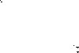One way social scientists have probed the effects of career setbacks is to look at scientists of very similar qualifications. These scientists, for reasons that are mostly arbitrary, either just missed getting a research grant or just barely made it. In social sciences, this is known as examining "near misses" and "narrow wins" in areas where merit is subjective. That allows researchers to measure only the effects of being chosen or not. Studies in this area have found conflicting results. In the competitive game of biomedical science, research has been done on scientists who narrowly lost or won grant money. It



suggests that narrow winners become even bigger winners down the line. In other words, the rich get

richer.

1. A 2018 study published in the *Proceedings of the National Academy of Sciences,* for example, followed researchers in the Netherlands. Researchers concluded that those who just barely qualified for a grant were able to get twice as much money within the next eight years as those who just missed out. And the narrow winners were 50 percent more likely to be given a professorship.
2. Others in the US have found similar effects with National Institutes of Health early-career fellowships launching narrow winners far ahead of close losers. The phenomenon is often referred to as the

Matthew effect fosp1red6- y ilie Bible's-wisdom diaf fo -those who have, more will be -given: There's-a good explanation for the phenomenon in the book *The Formula: The Universal Laws of Success* by

Albert Laszlo Barabasi. According to Barabasi, it's easier and less risky for those in positions of power to choose to hand awards and funding to those who've already been so recognized. 

1. This is bad news for the losers. Small early career setbacks seem to have a disproportionate effect down the line. What didn't kill them made them weaker. But other studies using the same technique have shown there's sometimes no penalty to a near miss. Students who just miss getting into top high

schools or universities do just as well later in life as those who just manage to get accepted. In this case, what didn't kill them simply didn't matter. So is there any evidence that setbacks might actually improve our career prospects? There is now.



1. In a study published in *Nature Communications,* Northwestern University sociologist Dashun Wang tracked more than 1 , 100 scientists who were on the border between getting a grant and missing out between 1990 and 2005. He followed various measures of performance over the next decade. These included how many papers they authored and how influential those papers were, as measured by the number of subsequent citations. *As* expected, there was a much higher rate of *attrition* (g!) among

Im 2021 &'f 6 }3

scientists who didn't get grants. But among those who stayed on, the close losers performed even better than the narrow winners. To make sure this wasn't by chance, Wang conducted additional tests using different performance measures. He examined how many times people were first authors on influential studies, and the like.

1. One straightforward reason close losers might outperform narrow winners is that the two groups have comparable ability. In Wang's study, he selected the most determined, passionate scientists from the loser group and ***culled*** (J1J ) what he deemed the weakest members of the winner group. Yet the persevering losers still came out on top. He thinks that being a close loser might give people a psychological boost, or the proverbial kick in the pants.
2. Utrecht University sociologist Arnout van de Rijt was the lead author on the 2018 paper showing the  rich get richer. He said the new finding is apparently reasonable and worth some attention. His own work showed that although the narrow winners did get much more money in the near future, the actual performance of the close losers was just as good.
3. He said the people who should be paying regard to the Wang paper are the funding agents who



distribute government grant money. After all, by continuing to pile riches on the narrow winners, the



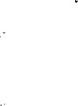taxpayers are not getting the maximum bang for their buck if the close losers are performing just as well or even better. There's a huge amount of time and effort that goes into the process of selecting who gets grants, he said, and the latest research shows that the scientific establishment is not very



good at distributing money. "Maybe we should spend less money trying to figure out who is better than



who," he said, suggesting that some more equal dividing up of money might be more productive and more efficient. Van de Rijt said he's not convinced that losing out gives people a psychological boost; It may yet be a selection effect. Even though Wang tried to account for this by culling the weakest winners, it's impossible to know which of the winners would have quit had they found themselves on the losing side.  



1. For his part, Wang said that in his own experience, losing did light a motivating fire. He recalled a recent paper he submitted to a journal, which accepted it only to request extensive editing, and then reversed course and rejected it. He submitted the unedited version to a more respected journal and got accepted.
2. 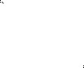In sports and many areas of life, we think of failures as evidence of something we could have done better. We regard these disappointments as a fate we could have avoided with more careful preparation, different training, a better strategy, or more focus. And there it makes sense that failures show us the road to success. These papers deal with a kind of failure people have little control over-rejection. Others determine who wins and who loses. But at the very least, the research is starting to show that early setbacks don't have to be fatal. They might even make us better at our jobs'.

Getting paid like a winner, though? That's a different matter.

1. Being a close loser could greatly motivate one to persevere in their research.
2. Grant awarders tend to favor researchers alretJ.dy recoized i:11 their repective fif?Jd_s _. __



1. Suffering early setbacks might help people improve their job performance.
2. Research by social scientists on the effects of career setbacks has produced contradictory findings.

fill€fl! 2021  6 J3

1. It is not to the best interest of taxpayers to keep giving money to narrow winners.
2. Scientists who persisted in research without receiving a grant made greater achievements than those who got one with luck, as suggested in one study.
3. A research paper rejected by one journal may get accepted by another.
4. According to one recent study, narrow winners of research grants had better chances to be promoted to professors. 
5. One researcher suggests it might be more fruitful to distribute grants on a relatively equal basis.
6. Minor setbacks in their early career may have a strong negative effect on the career of close losers.

## Section C

**Directions:** *There are 2 passa,ges in this section* . *F.ach passage is followed by some questions or unfinished*



*statements. For each of them there are four choices marked A), B),* C) *and D). You should decide on the*

*best choice and mark the corresponding letter on* ***Answer Sheet 2*** *with a single line through the centre.*

**Passage One** 



**Questions 46 to 50 are based on the following passage.**

Boredom has become trendy. Studies point to how boredom is good for creativity and innovation, as well as mental health. It is found that people are more creative following the completion of a tedious task. When people are bored, they have an increase in "associative thought"-the process of making new

connections between ideas, which is linked to innovative thinking. These studies are impressive, but in reality, the benefits of boredom may be related to having time to clear your mind, be quiet, or daydream.

In our stimulation-rich world, it seems unrealistic that boredom could occur at all. Yet, there are valid reasons boredom may feel so painful. As it turns out, boredom might signal the fact that you have a

need that isn't being met.

Our always-on world of social media may result in more connections, but they are superficial and can t in h _\\"_ay_ _f buildin _a real se *!'!_* b_elonging. Feeling bored may signal the desire for a greater sense of community and the feeling that you fit in with others around you. So take the step of joining an organization to build face-to-face relationships. You'll find depth that you won't get from your screen no matter how many likes you get on your post.

Similar to the need for belonging, bored people often report that they feel a limited sense of meaning. It's a fundamental human need to have a larger purpose and to feel like we're part of something bigger than ourselves. When people are bored, they're more likely to feel less meaning in their lives. If you want to reduce boredom and increase your sense of meaning, seek work where you can make a unique contribution, or find a cause you can support with your time and talent.

If your definition of boredom is being quiet, mindful, and reflective, keep it up. But if you're struggling with real boredom and the emptiness it provokes, consider whether you might seek new connections and more significant challenges. These are the things that will genuinely relieve boredom and make you more effective in the process.

1. What have studies found about boredom? A) It facilitates innovative thinking. B) It is a result of doing boring tasks.

fill 2021 6 Ji

* 1. **It helps people connect with others.**
  2. **It does harm to one's mental health.**

1. **What does the author say boredom might indicate? A) A need to be left alone.**
   1. **A desire to be fulfilled.**
   2. **A conflict to be resolved.**
   3. **A feeling to be validated.**
2. 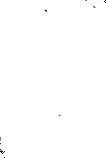**What do we learn about social media from the passage?**
   1. It **may be an obstacle to expanding one's connections.**
   2. It **may get in the way of enhancing one's social status.**



* 1. **It may prevent people from developing a genuine sense of community.**



* 1. 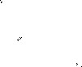**It may make people feel that they ought to fit in with the outside world.**



1. **What does the author suggest people do to get rid of boredom?** **A) Count the likes they get on their posts.**
   1. **Reflect on how they relate to others.**
   2. **Engage in real-life interactions.**
   3. **Participate in online discussions.**
2. **What should people do to enhance their sense of meaning? A) Try to do something original.**
   1. **Confront significant challenges.**
   2. **Define boredom in their unique way.**
   3. **Devote themselves to a worthy cause. Passage Two**

**Questions 51 to 55 are based on the following passage.** 

**Can you remember what you ate yesterday? If asked, most people will be able to give a vague description of their main meals: breakfast, lunch, dinner. But can you be sure you've noted every snack bar in your car, or every handful of nuts at your desk? Most people will have a feeling that they've missed**

**something out.**   

**We originally had this suspicion back in 2016, puzzled by the fact that national statistics showed calorie consumption falling dramatically over past decades. We found reliable evidence that people were**



**drastically under-reporting what they ate.**

**Now the Office for National Statistics has confirmed that we are consuming 50% more calories than our national statistics claim.**

**Why is this happening? We can point to at least three potential causes. One is the rise in obesity levels itself. Under-reporting rates are much higher for obese people, because they simply consume more food,** **and thus have more to remember.**

**Another cause is that the proportion of people who are trying to lose weight has been increasing over**



**time. People who want to lose weight are more likely to under-report their eating-regardless of whether they are overweight or not. This may be driven partly by self-deception or "wishful thinking''.**



**The final potential cause is an increase in snacking and eating out over recent decades-both in terms of how often they happen and how much they contribute to our overall energy intake. Again, there is**

**ll!I** 2021  6 **JI**

evidence that food conswned out of the home is one of the most poorly recorded categories in surveys.

So, what's the message conveyed? For statistics, we should invest in more accurate measurement options. For policy, we need to focus on options that make it easy for people to eat fewer calories. If people do not know how much they are eating, it can be really hard for them to stick to a diet. Also, we should be looking for new ways to ensure what people eat wouldn't have much impact on their waistlines.

If this works, it won't matter if they can't remember what they ate yesterday.

1. What did the author suspect back in 2016?
   1. Calorie conswnption had fallen drastically over the decades.
   2. Most people surveyed were reluctant to reveal what they ate.
   3. The national statistics did not reflect the actual calorie conswnption.
   4. Most people did not include snacks when reporting their calorie intake.
2. What has the Office for National Statistics verified?
   1. People's calorie intake was far from accurately reported. 
   2. The missing out of main meals leads to the habit of snacking.
   3. The nation's obesity level has much to do with calorie intake.
   4. Calorie conswnption is linked to the amount of snacks one eats.
3. What do we learn about obese people from the passage? A) They usually keep their eating habits a secret.
   1. They overlook the potential causes of obesity.
   2. They cannot help eating more than they should.
   3. They have difficulty recalling what they have eaten.
4. What often goes unnoticed in surveys on food conswnption? A) The growing trend of eating out. B) The potential causes of snacking.

C) People's home energy consumption.

 - D)_People's chang diet ove!Jh-rs. _______ _



1. What does the author suggest policymakers do about obesity? A) Remind people to cut down on snacking.
   1. Make sure people eat non-fattening food.
   2. Ensure people don't miss their main meals. 
   3. See that people don't stick to the same diet.

# Part *N* Translation ( 30 minutes)

**Directions:** *For this part , you are allowed 30 minutes to translate a passage from Chinese into English . You should write your answer on* ***Answer Sheet 2.***



**Part I Writing ( 30 minutes)** II

I!]• . ,•

.1<.iMpp

1:lf§ffi""F **Directions:** *For this part, you are allowed 80 minutes to write an essay titled "Is* ***technology making people lazy?".*** *The statement given below is for your reference. You should write at least*  *words but no more than 180 words.*

***Many studies claim that computers distract people, make them lazy tmnkers and even lower their work efficiency.***

 **Part ]I**  **Listening Comprehension ( 25 minutes)**

**Section A**

**Directions:** *In this section, you will hear three news reports. At the end of each news report, you will hear two or three questions. Both the news report and the questions will be spoken only once. After you hear a*

*question, you must choose the best answer from the four choices marked A), B),* C) *and D). Then mark the corresponding letter on* ***Answer Sheet 1*** *with a single line through the centre.* **Questions 1 and 2 are based on the news report you have just heard.**

1. A) See the Pope. C) Travel to Germany.
   1. Go to Newcastle. D) Tour an Italian city.
2. A) He was taken to hospital in an ambulance. **B)** His car hit a sign and was badly damaged.

-8)-His-GPS-system-went out of-order;--

D) He ended up in the wrong place.

**Questions 3 and 4 are based on the news report you have just heard.**

1. A) Scotland will reach the national target in carbon emissions reduction ahead of schedule. **B)** Glasgow City Council has made a deal with ScottishPower on carbon emissions.
   1. Glasgow has pledged to take the lead in reducing carbon emissions in the UK.
   2. First Minister Nicola Sturgeon urged ScottishPower to reduce carbon emissions.
2. A) Glasgow needs to invest in new technologies to reach its goal. **B)** Glasgow is going to explore new sources of renewable energy.
   1. Stricter regulation is needed in transforming Glasgow's economy.
   2. It's necessary to create more low-emission zones as soon as possible.

**Questions 5 to 7 are based on the news report you have just heard.**

1. A) It donates money to overpopulated animal shelters.
   1. It permits employees to bring cats into their office.
   2. It gives 5,000 yen to employees who keep pet cats.
   3. It allows workers to do whatever their hearts desire. fill 2021 &f 6 A
2. A) Keep cats off the street. C) Volunteer to help in animal shelters.
   1. Rescue homeless cats. **D)** Contribute to a fund for cat protection.
3. A) **It** has contributed tremendously to the firm's fame. **B) It** has helped a lot to improve animals' well-being.

C) **It** has led some other companies to follow suit. **D) It** has resulted in damage to office equipment.

# Section B

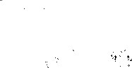**Directions:** *In this section, you will hear two long conversations. At the end of each conversation, you will hear four questions. Both the conversation and the questions wili be spoken only once. After you hear a question, you must choose the best answer from the four choices marked A), B),* C) *and* D). *Then mark the corresponding letter on* ***Answer Sheet 1*** *with a single line through the centre.* **Questions 8 to 11 are based on the conversation you have just heard.**

1. A) Find out where Jimmy is. C) Make friends with Jimmy.

 B) Borrow money from Jimmy. D) Ask Jimmy what is to be done.

1. A) He was unsure what kind of fellow Jimmy was.
   1. He was working on a study project with Jimmy.
   2. He wanted to make a sincere apology to Jimmy.
   3. 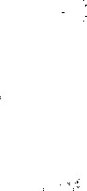He wanted to invite her to join in a study project.
2. A) He got a ticket for speeding. C) He was involved in a traffic accident. B) He got his car badly damaged. D) He had an operation for his injury.
3. A) He needed to make some donation to charity.
   1. He found the 60 pounds in his pocket missing.
   2. He wanted to buy a gift for his mother's birthday. D) He wanted to conceal something from his parents.

**Questions 12 to 15 are based on the conversation you have just heard.**

1. A) Shopping delivery.  C) Where he goes shopping.
   1. Shopping online. **D)** How often he does shopping.
2. A) Searching in the aisles. C) Driving too long a distance. **B)** Dealing with the traffic. D) Getting one's car parked.
3. A) The after-sales service.  C) The quality of food products.
   1. The replacement policy. D) The damage to the packaging.
4. A) **It** saves money. C) **It** increases the joy of shopping. **B) It** offers more choice. D) **It** is less time-consuming.

# Section C

**Directions:** *In this section, you will hear three passages. At the end of each passage, you will hear three or four questions. Both the passage and the questions will be spoken only once* . *After you hear a question* , *you must choose the best answer from the four choices marked A* ) , *B* ) , **C )** *and D* ) . *Then mark the*

*corresponding letter on* ***Answer Sheet 1*** *with a single line through the centre.* **Questions 16 to 18 are based on the passage you have just heard.**



1. A) They have little talent for learning math.
   1. They need_«!dical help f math anxiety. __



* 1. They need extra help to catch up in the math class. D) They have strong negative emotions towards math.

fill 2021 &p 6 JJ 25



1. A) **It** will gradually pass away without teachers' help. B) **It** affects low performing children only.
   * 1. **It** is related to a child's low intelligence.
     2. **It** exists mostly among children from poor families.
2. A) Most of them have average to strong math ability. B) Most of them get timely help from their teachers.

C) They will regain confidence with counselling. D) They are mostly secondary school students.

**Questions 19 to 21 are based on the passage you have just heard.**

1. A) Social media addiction is a threat to our health. B) Too many people are addicted to smartphones.
   * 1. Addiction to computer games is a disease.
     2. Computer games can be rather addictive. 
2. A) They prioritize their favored activity over what they should do.
   * 1. They do their favored activity whenever and wherever possible.
     2. They are unaware of the damage their behavior is doing to them.
     3. They are unable to get rid of their addiction without professional help.
3. A) **It** may be less damaging than previously believed.
   * 1. There will never be agreement on its harm to people. 
     2. **It** may prove to be beneficial to developing creativity. D) There is not enough evidence to classify it as a disease.

**Questions 22 to 25 are based on the passage you have just heard.**

1. A) They are relatively uniform in color and design. B) They appear more formal than other passports.
   * 1. They are a shade of red bordering on brown.
     2. They vary in color from country to country.
2. A) They must endure wear and tear. C) They must be made from a rare material.

B) They must be of the same size. D) They must follow some common standards.

- - - -24 ~~-A7~~ -'Fhey-look-more-traditional-;- - - - - - - -- - - - ~~- -- C-)~~ They are favored -by-airlines-; - - - - - - - - - -

B) They look more official. D) They are easily identifiable.

25. A) For beauty. C) For visibility. B) For variety. D) For security.

**Part D[ Reading Comprehension ( 40 minutes)**

**Section A**

**Directions:** *In this section* , *there is a passage with ten blanks. You are required to select one word for each blank from a list of choices given in a word bank following the passage. Read the passage through carefully*

*before making your choices. &eh choice in the bank is identified by a letter. Please mark the corresponding letter for each item on* ***Answer Sheet 2*** *with a single line through the centre. You may not use any of the*

*words in the bank more than once* .

Social isolation poses more health risks than obesity or smoking 15 cigarettes a day, according to research published by Brigham Young University. The is that loneliness is a huge, if silent, risk factor. 

Loneliness affects physical health in two ways. First, it produces stress hormones that can lead to many health problems. Second, people who live alone are less likely to go to the doctor _E_, to

[9 20211¥- 6 fa.I

**exercise or to eat a healthy diet.**

**Public health experts in many countries are how to address widespread loneliness in our society. Last year Britain even appointed a minister for loneliness. "Loneliness almost every one of us at some point," its minister for loneliness Baroness Barran said. "It can lead to very serious health**

**30 for individuals who become isolated and disconnected. "**

**Barran started a "Let's Talk Loneliness" campaign that ___l!_ difficult conversations across Britain. He is now supporting "_;g_ benches," which are public seating areas where people are encouraged to go and chat with one another. The minister is also _lL to stop public transportation from being cut in ways that leave people isolated.**

**More than one-fifth of adults in both the United States and Britain said in a** 2018 **____M_ that they often or always feel lonely. More than half of American adults are unmarried, and researchers have found that even among those who are married, 30% of relationships are strained. A quarter of Americans now live alone, and as the song says, one is the loneliest number.**

1. **abruptly F) friendly K) severely**
2. **appointments G) hindered L) sparked**
3. **consequences H) idiom M) splitting**
4. **debating I) implication N) survey**
5. **dimensions J) pushing 0) touches**

# Section B

**Directions: *In this section, you are going to read a passage with ten statements attached to it. Each statement contains information given in one of the paragraphs. Identify the paragraph from which the information is derived. You may choose a paragraph more than once. &eh paragraph is marked with a letter. Answer the questions by marking the corresponding letter on Answer Sheet 2.***

**What happens when a language bas no words for numbers?**

1. **Numbers do not exist in all cultures. There are numberless hunter-gatherers in Amazonia, living along branches of the world's largest river tree. Instead of using words for precise quantities, these people rely exclusively on terms similar to "a few" or "some. " In contrast, our own lives are governed by numbers. As you read this, you are likely aware of what time it is, how old you are, your checking account balance, your weight and so on. The exact numbers we think with impact everything in our lives.**
2. **But, in a historical sense, number-conscious people like us are the unusual ones. For the bulk of our species' approximately** 200, **OOO-year lifespan, we had no means of precisely representing quantities. What's more, the 7 ,OOO or so languages that exist today vary dramatically in how they utilize numbers.**
3. **Speakers of anumeric, or numberless, languages offer a window into how the invention of numbers reshaped the human experience. Otltures without nwnbers, or with only one or two precise numbers, include the Munduruku** and **Piraha in Amazonia. Researchers have also studied some adults** in **Nicaragua who were never taught number words. Without numbers, healthy human adults struggle to precisely distinguish and recall quantities as low as four. In an experiment, a researcher will place nuts into a can one at a time and then remove them one by one. The person watching is asked to signal when all the nuts have been removed. Responses suggest that anumeric people have some trouble keeping track of how many nuts remain in the can, even if there are only four or five in total.**



1. **This and many otherexiteriments hav-e led toa simpleconclusionJ\lhepeopldQD.QtJ1av-eumber words, they struggle to make quantitative distinctions that probably seem natural to someone like you or me. While only a small portion of the world's languages are anumeric or nearly anumeric, they**

**Im 2021 6 JI 27**

demonstrate that number words are not a human universal.

1. It is worth stressing that these anumeric people are *cognitively* (,1£ R -jj" i:1) normal, well-adapted to the surroundings they have dominated for centuries. As a child, I spent some time living with anumeric people, the Piraha who live along the banks of the black Maici River. Like other outsiders, I was continually impressed by their superior understanding of the ecology we shared. Yet numberless people struggle with tasks that require precise discrimination between quantities. Perhaps this should be unsurprising. After all, without counting, how can someone tell whether there are, say, seven or eight *coconuts* ( -1-) in a tree? Such seemingly straightforward distinctions become blurry through numberless

eyes. 



1. This conclusion is echoed by work with anumeric children in industrialized societies. Prior to being spoon-fed number words, children can only approximately discriminatequantities beyond three. We must be handed the cognitive tools of numbers before we can consistently and easily recognize higher quantities. In fact, acquiring the exact meaning of number words is a painstaking process that takes children years. Initially, kids learn numbers much like they learn letters. They recognize that numbers are organized sequentially, but have little awareness of what each individual number means. With time, they start to understand that a given number represents a quantity greater by one than the



number coming before it. This "successor principle" is part of the foundation of our *numerical* ( e{j) cognition, but requires extensive practice to understand. 

1. None of us, then, is really a "numbers person." We are not born to handle quantitative distinctions skillfully. In the absence of the cultural traditions that fill our lives with numbers from infancy, we would all struggle with even basic quantitative distinctions. Number words and their written forms transform our quantitative reasoning as they are introduced into our cognitive experience by our



parents, peers and school teachers. The process seems so normal that we sometimes think of it as a natural part of growing up, but it is· not. Human brains come equipped with certain quantitative instincts that are refined with age, but these instincts are very limited.

1. Compared with other mammals, our numerical instincts are not as remarkable as many assume. We even share some basic instinctual quantitative reasoning with distant non-mammalian relatives like birds. Indeed, work with some other species suggests they too can refine their quantitative thought if

- - - ----they are introduced to the cognitive power tools we call numbers.

1. So, how did we ever invent "unnatural" numbers in the first place? The answer is, literally, at your fingertips. The bulk of the world's languages use base-10, base-20 or base-5 number systems. That is, these smaller numbers are the basis of larger numbers. English is a base-10 or *decimal* ( -r :ttr. -$1] e{j ) language, as evidenced by words like 14 ("four"+ "10") and 31 ("three" X "10" +"one"). We speak a decimal language because an ancestral tongue, proto-Indo-European, was decimally based. Proto-IndoEuropean was decimally oriented because, as in so many cultures, our ancestors' hands served as the gateway to the realization that" five fingers on one hand is the same as five fingers on the other. " Such momentary thoughts were represented in words and passed down across generations. This is why the word"five" in many languages is derived from the word for "hand." Most number systems, then, are the by-product of two key factors: the human capacity for language and our inclination for focusing on our hands and fingers. This manual fixation-an indirect by-product of walking upright on two legshas helped yield numbers in most cultures, but not all.
2. Cultures without numbers also off er insight into the cognitive influence of particular numeric traditions. Consider what time it is. Your day is ruled by minutes and seconds, but these concepts are not real in any physical sense and are nonexistent to numberless people. Minutes and seconds are the verbal and written representations of an uncommon base-60 number system used in ancient

ll!I 2021 &f 6 Jj

Mesopotamia. They reside in our minds, numerical ***artifacts*** (A..I.! ) that not all humans inherit conceptually.

1. Research on the language of numbers shows, more and more, that one of our species' key characteristics is tremendous ***linguistic*** ( ii*~~i.~~* €r?) and cognitive diversity. If we are to truly understand how much our cognitive lives differ cross-culturally, we must continually explore the depths of our species' linguistic diversity.
2. It is difficult for anumeric people to keep track of the change in numbers even when the total is very small.
3. Human numerical instincts are not so superior to those of other mammals as is generally believed.
4. The author emphasizes being anumeric does not affect one's cognitive ability.
5. In the long history of mankind, humans who use numbers are a very small minority.
6. An in-depth study of differences between human languages contributes to a true understanding of cognitive differences between cultures.
7. A conclusion has been drawn from many experiments that anumeric people have a hard time distinguishing quantities.
8. Making quantitative distinctions is not an inborn skill.
9. Every aspect of our lives is affected by numbers.
10. Larger numbers are said to be built upon smaller numbers.



1. It takes great efforts for children to grasp the concept of number words.

# Section C

**Directions: *There are 2 passages in this section. Each passage is fallowed by some questions or unfinished statements. For each of them there are four choices marked A), B),*** C) ***and*** D). ***You should decide on the***

***best choice and mark the corresponding letter on Answer Sheet 2 with a single line through the centre.***

 **Passage One** 

**Questions 46 to 50 are based on the following passage.**

Sugar shocked. That describes the reaction of many Americans this week following revelations that, 50 years ago, the sugar industry paid Harvard scientists for research that shifted the focus away from sugar's role in heart disease-and put the ***spotlight*** 0.i 1;€r? 4' *1\>')* squarely on dietary fat.

What might surprise consumers is just how many present-day nutrition studies are still funded by the food industry. Nutrition scholar Marion Nestle of New York University spent a year informally tracking industry-funded studies on food. "Roughly 90% of nearly 170 studies favored the sponsor's interest," Nestle tells us. Other systematic reviews support her conclusions.

For instance, studies funded by Welch Foods-the brand behind Welch's 100% Grape Juice-found that drinking Concord grape juice daily may boost brain function. Another, funded by Quaker Oats, concluded, as a ***Daily Mail*** story put it, that "hot ***oatmeal*** ( !: ) breakfast keeps you full for longer. "

Last year, ***The New York Times*** revealed how Coca-Cola was funding well-known scientists and organizations promoting a message that, in the battle against weight gain, people should pay more attention to exercise and less to what they eat and drink. Coca-Cola also released data detailing its funding of several medical institutions and associations between 2010 and 2015.

"It's certainly a problem that so much research in nutrition and health is funded by industry," says Bonnie Liebman, director of nutrition at the Center for Science in the Public Interest. "When the food industry pays for research, it often gets what it pays for." And what it pays for is often a pro-industry finding.

_Giveathisenv ironment,_consumeruhould-beskepticaL(/$-AfJ-}-whenreading-the-latest-finding- ~~in~~nutrition science and ignore the latest study that pops up on your news feed. "Rely on health experts who've reviewed all the evidence," Liebman says, pointing to the official government Dietary Guidelines,

fill 2021  6 Jj 29

which are based on reviews of hundreds of studies. 

"And that expert advice remains pretty simple," says Nestle. "We know what healthy diets are--lots of vegetables, not too much junk food, balanced calories. Everything else is really difficult to do experimentally. "

1. What did Harvard scientists do 50 years ago?
   1. They raised public awareness of the possible causes of heart disease.
   2. They turned public attention away from the health risks of sugar to fat.
   3. They placed the sugar industry in the spotlight with their new findings.
   4. They conducted large-scale research on the role of sugar in people's health.
2. What does Marion Nestle say about present-day nutrition studies? A) They took her a full year to track and analyze.
   1. Most of them are based on systematic reviews.
   2. They depend on funding from the food industries.
   3. Nearly all of them serve the purpose of the funders.
3. What did Coca-Cola-funded studies claim?
   1. Exercise is more important to good health than diet. 
   2. Choosing what to eat and drink is key to weight control.
   3. Drinking Coca-Cola does not contribute to weight gain.
   4. The food industry plays a major role in fighting obesity.
4. What does Liebman say about industry-funded research? A) **It** simply focuses on nutrition and health.
   1. **It** causes confusion among consumers.
   2. **It** rarely results in objective findings.
   3. **It** runs counter to the public interest. 
5. What is the author's advice to consumers?
   1. Follow their intuition in deciding what to eat.
   2. Be doubtful of diet experts' recommendations.
   3. Ignore irrelevant information on their news feed.
   4. Think twice about - new nutrition -- --- -research findings. **Passage Two**

**Questions 51 to SS are based on the following passage.**

Success was once defined as being able to stay at a company for a long time and move up the corporate ladder. The goal was to reach the top, accumulate wealth and retire to a life of ease. My father is a successful senior executive. In 35 years, he worked for only three companies.

When I started my career, things were already different. If you weren't changing companies every three or four years, you simply weren't getting ahead in your career. But back then, if you were a consultant or ***freelancer*** ( ro lb JfR 3k *) , people would wonder what was wrong with you. They would assume you had problems getting a job.

Today, consulting or freelancing for five businesses at the same time is a badge of honor. **It** ·shows how valuable an individual is. Many companies now look to these "ultimate professionals" to solve problems their full-time teams can't. Or they save money by hiring ***"top-tier*** c-m ) experts" only for particular projects.

Working at home or in cafes, starting businesses of their own, and even launching business ventures that eventually may fail, all indicate "initiative," "creativity," and "adaptability," which are desirable qualities in today's workplace. Most important, there is a growing recognition that people who balance

lm#i 2021 *!if::* 6 A

work and play, and who work at what they are passionate about, are more focused and productive, delivering greater value to their clients.



Who are these people? They are artists, writers, programmers, providers of office services and career advice. What's needed now is a marketplace platform specifically designed to bring freelancers and clients together. Such platforms then become a place to feature the most experienced, professional, and creative talent. This is where they conduct business, where a sense of community reinforces the culture and values of the*gig economy* (-* .:c. *"), and where success is rewarded with good reviews that encourage more business.

Slowly but surely, these platforms create a bridge between traditional enterprises and this emerging economy. Perhaps more important, as the global economy continues to be disrupted by technology and other massive change, the gig economy will itself become an engine of economic and social transformation. 

1. What does the author use the example of his father· to illustrate? A) How long people took to reach the top of their career.
   1. How people accumulated wealth in his father's time.
   2. How people viewed success in his father's time.
   3. How long people usually stayed in a company.
2. Why did people often change jobs when the author started his career? A) It was considered a fashion at that time.
   1. It was a way to advance in their career.
   2. It was a response to the changing job market.
   3. It was difficult to keep a job for long.
3. What does the author say about people now working for several businesses at the same time? A) They are often regarded as most treasured talents.
   1. They are able to bring their potential into fuller play.
   2. They have control over their life and work schedules. 
   3. They feel proud of being outstanding problem solver.
4. What have businesses come to recognize now? 
   1. Who is capable of solving problems with ease.
   2. How people can be more focused and productive.
   3. What kind of people can contribute more to them.
   4. Why some people are more passionate about work.
5. What does th~~e~~ author say about the gig economy? 
   1. It may force companies to reform their business practice.
   2. It may soon replace the traditional economic model. 
   3. It will drive technological progress on a global scale.
   4. It will bring about radical economic and social changes. 

# Part *N* Translation ( 30 minutes)

**Directions:** *For this part* , *you are allowed 30 minutes to translate a passage from Chinese into English. You should write your answer on* ***Answer Sheet 2.***